TRAUMATIC BRAIN INJURY IN THE UNITED STATES

Emergency Department Visits, Hospitalizations and Deaths 2002 – 2006

Prepared by: the Division of Injury Response, National Center for Injury Prevention and Control

Centers for Disease Control and Prevention, U.S. Department of Health and Human Services

Traumatic Brain Injury In The United States: Emergency Department Visits, Hospitalizations and Deaths 2002 – 2006
is a publication of the National Center for Injury Prevention and Control, Centers for Disease Control and Prevention.

Centers for Disease Control and Prevention: Thomas R. Frieden, MD, MPH, Director

National Center for Injury Control and Prevention: Robin Ikeda, MD, MPA, Acting Director

Division of Injury Response: Richard C. Hunt, MD, FACEP, Director

Authors from the Division of Injury Response:
Mark Faul, PhD, MS, Behavioral Scientist
Likang Xu, MD, MS, Mathematical Statistician
Marlena M. Wald, MPH, MLS, Epidemiologist
Victor Coronado, MD, MPH, Medical Officer

The authors would like to thank Dr. Vikas Kapil and Dr. Lisa McGuire for their editorial comments as well as, Karen Thomas, MPH, for her programming assistance. The authors also offer sincere appreciation to the many advisors for this report including Dionne J. Williams, MPS and Kevin Webb for their guidance.

Suggested citation: Faul M, Xu L, Wald MM, Coronado V. Traumatic Brain Injury in the United States: Emergency Department Visits, Hospitalizations and Deaths, 2002-2006. Atlanta, Georgia: Centers for Disease Control and Prevention, National Center for Injury Prevention and Control; 2010.

The findings and conclusions in this report are those of the authors and do not necessarily represent the official views of the Centers for Disease Control and Prevention.

The Power of Data…

Society is more likely to wage a battle against the ravages of traumatic brain injury if it understands how pernicious, pervasive, and huge the problem is.

This body of work is a vital tool for those who devise the strategies for prevention and treatment. However, a critical dimension will be lost if one sees it only as data, if one does not try to put even a fleeting face behind the numbers. They represent people who – if they survived – have had their lives significantly worsened, their dreams most likely lost, their care a burden to countless others, their injury a rent in the fabric of their (and our) community.

We are finding better ways to prevent injury and improve acute care. We who are injured may experience improvement both in function and in the quality of our lives when we have access to rehabilitation and support to develop and utilize our remaining strengths and abilities.

As a survivor, as a disabled physician, I applaud this publication as a step toward making that possible.

Claudia L. Osborn, DO, FACOI
College of Osteopathic Medicine, Michigan State University

Table of Contents

Sections
Executive Summary, Page 6
Introduction, Page 9
Overview of TBI in the United States, Page 11
Average Annual Numbers of All Visits, All Injuries, and Traumatic Brain Injury-related Emergency Department Visits, Hospitalizations, and Deaths, United States, 2002-2006, Page 11
--TBI by Age: Comparing the Numbers, Page 13
--TBI by Age: Comparing the Rates, Page 14
--TBI by Sex: Comparing the Numbers, Page 15

--TBI by Sex: Comparing the Rates, Page 16
Estimated Average Annual Numbers of Traumatic Brain Injury-related Emergency Department Visits, Hospitalizations, and Deaths, by External Cause, United States, 2002-2006, Page 17
--TBI by External Cause: Comparing the Percentages, Page 19
--TBI by External Cause: Comparing the Percentages by Age Groups, Page 20
Summary of Findings, Page 23
Conclusion, Page 23

Table of Contents Continued

Appendix A: Tables and Figures, Page 24
Estimated Average Annual Numbers, Rates, and Percentages of Traumatic Brain Injury-related Emergency Department Visits, Hospitalizations, and Deaths by Age Group, United States, 2002-2006, Page 25
--By Age Group and Disposition, Page 26
--By Age Group and Sex, Page 27
--By Age Group and Race, Page 28
--By Age Group and External Cause, Page 30
--By Age Group and Specific Motor Vehicle Traffic (MVT) External Causes, Page 32
Estimated Average Annual Numbers and Percentages of Traumatic Brain Injury-related Emergency Department Visits, by Age Group and Expected Source of Payment, United States, 2002-2006, Page 34
Estimated Average Annual Numbers and Percentages of Traumatic Brain Injury-related Hospitalization, by Age Group and Disposition, United States, 2002-2006, Page 36
Estimated Average Annual Numbers and Percentages of Traumatic Brain Injury-related Hospitalization, by Age Group and Sex, United States, 2002-2006, Page 38
--By Age Group and Race, Page 39
--By Age Group and External Cause, Page 40
--By Age Group and Specific Motor Vehicle Traffic (MVT) External Causes, Page 42
--By Age Group and Expected Source of Payment, Page 44
Average Annual Numbers, Rates, and Percentages of Traumatic Brain Injury-related Deaths, by Age Group and Sex, United States, 2002-2006, Page 46
--By Age Group and Race, Page 47
--By Age Group and External Cause, Page 48
--By Age Group and Specific Motor Vehicle Traffic (MVT) External Causes, Page 49
Annual Number of all Traumatic Brain Injury-related Emergency Department Visits, Hospitalizations, and Deaths, United States, 2002-2006, Page 50
--Within Children Ages 0-14, Page 52
--Within Adults Ages 65 and Older, Page 54

Appendix B, Methods and Data Sources, Page 56
Data Sources, Page 57
Identification of TBI Cases, Page 59
External Cause of Injury, Page 62
Population Data, Page 62
Statistical Analysis and Age-Adjusted Rates, Page 64
Estimated Average Annual 2002-2006 Population by Age Group, Sex, and Race: Weights for 2000 Standard Population by Age Group, Page 66
Limitations, Page 67

References, Page 71

Executive Summary

Background and Purpose of the Report

Traumatic brain injury (TBI) is an important public health problem in the United States (U.S.). Because the complications that result from TBI, such as impaired cognition and memory, are often not readily apparent, and because awareness about TBI among the general public is limited, it is frequently referred to as the “silent epidemic.”

Population-based data on TBI in the U.S. are critical to understanding the impact of TBI on the American people. This report presents basic data about emergency department (ED) visits, hospitalizations, and deaths for the years 2002 through 2006. ED visits represent approximately 80% of all TBIs. These data answer a wide range of important questions about how many TBIs occur each year in the U.S., who is affected, and how these TBIs occur. The report is intended as a reference for policy makers, service providers, educators, researchers, advocates, and others interested in knowing more about the impact of TBI.

This document is designed to be an update to a previously published report in 2006, entitled Traumatic Brain Injury in the United States: Emergency department visits, hospitalizations, and deaths which covered the years 1995-2001.

Highlights of the Results

Each year in the United States:

- Approximately 1.7 million people sustain a TBI. Of them, about 52,000 die, 275,000 are hospitalized, and 1,365 million are treated and released from an ED.

- Approximately 511,000 TBIs occur among children ages 0 to 14 years; ED visits account for more than 90% of the TBIs in this age group.

- Falls are the leading cause of TBI. Rates are highest for children ages 0 to 4 years and for adults 65 years or older.
- In every age group, TBI rates are higher for males than for females.

- Falls result in the greatest number of TBI-related hospitalizations.

- Adults ages 75 years or older have the highest rates of TBI-related hospitalization and death.

- Motor vehicle-traffic (MVT) is the leading cause of TBI-related death. Rates are highest for ages 20 to 24 years.

Conclusion

An estimated 1.7 million TBI-related deaths, hospitalizations, and ED visits occur in the U.S. each year. An estimated 124,626 people with TBI experience long-term impairment or disability from their injury. [Citation Number 4] Thus, TBI prevention to reduce the incidence of TBIs and improved acute care, and rehabilitation services to reduce the likelihood of TBI-related disability are critical.

Introduction

Background

Traumatic brain injury (TBI) is an important public health issue in the U.S. It is frequently referred to as the “silent epidemic”, because the complications that result from TBI, such as those of impaired cognition and memory, are often not visible, and because awareness about TBI among the general public is limited. Population-based data on TBI in the U.S. are critical to understanding the impact of the TBI on the American people. A previous CDC report, Traumatic Brain Injury in the United States: A Report to Congress,[Citation Number One] provided useful information about TBI. It included information about TBI-related deaths and hospitalizations; however, it did not describe TBIs of patients who were treated and released from the ED. ED visits account for about 80% of TBIs and include a large number of mild TBIs and are included in this report.

TBI is generally categorized as mild, moderate or severe. Most TBIs are mild TBI (MTBI). MTBI refers to those in which the injury to the brain itself is diagnosed as mild at the time the person is initially evaluated. Most people recover fully from a MTBI, but occasionally have serious long-term consequences may occur. For this reason, more data are needed about MTBIs, including those seen in the ED. Additional information on MTBI can be found in TBI in the United States: A Report to Congress, published by CDC in 2003.[Citation Number Two]
Major sections of this report include:

- TBI as a portion of all injuries
- TBI by age
- TBI by race
- TBI by external cause
- TBI trends
- Overall, trends show the frequency of TBI cases increasing from 2002 to 2006 with a peak noted in 2005.

State level data fro ED visits and hospitalizations are not available. Therefore, TBI state estimates could not be created. Also, this report does not include TBIs from federal, military, or Veterans’ Administration hospitals.

Purpose of the Report

This report, Traumatic Brain Injury in the United States: Emergency Department Visits, Hospitalizations, and Deaths, 2002-2006, presents data on the incidence of TBI. This report answers a wide range of important questions about how many TBIs occur each year in the U.S., who is affected, and how these TBIs occur. These data can answer questions such as “Do men sustain TBIs more often than women? Are children more likely to have a TBI than adults? Are motor vehicle-traffic injuries a substantial cause of TBI among older adults?” This report is intended as a reference for policy makers, service providers, educators, researchers, advocates, and others interested in knowing more about the impact of TBI in the U.S. This information can be used to document the need for TBI prevention, to identify priorities for research, and to support the need for services among those living with TBI-related impairment and disability.

Contents and Organization

This report describes TBI-related ED visits, hospitalizations, and deaths in the U.S. for the years 2002 through 2006. Average annual numbers of TBIs per year and annual rates are reported. The numbers show the magnitude of the problem, but the rates are also important. Rates show how a certain group is affected by TBI by relating the number of TBIs to the size of the population. For example, a relatively small number of TBIs occurring in a small population (e.g., persons ages 75 years or older) would result in a higher TBI rate than if the same number of TBIs occurred in a larger population (e.g., persons ages 25 to 34 years). The report findings are organized into two main sections. The Overview summarizes and interprets some key findings. The Appendices present more detailed data tables, along with a description of the methods and limitations.

Overview of TBI in the United States

In the U.S., approximately 1.7 million traumatic brain injures occur each year. Of the approximately 1.7 million TBI injuries occurring each year, 1,365,000 (80.7%) were ED visits, 275,000 (16.3%) were hospitalizations, and 52,000 (3.0%) were deaths. The following figure is a pyramid depicting the estimated average annual number of TBI-related ED visits, hospitalizations, and deaths in the U.S. for the years 2002 to 2006. The base of the pyramid is represented by dashes because this number is unknown. Anecdotal evidence indicates that individuals with a TBI may decide to treat themselves at home or seek other forms of medical treatment that are not tracked by existing national data sets. Data for the number of individuals receiving other medical are or no care are not included in this report. (See Limitations section in Appendix B) The next level above the pyramid’s base is ED visits. The estimate for these visits is 1,365,000. Above ED visits is that of hospitalizations with an estimate of 275,000. Finally, at the top of the pyramid is the estimate for TBI deaths which equals 52,000.

Figure 1: Estimated Average Annual Number of Traumatic Brain Injury-Related Emergency Department Visits, Hospitalizations, and Deaths, United States, 2002-2006
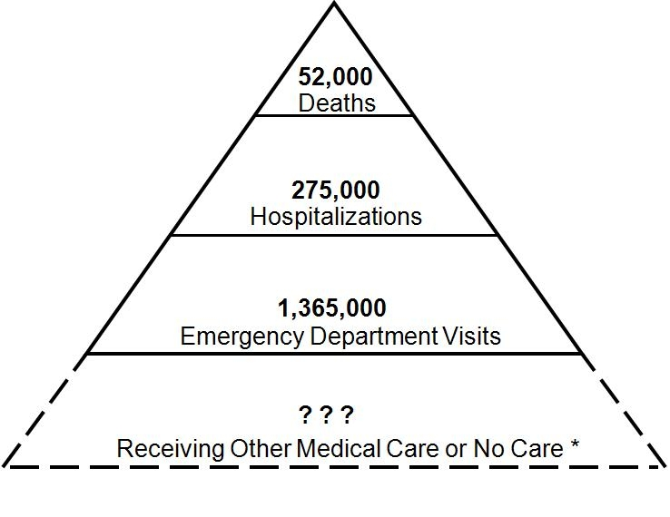
The following table, Table A, depicts the estimated annual average number of ED visits, hospitalizations, and deaths for all injuries in the U.S. for the years 2002-2006. Included in this table are the estimates of TBI as a sub-set of all injuries. For these years, TBI comprised 4.8% of all injuries seen in EDs and 15.1% of all hospitalizations. Of all injury-related deaths in the U.S., TBI was a contributing factor 30.5% of the time.

Table A: Estimated Percentage of All Injuries, and Traumatic Brain Injury-Related Emergency Department Visits, Hospitalizations, and Deaths, United States, 2002-2006

 | All Injuries |  |  | Traumatic Brain Injuries
Category | All Visits | Number | % of All Visits | Number | % of All Injuries | % of All Visits
ED Visits | 96,839,411 | 28,697,028 | 29.6 | 1,364,797 | 4.8 | 1.4
Hospitalizations | 36,693,646 | 1,826,548 | 5.0 | 275,146 | 15.1 | 0.7
Deaths | 2,432,714 | 169,055 | 6.9 | 51,538 | 30.5 | 2.1
Total | 135,965,771 | 30,692,631 | 22.6 | 1,691,481 | 5.5 | 1.2

Notes regarding the data in Table A: For the category ED Visits, persons who died in the ED, were admitted to the hospital from the ED, or were transferred from the ED to another facility were excluded. For the category Hospitalizations, in-hospital deaths and patients who transferred from another hospital were excluded. For the category of TBI-related Deaths, 128 mortality records for the years 2002-2006 were omitted because of missing age information.

TBI by Age: Comparing the Numbers

Table B: Estimated Average Annual Numbers of Traumatic Brain Injury-Related Emergency Department Visits, Hospitalizations, and Deaths by Age Group, United States, 2002-2006

Age Group | ED Visits | Hospitalizations | Deaths | Total
Children (0-14 years) | 473,947 | 35,136 | 2,174 | 511,257
Older Adults (> 65 years) | 141,998 | 81,499 | 14,347 | 237,844

Notes regarding the data in Table B: The estimated annual average number of TBI that occurs each year among children ages 0 to 14 years is 511,257. In contrast, the number of traumatic brain injuries that occur each year among older adults ages 65 and older is 237,844. TBI-related ED visits accounted for a larger proportion of children (92.7%) than in older adults (59.7%).

TBI by Age: Comparing the Rates

The following figure, Figure 2, is a graph depicting the estimated average annual rates of TBI-related ED visits, hospitalizations, and deaths by age groups in the U.S. for the years 2002 to 2006. This graph is a comparison of TBI rates and outcome by age. The x axis represents age in years. Reading left to right the units of measure are: 0-4, 5-9, 10-14, 15-19, 20-24, 25-34, 35-44,45-54, 55-64,65-74, and greater than or equal to 75 years. The y axis represents the rate per 100,000 population. The units of measure, beginning with zero and in ascending order are 200, 400, 600, 800, 1,000, 1,200, and 1,400. Three lines are plotted on the graph: ED visits, Hospitalizations, and Deaths. During 2002 to 2006, very young children ages 0 to 4 years had the highest rate of TBI-related ED visits, 1,256 per 100,000 population, followed by older adolescents ages 15 to 19 years, 757 per 100,000. From age 20 to age 64 the rates for ED visits steadily decline, then begin to rise again for those ages 65-74. The highest rates of TBI-related hospitalization and death occurred among adults age 75 years or older (339 per 100,000 and 57 per 100,000, respectively).

Figure 2: Estimated Average Annual Rates of Traumatic Brain Injury-Related Emergency Department Visits, Hospitalizations, and Deaths, by Age Group, United States, 2002-2006

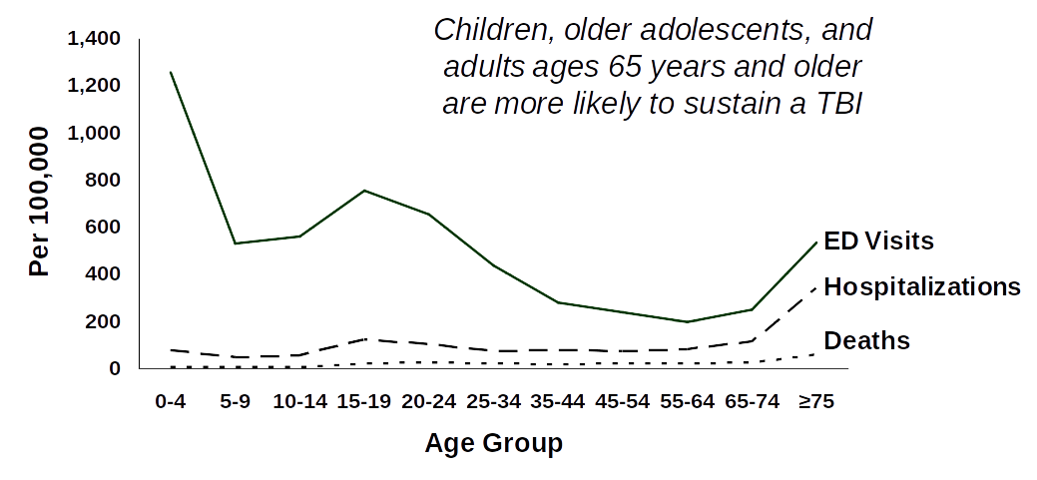

TBI by Sex: Comparing the Numbers

The following table, Table C, represents the estimated average annual numbers of TBI-related ED visits, hospitalizations, and deaths, by sex, in the U.S. for the years 2002 to 2006. An estimated average of 998,176 TBIs occurred each year among males compared with 693,329 TBIs which occurred each year among females. Overall, approximately 1.4 times as many TBIs occurred among males as among females.

Sex | ED Visits | Hospitalizations | Deaths | Total
Male | 789,925 | 170,257 | 37,994 | 998,176
Female | 574,870 | 104,890 | 13,569 | 693,329

TBI by Sex: Comparing the Rates

The following figure, Figure 3, is a graph depicting the estimated average annual rates of TBI-related ED visits, hospitalizations, and deaths by sex in the U.S. for the years 2002 to 2006. The x axis represents age in years. Reading left to right the units of measure are: 0-4, 5-9, 10-14, 15-19, 20-24, 25-34, 35-44,45-54, 55-64,65-74, and greater than or equal to 75 years. The y axis represents the rate per 100,000 population. The units of measure, beginning with zero and in ascending order are 200, 400, 600, 800, 1,000, 1,200, 1,400, and 1,600. Two lines are plotted on the graph, one for males and one for females. Both genders have tri-modal curves. Males from 0 to 4 years of age had the highest rates for TBI-related ED visits, hospitalizations, and deaths combined, 1,451 per 100,000. Rates were also high for females from 0 to 4 years of age, 1,218 per 100,000. Both males and females had high rates for ages 15 to 19 years, 896 per 100,000. For persons ages 75 years or older, the rate was 932 per 100,000. In every age group, TBI rates were higher for males than females.

Figure 3: Estimated Average Annual Rates of Traumatic Brain Injury-Combined Emergency Department Visits, Hospitalizations, and Deaths, by Sex, United States, 2002-2006

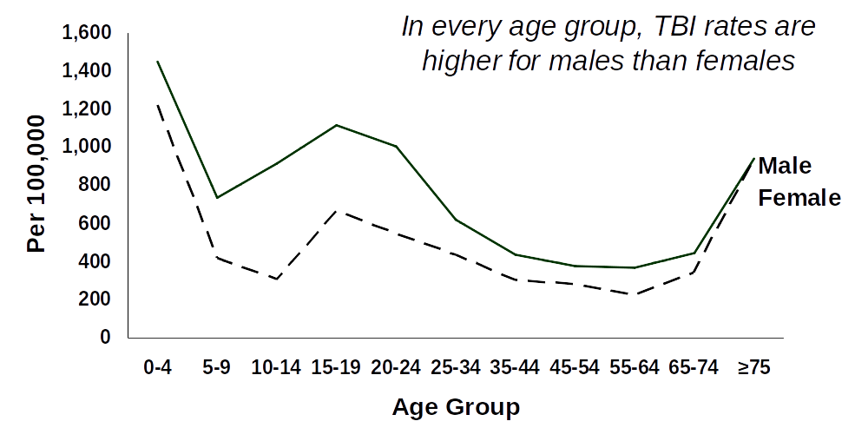

Table D: Estimated Average Annual Numbers of Traumatic Brain Injury-Related Emergency Department Visits, Hospitalizations, and Deaths, by External Cause, United States, 2002-2006

Cause | ED Visits | Hospitalizations | Deaths | Total
Falls | 523,043 | 62,334 | 9,718 | 595,095
Struck by or against | 271,713 | 7,791 | 378 | 279,882
Motor Vehicle-Traffic | 218,936 | 56,864 | 16,402 | 292,202
Assault | 148,471 | 15,341 | 5,813 | 169,625
Other | 108,467 | 27,536 | 19,252 | 155,255
Unknown | 94,165 | 105,282 | --0-- | 199,447

Notes regarding the data in Table D: An estimated average of 595,095 are fall-related TBIs, 292,202 motor vehicle - traffic TBIs, 279,882 struck by or against events, and 169,625 assault-related TBIs occurred annually. Motor vehicle-traffic resulted in the greatest number of TBI-related deaths; however, falls resulted in the greatest number of ED visits and hospitalizations.

The following figure, Figure 4, is a graph depicting the estimated average annual rates of TBI-related ED visits, hospitalizations, and deaths by external cause in the U.S. for the years 2002-2006. The x-axis represents axis age in years. Reading left to right the units of measure are: 0-4, 5-9, 10-14, 15-19, 20-24, 25-34, 35-44,45-54, 55-64,65-74, and greater than or equal to 75 years. The y axis represents the rate per 100,000 population. The units of measure, beginning with zero and in ascending order are 200, 400, 600, 800, and 1,000.
The data indicate that Falls were the leading cause of TBI in the U.S. during these years. Rates were highest among ages 0-4 years and 65 years and older. The rate of fall-related TBI was highest among children 0 to 4 years, 839 per 100,000, and adults ages 75 years or older, 599 per 100,000. The rates for both motor vehicle-traffic and assault-related TBI were highest among young adults ages 20 to 24 years, 261 per 100,000 and 175 per 100,000 respectively.

Figure 4: Estimated Average Annual Rates of Traumatic Brain Injury-Combined Emergency Department Visits, Hospitalizations, and Deaths, by External Cause, United States, 2002-2006
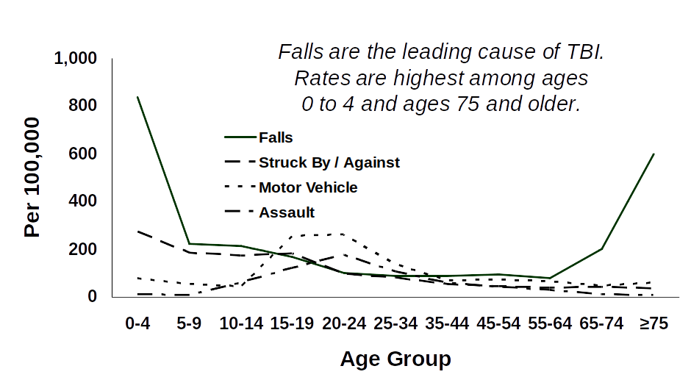

TBI by External Cause: Comparing the Percentages

The following figure, Figure 5, is a pie chart depicting the estimated percentage of the average annual TBI-related ED visits, hospitalizations, and deaths by external cause in the U.S. for the years 2002 to 2006. The pie chart is divided into five pieces. Falls were the leading known cause of TBI during this time period, and this slice is 35.2%. The second leading known cause was motor vehicle-traffic-related TBI and this slice is 17.3%. The third leading known cause was struck by or against events, and this slice is 16.5%. The fourth leading known cause was assaults, and this slice is 10%. Unknown and other causes represented 21% of the total pie.

Figure 5: Estimated Average Percentage of Annual Traumatic Brain Injury-Combined Emergency Department Visits, Hospitalizations, and Deaths, by External Cause, United States, 2002-2006

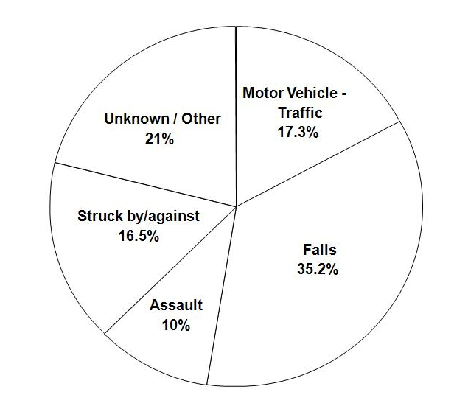

TBI by External Cause: Comparing the Percentages by Age Groups

The following two figures, Figure 6 and Figure 7, are pie charts. Each depicts the estimated percentage of average annual TBI-related ED visits, hospitalizations, and deaths by external cause in the U.S. for the years 2002 to 2006. Figure 6 presents data for children ages 0 to 14 years. Figure 7 presents data for adults age 65 or older.

First, regarding Figure 6, this pie chart is divided into five pieces. For children ages 0 to 14 years, falls were the leading known external cause of TBI during this time period, and this slice is slightly more than half at 50.2%. The second leading known external cause was struck by or against events, and this slice is almost a quarter of the pie at 24.8%. The third leading known external cause was motor vehicle-traffic-related TBI and this slice is 6.8%. The fourth leading known cause was assaults, and this slice is 2.9%. Unknown and other causes represent 15.3% of the total pie.

Second, regarding Figure 7, this pie chart is divided into five pieces. For adults age 65 years or older, falls were the leading known external cause of TBI during 2002-2006, and this slice is almost two-thirds of the pie at 60.7%. The second leading known external cause was motor vehicle-traffic-related TBI and this slice is 7.9%. The third leading known external cause was struck by or against events, and this slice is 5.7%. The fourth leading known external cause was assaults, and this slice is 1%. Unknown or other external causes represent 24.7% of the total pie.

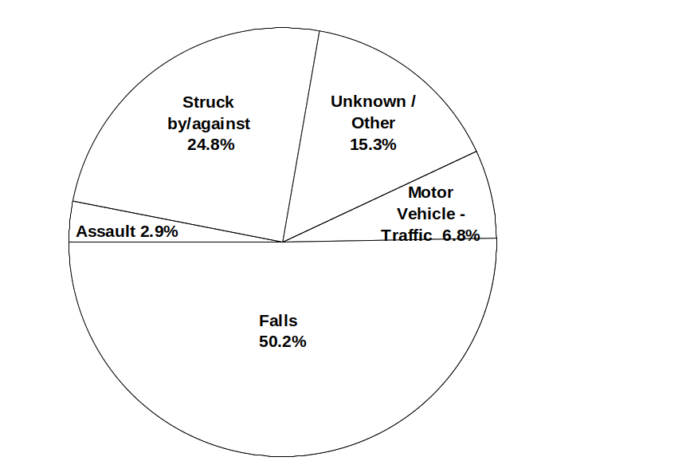
Figure 6: Estimated Average Percentage of Annual Traumatic Brain Injury-Combined Emergency Department Visits, Hospitalizations, and Deaths Among Children 0 to 14 Years, by External Cause, United States, 2002-2006

Figure 7: Estimated Average Percentage of Annual Traumatic Brain Injury-Combined Emergency Department Visits, Hospitalizations, and Deaths Among Older Adults 65 Years or Older, by External Cause, United States, 2002–2006
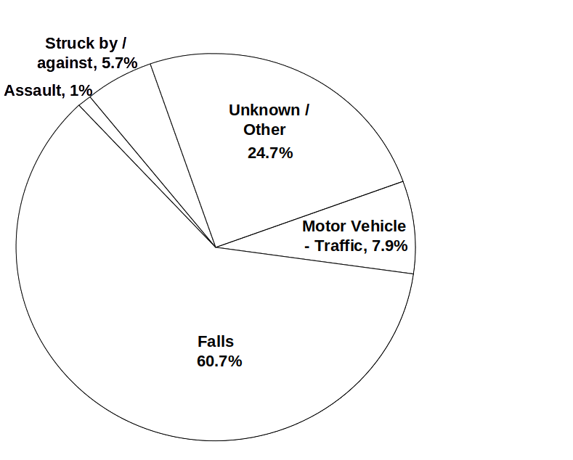

Summary of Findings

Of all the age groups falls was the leading external cause of TBI (35.2%). The proportion of falls was much higher in both children and older adults. Falls represented 50.2% of all external causes among children (0-14 years) compared with 60.7% among older adults 65 years or older. Overall, motor vehicle–traffic was the second leading external cause of TBI, with 17.3%. For children (0-14 years), the second leading external cause of TBI was in the being struck by or against category of injury, 24.8%. Although assaults accounted for a small percentage of TBIs among both children 0-14 years; (2.9%) and older adults 65 years or older; (1%), assaults produce many more TBIs in the general population (10%).

Conclusion

An estimated 1.7 million TBI-related ED visits, hospitalizations, and deaths occur in the U.S. each year. This estimate is larger than what has been reported in previous reports, including TBI in the United States: A Report to Congress, published by CDC in 2003 [Citation Number Two] and the previous edition of Traumatic Brain Injury in the United States, Emergency Department Visits, Hospitalizations and Deaths, published by CDC in 2004 and revised in 2006.[Citation Number Three] The findings show the importance of including ED visits because of the large number of TBIs seen only in that setting, especially among children. Although this report provides data on a wide range of TBIs occurring in the U.S., it still does not capture all of them. Many people recover from their injuries, but each year an estimated 124,626 Americans sustain a TBI resulting in permanent disability.[Citation Number Four] Thus, TBI prevention, improved acute care and rehabilitation to reduce the likelihood of TBI-related disability, and also increased access to services for those who do not fully recover are critical to improving quality of life of persons following TBI.

Appendix A: Tables and Figures

Table 1: Estimated Average Annual Numbers, Rates, and Percentages of Traumatic Brain Injury-Related Emergency Department Visits, Hospitalizations, and Deaths, by Age Group, United States, 2002-2006

 | Emergency Department Visits |  |  | Hospitalizations |  |  | Deaths |  |  | Total
Age | Number | Rate | Row % | Number | Rate | Row % | Number | Rate | Row % | Number | Rate
0-4 | 251,546 | 1256.2 | 93.9 | 15,239 | 76.1 | 5.7 | 998 | 5.0 | 0.4 | 267,783 | 1337.3
5-9 | 105,015 | 532.9 | 91.9 | 8,799 | 44.7 | 7.7 | 450 | 2.3 | 0.4 | 114,264 | 579.9
10-14 | 117,387 | 559.8 | 90.8 | 11,098 | 52.9 | 8.6 | 726 | 3.5 | 0.6 | 129,211 | 616.2
15-19 | 157,198 | 757.0 | 84.5 | 24,896 | 119.9 | 13.4 | 3,995 | 19.2 | 2.1 | 186,089 | 896.2
20-24 | 136,079 | 655.8 | 84.1 | 20,683 | 99.7 | 12.8 | 5,048 | 24.3 | 3.1 | 161,810 | 779.8
25-34 | 174,811 | 438.3 | 83.0 | 28,953 | 72.6 | 13.7 | 6,826 | 17.1 | 3.2 | 210,591 | 528.0
35-44 | 123,436 | 279.9 | 75.8 | 32,310 | 73.3 | 19.9 | 6,995 | 15.9 | 4.3 | 162,741 | 369.1
45-54 | 99,715 | 239.7 | 73.4 | 29,068 | 69.9 | 21.4 | 7,125 | 17.1 | 5.2 | 135,908 | 326.7
55-64 | 57,612 | 198.2 | 67.6 | 22,600 | 77.7 | 26.5 | 5,028 | 17.3 | 5.9 | 85,240 | 293.2
65-74 | 46,365 | 250.2 | 64.7 | 20,990 | 113.3 | 29.3 | 4,252 | 22.9 | 5.9 | 71,607 | 386.4
>75 | 95,633 | 536.2 | 57.5 | 60,510 | 339.3 | 36.4 | 10,095 | 56.6 | 6.1 | 166,237 | 932.0
Total | 1,364,797 | 465.4 | 80.7 | 275,146 | 93.8 | 16.3 | 51,538 | 17.6 | 3.0 | 1,691,481 | 576.8
Adjusted |  | 468.0 |  |  | 93.6 |  |  | 17.4 |  |  | 579.0

Notes regarding the data in Table 1:
Persons who were hospitalized, died or were transferred to another facility were excluded from the data for ED Visits. For Hospitalizations, in-hospital deaths and patients who were transferred to another hospital were excluded. For Deaths, 128 mortality records were omitted because of missing age information. The average annual rate is per 100,000 population. Finally, the last row represents age-adjusted rates to the 2000 U.S. standard population.

Table 2: Estimated Average Annual Numbers and Percentages of Traumatic Brain Injury-Related Emergency Department Visits, by Age Group and Disposition, United States, 2002-2006

 | Treated and Released |  | Other |  | Total
Age (yrs) | Number | Row % | Number | Row % | Number
0-4 | 251,546 | 92.9 | 19,106 | 7.1 | 270,652
5-9 | 105,015 | 86.1 | 16,940 | 13.9 | 121,955
10-14 | 117,387 | 92.4 | 9,617 | 7.6 | 127,004
15-19 | 157,198 | 88.6 | 20,131 | 11.4 | 177,329
20-24 | 136,079 | 85.6 | 22,949 | 14.4 | 159,028
25-34 | 174,811 | 92.1 | 15,005 | 7.9 | 189,816
35-44 | 123,436 | 83.8 | 23,936 | 16.2 | 147,372
45-54 | 99,715 | 78.8 | 26,898 | 21.2 | 126,613
55-64 | 57,612 | 74.6 | 19,623 | 25.4 | 77,235
65-74 | 46,365 | 78.9 | 12,394 | 21.1 | 58,759
> 75 | 95,633 | 66.3 | 48,681 | 33.7 | 144,314
Total | 1,364,797 | 85.3 | 235,280 | 14.7 | 1,600,077

Notes regarding the data in Table 2:
The third column, entitled ‘Other’, represents people who were hospitalized, died, or transferred to another facility. The records for these persons have been excluded from the other data tables regarding ED visits, e.g., Tables 1,3,4,6,7; Figures 8,9,10. Furthermore, regarding the column entitled ‘Other’, the sample sizes for some of the age groups were small and may not be stable. This was the case for Ages 0-4, 15-19, 20-24, 25-34, 35-44, and 45-54. For these groups, sample sizes ranged between 30 to 59. In addition, the sample sizes for some of the age groups were less than 30 and while the estimate is reported in this table, it is not considered stable. This was the case for age groups 5-9, 10-14, 55-64, and 65-74.

Table 3: Estimated Average Annual Numbers, Rates, and Percentages of Traumatic Brain Injury-Related Emergency Department Visits by Age Group and Sex, United States, 2002-2006

 | Male |  |  | Female |  |  | Total
Age (yrs) | Number | Rate | Row % | Number | Rate | Row % | Number | Rate
0-4 | 139,001 | 1357.4 | 55.3 | 112,545 | 1150.3 | 44.7 | 251,546 | 1256.2
5-9 | 68,671 | 681.2 | 65.4 | 36,343 | 377.6 | 34.6 | 105,014 | 532.9
10-14 | 90,221 | 840.0 | 76.9 | 27,166 | 265.6 | 23.1 | 117,387 | 559.8
15-19 | 98,761 | 926.6 | 62.8 | 58,437 | 578.2 | 37.2 | 157,198 | 757.0
20-24 | 86,669 | 812.2 | 63.7 | 49,410 | 490.3 | 36.3 | 136,079 | 655.8
25-34 | 97,845 | 483.8 | 56.0 | 76,966 | 391.5 | 44.0 | 174,811 | 438.3
35-44 | 68,527 | 311.4 | 55.5 | 54,909 | 248.6 | 44.5 | 123,436 | 279.9
45-54 | 50,941 | 249.2 | 51.1 | 48,775 | 230.5 | 48.9 | 99,716 | 239.7
55-64 | 32,226 | 230.2 | 55.9 | 25,386 | 168.4 | 44.1 | 57,612 | 198.2
65-74 | 23,146 | 273.7 | 49.9 | 23,218 | 230.5 | 50.1 | 46,364 | 250.2
> 75 | 33,917 | 504.4 | 35.5 | 61,716 | 555.4 | 64.5 | 95,633 | 536.2
Total | 789,925 | 547.6 | 57.9 | 574,871 | 385.9 | 42.1 | 1,364,796 | 465.4
Adjusted |  | 543.9 |  |  | 388.6 |  |  | 468.0

Notes regarding the data in Table 3:
First, persons who were hospitalized, died or were transferred to another facility were excluded from the data for ED Visits. Second, the rates stated in columns 3, 6, and 9, represent average annual rates per 100,000 population. Third, the value of the estimates for females in age groups 10-14, 55-64 and 65-74 were reported but may not be stable because sample sizes ranged between 30 to 59. In addition, the value of the estimates for males in age groups 55-64, 65-74, and 75 and above were reported but may not be stable because sample sizes ranged between 30 to 59. Finally, the last row represents age-adjusted rates to the 2000 U.S. standard population.

Table 4: Estimated Average Annual Numbers, Rates, and Percentages of Traumatic Brain Injury-Related Emergency Department Visits, by Age Group and Race, United States, 2002-2006

 | White |  |  | Black |  |  | American Indian, or Alaska Native, or Asian, or Pacific Islander |  |  | Other or Unknown |  | Total
Age (yrs) | Number | Rate | Row % | Number | Rate | Row % | Number | Rate | Row % | Number | Row% | Number | Rate
0-4 | 180,880 | 1160.8 | 71.9 | 56,942 | 1746.6 | 22.6 | 13,576 | 1148.5 | 5.4 | 147 | 0.1 | 251,545 | 1256.2
5-9 | 76,588 | 499.5 | 72.9 | 22,994 | 718.5 | 21.9 | 5,433 | 463.1 | 5.2 |  |  | 105,015 | 532.9
10-14 | 84,096 | 517.2 | 71.6 | 27,156 | 775.0 | 23.1 | 5,509 | 456.5 | 4.7 | 625 | 0.5 | 117,386 | 559.8
15-19 | 128,896 | 793.1 | 82.0 | 23,049 | 696.5 | 14.7 | 4,586 | 380.8 | 2.9 | 666 | 0.4 | 157,197 | 757.0
20-24 | 105,796 | 647.4 | 77.7 | 27,030 | 867.5 | 19.9 | 3,253 | 251.9 | 2.4 |  |  | 136,079 | 655.8
25-34 | 137,732 | 438.3 | 78.8 | 29,968 | 542.9 | 17.1 | 6,445 | 218.9 | 3.7 | 666 | 0.4 | 174,811 | 438.3
35-44 | 103,176 | 289.7 | 83.6 | 14,158 | 247.0 | 11.5 | 5,767 | 209.9 | 4.7 | 334 | 0.3 | 123,435 | 279.9
45-54 | 76,966 | 223.4 | 77.2 | 20,040 | 407.3 | 20.1 | 2,710 | 121.2 | 2.7 |  |  | 99,716 | 239.7
55-64 | 47,644 | 192.2 | 82.7 | 7,385 | 253.7 | 12.8 | 2,584 | 187.9 | 4.5 |  |  | 57,613 | 198.2
65-74 | 36,979 | 230.9 | 79.8 | 5,236 | 300.9 | 11.3 | 3,196 | 411.4 | 6.9 | 954 | 2.1 | 46,365 | 250.2
> 75 | 88,260 | 553.4 | 92.3 | 4,626 | 342.0 | 4.8 | 2,748 | 512.6 | 2.9 |  |  | 95,634 | 536.2
Total | 1,067,013 | 448.3 | 78.2 | 238,584 | 618.6 | 17.5 | 55,807 | 334.7 | 4.1 | 3,392 | 0.2 | 1,364,796 | 465.4
Adjusted |  | 456.6 |  |  | 568.7 |  |  | 345.2 |  |  |  |  | 468.0

Notes regarding the data in Table 4:
- Persons who were hospitalized, died or were transferred to another facility were excluded from the data for ED Visits.
- The rates stated in columns 3, 6, 9, and 14 represent average annual rates per 100,000 population.
- Data could not be calculated for the category “Other or Unknown” for the age groups 5-9, 20-24, 45-54, 55-64, and 75 and above. The remaining age groups in this category were reported but are not considered stable because the sample sizes were less than 30.
- The value of the estimates for Blacks in age groups 5-9, 10-14, 15-19, 20-24, 25-34, 35-44, and 45-54 were reported but may not be stable because sample sizes ranged between 30 to 59. In addition, the value of the estimates for Blacks in age groups 55-64, 65-74, and 75 and above were reported but are not considered stable because the sample sizes were less than 30.
- The value of the estimates for American Indian, Alaska Native, Asian, or Pacific Islander for the age group 0-4 were reported but may not be stable because the sample size ranged between 30 to 59. The remaining age groups in this category were reported but are not considered stable because the sample sizes were less than 30.
- The last row provides age-adjusted rates to the 2000 U.S. standard population.

Table 5: Estimated Average Annual Numbers, Rates, and Percentages of Traumatic Brain Injury-Related Emergency Department Visits, by Age Group and External Cause, United States, 2002-2006

 | Motor Vehicle-Traffic (MVT) |  |  | Falls |  |  | Assault |  |  | Struck By or Struck Against |  |  | Other or Unknown |  |  | Total
Age (yrs) | Number | Rate | Row % | Number | Rate | Row % | Number | Rate | Row % | Number | Rate | Row % | Number | Rate | Row % | Number | Rate
0-4 | 12,852 | 64.2 | 5.1 | 161,455 | 806.3 | 64.2 | 362 | 1.8 | 0.1 | 53,922 | 269.3 | 21.4 | 22,954 | 114.6 | 9.1 | 251,545 | 1256.2
5-9 | 7,310 | 37.1 | 7.0 | 42,371 | 215.0 | 40.3 | 1,033 | 5.2 | 1.0 | 35,583 | 180.6 | 33.9 | 18,718 | 95.0 | 17.8 | 105,015 | 532.9
10-14 | 6,529 | 31.1 | 5.6 | 42,843 | 204.3 | 36.5 | 11,385 | 54.3 | 9.7 | 34,572 | 164.9 | 29.5 | 22,057 | 105.2 | 18.8 | 117,386 | 559.8
15-19 | 40,466 | 194.9 | 25.7 | 32,740 | 157.7 | 20.8 | 22,272 | 107.3 | 14.2 | 36,512 | 175.8 | 23.2 | 25,207 | 121.4 | 16.0 | 157,197 | 757.0
20-24 | 44,209 | 213.1 | 32.5 | 19,845 | 95.6 | 14.6 | 33,360 | 160.8 | 24.5 | 19,205 | 92.6 | 14.1 | 19,459 | 93.8 | 14.3 | 136,078 | 655.8
25-34 | 42,213 | 105.8 | 24.1 | 31,794 | 79.7 | 18.2 | 36,385 | 91.2 | 20.8 | 30,464 | 76.4 | 17.4 | 33,954 | 85.1 | 19.4 | 174,810 | 438.3
35-44 | 19,687 | 44.6 | 15.9 | 34,510 | 78.3 | 28.0 | 20,775 | 47.1 | 16.8 | 21,689 | 49.2 | 17.6 | 26,776 | 60.7 | 21.7 | 123,437 | 279.9
45-54 | 20,210 | 48.6 | 20.3 | 33,779 | 81.2 | 33.9 | 14,610 | 35.1 | 14.7 | 17,216 | 41.4 | 17.3 | 13,900 | 33.4 | 13.9 | 99,715 | 239.7
55-64 | 14,454 | 49.7 | 25.1 | 16,485 | 56.7 | 28.6 | 6,548 | 22.5 | 11.4 | 10,015 | 34.4 | 17.4 | 10,110 | 34.8 | 17.5 | 57,612 | 198.2
65-74 | 5,904 | 31.9 | 12.7 | 28,698 | 154.9 | 61.9 | 1,329 | 7.2 | 2.9 | 7,123 | 38.4 | 15.4 | 3,311 | 17.9 | 7.1 | 46,365 | 250.2
> 75 | 5,102 | 28.6 | 5.3 | 78,523 | 440.2 | 82.1 | 411 | 2.3 | 0.4 | 5,412 | 30.3 | 5.7 | 6,185 | 34.7 | 6.5 | 95,633 | 536.2
Total | 218,936 | 74.7 | 16.0 | 523,043 | 178.4 | 38.3 | 148,470 | 50.6 | 10.9 | 271,713 | 92.7 | 19.9 | 202,631 | 69.1 | 14.8 | 1,364,793 | 465.4
Adjusted |  | 74.0 |  |  | 180.2 |  |  | 50.2 |  |  | 93.9 |  |  | 69.7 |  |  | 468.0

Notes regarding the data in Table 5:
- Persons who were hospitalized, died or were transferred to another facility were excluded from the data for ED Visits.
- In columns 2, 3, and 4, “Motor Vehicle-Traffic” includes the following persons: occupant, motorcyclist, pedal cyclist, pedestrian, other and unspecified person involved in a motor vehicle-traffic incident.
- The rates for each external cause in columns 3, 6, 9, 12, 15, and 18 are stated as an average annual rate per 100,000 population.
- The value of the estimates for “Motor Vehicle-Traffic’ for age groups 25-34,35-44, and 45-54 were reported, but may not be stable because the sample size ranged between 30 to 59.
- The value of the estimates for “Motor Vehicle Traffic’ for age groups 0-4, 5-9. 10-14, 55-64, 65-74, and 75 and above were reported, but are not considered stable because the sample size is less than 30.
- The value of the estimates for “Falls” for age groups 10-14, 15-19, 20-24,25-34, 35-44, 45-54, 55-64, and 65-74 were reported but may not be stable because the sample size ranged between 30 to 59.
- The value of the estimates for “Assaults” for the age groups 15-19, 20-24, 25-34, and 35-44 were reported, but may not be stable because the sample size ranged between 30-59.
- The value of the estimates for “Assaults” for the age groups 0-4, 5-9,10-14, 45-54, 55-64, 65-74, and 75 and above were reported but are not considered stable because the sample size is less than 30.
- The value of the estimates for “Struck By or Struck Against” for the age groups 5-9, 25-34, and 35-44 were reported but may not be stable because the sample size ranged between 30-59.
- The value of the estimates for “Struck By or Struck Against” for the age groups 20-24, 45-54, 55-64, 65-74, and 75 and above were reported but are not considered stable because the sample size is less than 30.
- The value of the estimates for “Other or Unknown” for the age groups 0-4, 5-9, 10-14, 15-19, 25-34, and 35-44 were reported but may not be stable because the sample size ranged between 30-59.
- The value of the estimates for “Other or Unknown” for the age groups 20-24, 45-54, 55-64, 65-74, and 75 and above were reported but are not considered stable because the sample size is less than 30.
- The last row of the table contains rates age-adjusted to the 2000 US standard population.

Table 6: Estimated Average Annual Numbers, Rates, and Percentages of Traumatic Brain Injury-Related Emergency Department Visits, by Age Group and Specific Motor Vehicle Traffic (MVT) External Causes, United States, 2002-2006

 | MVT-Occupant |  |  | MVT- Motorcycle |  |  | MVT- Pedal Cycle |  |  | MVT- Pedestrian |  |  | MVT- Other or Unspecified |  |  | Total
Age  (yrs) | Number | Rate | Row  % | Number | Rate | Row  % | Number | Rate | Row  % | Number | Rate | Row  % | Number | Rate | Row  % | Number | Rate
0-4 | 9,498 | 47.4 | 73.9 |  |  |  |  |  |  |  |  |  | 3,355 | 16.8 | 26.1 | 12,853 | 64.2
5-9 | 1,427 | 7.2 | 19.5 |  |  |  | 513 | 2.6 | 7.0 | 514 | 2.6 | 7.0 | 4,856 | 24.6 | 66.4 | 7,310 | 37.1
10-14 | 2,455 | 11.7 | 37.6 | 787 | 3.8 | 12.1 |  |  |  | 2,959 | 14.1 | 45.3 | 328 | 1.6 | 5.0 | 6,529 | 31.1
15-19 | 18,828 | 90.7 | 46.5 | 568 | 2.7 | 1.4 |  |  |  | 324 | 1.6 | 0.8 | 20,745 | 99.9 | 51.3 | 40,465 | 194.9
20-24 | 24,985 | 120.4 | 56.5 | 3,110 | 15.0 | 7.0 | 37 | 0.2 | 0.1 | 1,420 | 6.8 | 3.2 | 14,657 | 70.6 | 33.2 | 44,209 | 213.1
25-34 | 18,786 | 47.1 | 44.5 | 4,847 | 12.2 | 11.5 | 563 | 1.4 | 1.3 |  |  |  | 18,017 | 45.2 | 42.7 | 42,213 | 105.8
35-44 | 6,632 | 15.0 | 33.7 | 189 | 0.4 | 1.0 |  |  |  | 307 | 0.7 | 1.6 | 12,559 | 28.5 | 63.8 | 19,687 | 44.6
45-54 | 12,616 | 30.3 | 62.4 | 304 | 0.7 | 1.5 |  |  |  | 1,233 | 3.0 | 6.1 | 6,057 | 14.6 | 30.0 | 20,210 | 48.6
55-64 | 6,450 | 22.2 | 44.6 | 133 | 0.5 | 0.9 |  |  |  | 169 | 0.6 | 1.2 | 7,701 | 26.5 | 53.3 | 14,453 | 49.7
65-74 | 2,689 | 14.5 | 45.6 |  |  |  |  |  |  | 1,000 | 5.4 | 16.9 | 2,214 | 12.0 | 37.5 | 5,903 | 31.9
>75 |  |  |  |  |  |  |  |  |  |  |  |  | 5,102 | 28.6 | 100.0 | 5,102 | 28.6
Total | 104,366 | 35.6 | 47.7 | 9,938 | 3.4 | 4.5 | 1,113 | 0.4 | 0.5 | 7,926 | 2.7 | 3.6 | 95,591 | 32.6 | 43.7 | 218,934 | 74.7
Adjusted |  | 35.0 |  |  | 3.3 |  |  | 0.4 |  |  | 2.7 |  |  | 32.5 |  |  | 74.0

Notes regarding the data in Table 6:
- Persons who were hospitalized, died or were transferred to another facility were excluded from the data for ED Visits.
- The rates stated in columns 3, 6, 9, 12, 15, and 18 represent average annual rates per 100,000 population.
- Data could not be calculated for the external cause “MVT-Occupant” for the age group 75 and above, Also, data could not be calculated for the external cause “MVT-Motorcycle” for the age groups 0-4, 5-9, 65-74, and 75 and above. Furthermore, data could not be calculated for the external cause “MVT-Pedal Cycle” for the age groups 0-4, 10-14, 15-19, 35-44, 45-54, 55-64, 65-74, and 75 and above. Finally, data could not be calculated for the external cause “MVT-Pedestrians” for the age groups 0-4, 25-34, and 75 and above.
- The value of the estimates for the external cause “MVT-Occupant“ for the ages groups 15-19 and 20-24 were reported but may not be stable because the sample size ranged between 30-59. The stability of the sample for the ‘Totals’ for age groups 25-34, 35-44 and 45-54 were also reported but may not be stable because the sample size ranged between 30-59.
- All the remaining ages groups, for all the external causes were reported, but the values of the estimates is not considered stable because the sample size is less than 30.
- The totals reported for external causes “MVT-Motorcycle”, “MVT-Pedal Cycle”, and “MVT-Pedestrian” were reported, but the values of the estimates is not considered stable because the sample size is less than 30.
- The total estimated average annual numbers and rates for age groups 15-19 and 20-24 were stable due to the size of the sample; however, all the remaining age group totals were reported but are not considered stable because the sample size is less than 30.
- The last row represents age-adjusted rates to the 2000 U.S. standard population.

Table 7: Estimated Average Annual Numbers and Percentages of Traumatic Brain Injury-Related Emergency Department Visits, by Age Group and Expected Source of Payment, United States, 2002-2006

 | Private |  | Medicaid |  | Medicare |  | Worker’s Compensation |  | Other or Unknown |  | Total
Age  (yrs) | Number | Row % | Number | Row % | Number | Row % | Number | Row % | Number | Row % | Number
0-4 | 121,610 | 48.3 | 87,911 | 34.9 | 1,025 | 0.4 |  |  | 40,999 | 16.3 | 251,545
5-9 | 58,430 | 55.6 | 23,720 | 22.6 | 797 | 0.8 |  |  | 22,068 | 21.0 | 105,015
10-14 | 74,107 | 63.1 | 24,978 | 21.3 | 670 | 0.6 |  |  | 17,631 | 15.0 | 117,386
15-19 | 91,028 | 57.9 | 14,309 | 9.1 | 3,190 | 2.0 | 695 | 0.4 | 47,975 | 30.5 | 157,197
20-24 | 52,094 | 38.3 | 5,093 | 3.7 |  |  | 8,737 | 6.4 | 70,154 | 51.6 | 136,078
25-34 | 73,054 | 41.8 | 17,148 | 9.8 | 2,348 | 1.3 | 12,895 | 7.4 | 69,366 | 39.7 | 174,811
35-44 | 54,807 | 44.4 | 16,854 | 13.7 | 7,118 | 5.8 | 7,542 | 6.1 | 37,114 | 30.1 | 123,435
45-54 | 46,457 | 46.6 | 12,355 | 12.4 | 4,426 | 4.4 | 6,219 | 6.2 | 30,259 | 30.3 | 99,716
55-64 | 24,566 | 42.6 | 6,412 | 11.1 | 3,802 | 6.6 | 4,201 | 7.3 | 18,631 | 32.3 | 57,612
65-74 | 6,558 | 14.1 | 3,424 | 7.4 | 29,249 | 63.1 | 1,773 | 3.8 | 5,361 | 11.6 | 46,365
> 75 | 5,636 | 5.9 | 10,461 | 10.9 | 70,994 | 74.2 | 1,571 | 1.6 | 6,971 | 7.3 | 95,633
Total | 608,347 | 44.6 | 222,665 | 16.3 | 123,619 | 9.1 | 43,633 | 3.2 | 366,529 | 26.9 | 1,364,793

Notes regarding the data in Table 7:
- Persons who were hospitalized, died or were transferred to another facility were excluded from the data for ED Visits.
- Under the expected source of payment entitled “Other or Unknown”, this category includes self pay, no charge, other government, as well as other, and unknown. Also, within this category, the value of the estimates for age groups 0-4, 5-9, 10-14, and 45-54 was reported but may not be stable because the sample size ranged from 30-59. Furthermore, within this category, the value of the estimates for age groups 55-64, 65-74, and 75 and above was also reported, but is not considered stable because the sample size is less than 30.
- Under the expected source of payment entitled “Private”, the value of the estimate for age group 55-64 was reported, but may not be stable because the sample size ranged from 30-59. Also, within this category, the value of the estimates for age groups 65-74 and 75 and above were reported, but is not considered stable because the sample size is less than 30.
- Under the expected source of payment entitled “Medicaid”, the value of the estimates for age groups, 5-9, 10-14, 15-19, 25-34, and 35-44 was reported, but may not be stable because the sample size ranged from 30-59. Also, within this category, the value of the estimates for age groups 20-24, 45-54, 55-64, 65-74, and 75 and above was also reported, but is not considered stable because the sample size is less than 30.
- Under the expected source of payment entitled “Medicare”, no estimate was provided for the age group 20-24. Also, within this category, the value of the estimate for the age group 65-74 was reported, but may not be stable because the sample size ranged from 30-59. Furthermore, within this category, the value of the estimates for age groups 0-4, 5-9, 10-14, 15-19, 25-34, 35-44, 45-54, and 55-64 was also reported, but is not considered stable because the sample size is less than 30.
- Under the expected source of payment entitled “Worker’s Compensation,” no estimate was provided for age groups 0-4, 5-9, and 10-14. Also, within this category the value of the estimates for all the remaining age groups was reported, but is not considered stable because the sample size is less than 30.

Table 8: Estimated Average Annual Numbers and Percentages of Traumatic Brain Injury-Related Hospitalizations, by Age Group and Disposition, United States, 2002-2006

 | Discharged Alive
 | Home |  | Transferred |  | Other or Unknown |  | In-Hospital Deaths |  | Total
Age (yrs) | Number | Row % | Number | Row % | Number | Row % | Number | Row % | Number
0-4 | 15,564 | 87.8 | 855 | 4.8 | 903 | 5.1 | 406 | 2.3 | 17,728
5-9 | 8,996 | 89.8 | 283 | 2.8 | 281 | 2.8 | 461 | 4.6 | 10,021
10-14 | 10,855 | 89.4 | 326 | 2.7 | 429 | 3.5 | 535 | 4.4 | 12,145
15-19 | 21,971 | 78.9 | 2,064 | 7.4 | 2,459 | 8.8 | 1,356 | 4.9 | 27,850
20-24 | 18,261 | 79.8 | 1,567 | 6.9 | 1,776 | 7.8 | 1,277 | 5.6 | 22,881
25-34 | 23,239 | 75.7 | 1,976 | 6.4 | 4,295 | 14.0 | 1,199 | 3.9 | 30,709
35-44 | 25,192 | 73.9 | 3,154 | 9.3 | 4,864 | 14.3 | 881 | 2.6 | 34,091
45-54 | 23,042 | 72.4 | 3,166 | 9.9 | 3,782 | 11.9 | 1,827 | 5.7 | 31,817
55-64 | 16,359 | 64.6 | 4,223 | 16.7 | 3,112 | 12.3 | 1,617 | 6.4 | 25,311
65-74 | 13,331 | 55.7 | 5,670 | 23.7 | 2,969 | 12.4 | 1,983 | 8.3 | 23,953
>75 | 24,751 | 34.7 | 30,302 | 42.4 | 9,453 | 13.2 | 6,926 | 9.7 | 71,432
Total | 201,561 | 65.5 | 53,586 | 17.4 | 34,323 | 11.1 | 18,468 | 6.0 | 307,938

Notes regarding the data in Table 8:
- Under the major category entitled “Discharged Alive”, the sub-category labeled “Other or Unknown” include patients who left against medical advice but with no disposition stated, patients who were discharged alive but with no disposition stated, and patients with unknown disposition.
- Data regarding “Transferred” includes both long- term and short- term care facilities.
- “In-Hospital Deaths” and patients who transferred from another hospital were excluded from the remaining hospitalizations tables (Tables 9-13; Figures 8-10).
- The value of the estimates for category “Discharged Alive-Transferred”, for age groups 15-19 and 20-24 were reported but may not be stable because the sample size ranged between 30-59. Also, within this category, the value of the estimates for age groups 0-4, 5-9, and 10-14 was also reported, but is not considered stable because the sample size is less than 30.
- The value of the estimates for category “Discharged Alive-Other or Unknown”, for age groups 0-4 and 10-14 were reported but may not be stable because the sample size ranged between 30-59.
- For the value of the estimates for the category “In-Hospital Deaths”, for age groups 15-19, 20-24, 25-34, 35-44, 45-54, and 55-64 was reported but may not be stable because the sample size ranged between 30-59.
- For the value of the estimate for the category “Discharged Alive-Other or Unknown”, for the age group 5-9 was reported, but is not considered stable because the sample size is less than 30.
- For the value of the estimates for the category ““In-Hospital Deaths”, for age groups 0-4, 5-9, and 10-14 was reported but is not considered stable because the sample size is less than 30.

Table 9: Estimated Average Annual Numbers, Rates, and Percentages of Traumatic Brain Injury-Related Hospitalizations, by Age Group and Sex, United States, 2002-2006

 | Male |  |  | Female |  |  | Total
Age (yrs) | Number | Rate | Row % | Number | Rate | Row % | Number | Rate
0-4 | 9,019 | 88.1 | 59.2 | 6,220 | 63.6 | 40.8 | 15,239 | 76.1
5-9 | 5,296 | 52.5 | 60.2 | 3,503 | 36.4 | 39.8 | 8,799 | 44.7
10-14 | 7,407 | 69.0 | 66.7 | 3,691 | 36.1 | 33.3 | 11,098 | 52.9
15-19 | 17,189 | 161.3 | 69.0 | 7,708 | 76.3 | 31.0 | 24,897 | 119.9
20-24 | 16,341 | 153.1 | 79.0 | 4,343 | 43.1 | 21.0 | 20,684 | 99.7
25-34 | 22,438 | 110.9 | 77.5 | 6,516 | 33.1 | 22.5 | 28,954 | 72.6
35-44 | 22,417 | 101.9 | 69.4 | 9,893 | 44.8 | 30.6 | 32,310 | 73.3
45-54 | 20,085 | 98.2 | 69.1 | 8,983 | 42.5 | 30.9 | 29,068 | 69.9
55-64 | 15,269 | 109.1 | 67.6 | 7,331 | 48.6 | 32.4 | 22,600 | 77.7
65-74 | 11,437 | 135.2 | 54.5 | 9,553 | 94.8 | 45.5 | 20,990 | 113.3
> 75 | 23,360 | 347.4 | 38.6 | 37,150 | 334.3 | 61.4 | 60,510 | 339.3
Total | 170,258 | 118.0 | 61.9 | 104,891 | 70.4 | 38.1 | 275,149 | 93.8
Adjusted |  | 121.0 |  |  | 66.2 |  |  | 93.6

Notes regarding the data in Table 9:
First, in-hospital deaths and patients who transferred from another hospital were excluded from this table. Second, the average annual rate stated is a rate per 100,000 population. Finally, the last row reflects the rate age-adjusted to the 2000 U.S. standard population.

Table 10: Estimated Average Annual Numbers, Rates, and Percentages of Traumatic Brain Injury-Related Hospitalizations, by Age Group and Race, United States, 2002-2006

 | White |  |  | Black |  |  | American Indian, or Alaska Native, or Asian, or Pacific Islander |  |  | Other or Unknown |  | Total
Age (yrs) | Number | Rate | Row % | Number | Rate | Row % | Number | Rate | Row % | Number | Row % | Number | Rate
0-4 | 9,361 | 60.1 | 61.4 | 2,075 | 63.6 | 13.6 | 530 | 44.8 | 3.5 | 3,274 | 21.5 | 15,240 | 76.1
5-9 | 5,412 | 35.3 | 61.5 | 1,126 | 35.2 | 12.8 | 151 | 12.9 | 1.7 | 2,110 | 24.0 | 8,799 | 44.7
10-14 | 6,278 | 38.6 | 56.6 | 1,669 | 47.6 | 15.0 | 388 | 32.2 | 3.5 | 2,763 | 24.9 | 11,098 | 52.9
15-19 | 15,243 | 93.8 | 61.2 | 2,413 | 72.9 | 9.7 | 893 | 74.1 | 3.6 | 6,348 | 25.5 | 24,897 | 119.9
20-24 | 11,676 | 71.4 | 56.5 | 2,272 | 72.9 | 11.0 | 841 | 65.1 | 4.1 | 5,894 | 28.5 | 20,683 | 99.7
25-34 | 15,981 | 50.9 | 55.2 | 4,044 | 73.3 | 14.0 | 682 | 23.2 | 2.4 | 8,247 | 28.5 | 28,954 | 72.6
35-44 | 18,916 | 53.1 | 58.5 | 4,456 | 77.8 | 13.8 | 953 | 34.7 | 3.0 | 7,985 | 24.7 | 32,310 | 73.3
45-54 | 16,648 | 48.3 | 57.3 | 4,369 | 88.8 | 15.0 | 479 | 21.4 | 1.6 | 7,572 | 26.0 | 29,068 | 69.9
55-64 | 14,064 | 56.7 | 62.2 | 1,829 | 62.8 | 8.1 | 1,165 | 84.7 | 5.2 | 5,543 | 24.5 | 22,601 | 77.7
65-74 | 13,455 | 84.0 | 64.1 | 1,679 | 96.5 | 8.0 | 899 | 115.7 | 4.3 | 4,957 | 23.6 | 20,990 | 113.3
>75 | 42,735 | 268.0 | 70.6 | 2,644 | 195.5 | 4.4 | 1,370 | 255.5 | 2.3 | 13,761 | 22.7 | 60,510 | 339.3
Total | 169,769 | 71.3 | 61.7 | 28,576 | 74.1 | 10.4 | 8,351 | 50.1 | 3.0 | 68,454 | 24.9 | 275,150 | 93.8
Adjusted |  | 69.8 |  |  | 78.7 |  |  | 58.2 |  |  |  |  | 93.6

Notes regarding the data in Table10:
First, in-hospital deaths and patients who transferred from another hospital were excluded. Second, the average annual rate for each racial group, columns 3, 6, and 9, as well as the rate totals in column 14 are stated per 100,000 population. Third, the value of the estimate for the number, rate and row percent for “American Indian, Alaska Native, Asian, or Pacific Islander” for the age group 75 and older was reported but may not be stable because the sample size ranged between 30 to 59. Furthermore, the value of the estimate for the number, rate, and row percent for “American Indian, Alaska Native, Asian, or Pacific Islander” for all the other age groups was reported but is not considered stable because the sample size is less than 30. Finally, the last row reflects the rate age-adjusted to the 2000 U.S. standard population.

Table 11: Estimated Average Annual Numbers, Rates, and Percentages of Traumatic Brain Injury-Related Hospitalizations, by Age Group and External Cause, United States, 2002-2006

 | Motor Vehicle-Traffic (MVT) |  |  | Falls |  |  | Assault |  |  | Struck By or Struck Against |  |  | Other or Unknown |  |  | Total
Age (yrs) | Number | Rate | Row % | Number | Rate | Row % | Number | Rate | Row % | Number | Rate | Row % | Number | Rate | Row % | Number | Rate
0-4 | 2,182 | 10.9 | 14.3 | 6,458 | 32.2 | 42.4 | 893 | 4.5 | 5.9 | 867 | 4.3 | 5.7 | 4,840 | 24.2 | 31.8 | 15,240 | 76.1
5-9 | 2,566 | 13.0 | 29.2 | 1,733 | 8.8 | 19.7 | 10 | 0.1 | 0.1 | 543 | 2.8 | 6.2 | 3,946 | 20.0 | 44.8 | 8,798 | 44.7
10-14 | 2,111 | 10.1 | 19.0 | 1,892 | 9.0 | 17.0 | 520 | 2.5 | 4.7 | 1,244 | 5.9 | 11.2 | 5,331 | 25.4 | 48.0 | 11,098 | 52.9
15-19 | 9,598 | 46.2 | 38.6 | 2,119 | 10.2 | 8.5 | 1,622 | 7.8 | 6.5 | 1,069 | 5.1 | 4.3 | 10,488 | 50.5 | 42.1 | 24,896 | 119.9
20-24 | 7,571 | 36.5 | 36.6 | 1,251 | 6.0 | 6.1 | 1,998 | 9.6 | 9.7 | 237 | 1.1 | 1.1 | 9,626 | 46.4 | 46.5 | 20,683 | 99.7
25-34 | 9,208 | 23.1 | 31.8 | 3,391 | 8.5 | 11.7 | 3,496 | 8.8 | 12.1 | 888 | 2.2 | 3.1 | 11,970 | 30.0 | 41.3 | 28,953 | 72.6
35-44 | 7,744 | 17.6 | 24.0 | 4,738 | 10.7 | 14.7 | 3,529 | 8.0 | 10.9 | 996 | 2.3 | 3.1 | 15,303 | 34.7 | 47.4 | 32,310 | 73.3
45-54 | 6,712 | 16.1 | 23.1 | 5,332 | 12.8 | 18.3 | 1,736 | 4.2 | 6.0 | 459 | 1.1 | 1.6 | 14,829 | 35.6 | 51.0 | 29,068 | 69.9
55-64 | 3,217 | 11.1 | 14.2 | 5,559 | 19.1 | 24.6 | 1,134 | 3.9 | 5.0 | 515 | 1.8 | 2.3 | 12,176 | 41.9 | 53.9 | 22,601 | 77.7
65-74 | 1,918 | 10.3 | 9.1 | 7,392 | 39.9 | 35.2 | 68 | 0.4 | 0.3 | 467 | 2.5 | 2.2 | 11,145 | 60.1 | 53.1 | 20,990 | 113.3
> 75 | 4,038 | 22.6 | 6.7 | 22,468 | 126.0 | 37.1 | 334 | 1.9 | 0.6 | 504 | 2.8 | 0.8 | 33,164 | 185.9 | 54.8 | 60,508 | 339.3
Total | 56,865 | 19.4 | 20.7 | 62,333 | 21.2 | 22.7 | 15,340 | 5.2 | 5.6 | 7,789 | 2.7 | 2.8 | 132,818 | 45.3 | 48.3 | 275,145 | 93.8
Adjusted |  | 19.4 |  |  | 21.2 |  |  | 5.2 |  |  | 2.7 |  |  | 45.1 |  |  | 93.6

Notes regarding the data in Table 11:
- In-hospital deaths and patients who transferred from another hospital were excluded.
- In columns 2, 3, and 4, “Motor Vehicle-Traffic” includes the following persons: occupant, motorcyclist, pedal cyclist, pedestrian, other and unspecified person involved in a motor vehicle-traffic incident.
- The rates for each external cause in columns 3, 6, 9, 12, 15, and 18 are stated as an average annual rate per 100,000 population.
- The value of the estimates for “Falls” for age group 20-24 was reported but may not be stable because the sample size ranged between 30 to 59.
- The value of the estimates for “Assaults” for the age groups 0-4 and 15-19 was reported, but may not be stable because the sample size ranged between 30-59.
- The value of the estimates for “Assaults” for the age groups 5-9,10-14, 55-64, 65-74, and 75 and above, were reported but are not considered stable because the sample size is less than 30.
- The value of the estimates for “Struck By or Struck Against” for the age groups 0-4, 5-9, 10-14, 15-19, and 35-44, was reported but may not be stable because the sample size ranged between 30-59.
- The value of the estimates for “Struck By or Struck Against” for the remaining age groups was reported but are not considered stable because the sample size is less than 30.
- Finally, The last row of the table contains rates age-adjusted to the 2000 US standard population.

Table 12: Estimated Average Annual Numbers, Rates, and Percentages of Traumatic Brain Injury-Related Hospitalizations, by Age Group and Specific Motor Vehicle Traffic (MVT) External Causes, United States, 2002-2006

 | MVT-Occupant |  |  | MVT- Motorcycle |  |  | MVT- Pedal Cycle |  |  | MVT- Pedestrian |  |  | MVT- Other or Unspecified |  |  | Total
Age  (yrs) | Number | Rate | Row  % | Number | Rate | Row  % | Number | Rate | Row  % | Number | Rate | Row  % | Number | Rate | Row  % | Number | Rate
0-4 | 1,426 | 7.1 | 65.3 |  |  |  |  |  |  | 744 | 3.7 | 34.1 | 12 | 0.1 | 0.6 | 2,182 | 10.9
5-9 | 1,487 | 7.5 | 57.9 | 100 | 0.5 | 3.9 | 147 | 0.7 | 5.7 | 677 | 3.4 | 26.4 | 156 | 0.8 | 6.1 | 2,567 | 13.0
10-14 | 984 | 4.7 | 46.6 | 91 | 0.4 | 4.3 | 360 | 1.7 | 17.0 | 650 | 3.1 | 30.8 | 26 | 0.1 | 1.2 | 2,111 | 10.1
15-19 | 6,802 | 32.8 | 70.9 | 1,182 | 5.7 | 12.3 | 243 | 1.2 | 2.5 | 650 | 3.1 | 6.8 | 722 | 3.5 | 7.5 | 9,599 | 46.2
20-24 | 5,567 | 26.8 | 73.5 | 614 | 3.0 | 8.1 | 143 | 0.7 | 1.9 | 703 | 3.4 | 9.3 | 543 | 2.6 | 7.2 | 7,570 | 36.5
25-34 | 6,048 | 15.2 | 65.7 | 1,428 | 3.6 | 15.5 | 357 | 0.9 | 3.9 | 792 | 2.0 | 8.6 | 583 | 1.5 | 6.3 | 9,208 | 23.1
35-44 | 5,216 | 11.8 | 67.4 | 1,299 | 2.9 | 16.8 | 66 | 0.1 | 0.8 | 852 | 1.9 | 11.0 | 311 | 0.7 | 4.0 | 7,744 | 17.6
45-54 | 4,263 | 10.2 | 63.5 | 1,114 | 2.7 | 16.6 | 131 | 0.3 | 1.9 | 697 | 1.7 | 10.4 | 506 | 1.2 | 7.5 | 6,711 | 16.1
55-64 | 1,872 | 6.4 | 58.2 | 434 | 1.5 | 13.5 | 49 | 0.2 | 1.5 | 498 | 1.7 | 15.5 | 364 | 1.3 | 11.3 | 3,217 | 11.1
65-74 | 1,374 | 7.4 | 71.6 | 88 | 0.5 | 4.6 | 28 | 0.2 | 1.5 | 212 | 1.1 | 11.1 | 215 | 1.2 | 11.2 | 1,917 | 10.3
>75 | 3,009 | 16.9 | 74.5 |  |  |  |  |  |  | 741 | 4.2 | 18.3 | 289 | 1.6 | 7.2 | 4,039 | 22.6
Total | 38,048 | 13.0 | 66.9 | 6,350 | 2.2 | 11.2 | 1,524 | 0.5 | 2.7 | 7,216 | 2.5 | 12.7 | 3,727 | 1.3 | 6.6 | 56,865 | 19.4
Adjusted |  | 12.9 |  |  | 2.2 |  |  | 0.5 |  |  | 2.5 |  |  | 1.3 |  |  | 19.4

Notes regarding the data in Table 12:

- In-hospital deaths and patients who transferred from another hospital were excluded.
- The rates stated in columns 3, 6, 9, 12, 15, and 18 represent average annual rates per 100,000 population.
- For age groups 0-4 and 75 and above data could not be calculated for the categories “MVT-Motorcycle” and “MVT-Pedal Cycle”.
- The value of the estimates for the category “MVT-Occupant“ for age groups 0-4, 5-9, and 10-14 was reported but may not be stable because the sample size ranged between 30-59.
- The value of the estimates for the category “MVT-Motorcycle“ for age groups 25-34, 35-44, and 45-54 was reported but may not be stable because the sample size ranged between 30-59. The value of the estimates for hospitalization for all the remaining age groups in the category “MVT-Motorcycle was reported, but it is not considered stable because the sample size is less than 30.
- The value of the estimates for the category “MVT-Pedal Cycle“ for the age group 10-14 was reported but may not be stable because the sample size ranged between 30-59. The value of the estimates for all the remaining age groups in the category “MVT-Pedal Cycle was reported, but it is not considered stable because the sample size is less than 30.
- The value of the estimates for the category “MVT-Pedestrian“ for age groups 5-9, 10-14, and 25-34 was reported but may not be stable because the sample size ranged between 30-59. The value of the estimates for all the remaining age groups in the category “MVT-Pedestrian was reported, but it is not considered stable because the sample size is less than 30.
- The value of all of the estimates for the category “MVT-Other or Unspecified” was reported, but it is not considered stable because the sample size is less than 30.
- The last row of the table represents rates age-adjusted to the 2000 U.S. standard population.

Table 13: Estimated Average Annual Numbers and Percentages of Traumatic Brain Injury-Related Hospitalizations, by Age Group and Expected Source of Payment, United States, 2002-2006

 | Private |  | Medicaid |  | Medicare |  | Worker’s Compensation |  | Other or Unknown |  | Total
Age  (yrs) | Number | Row % | Number | Row % | Number | Row % | Number | Row % | Number | Row % | Number
0-4 | 7,029 | 46.1 | 6,339 | 41.6 | 54 | 0.4 |  |  | 1,818 | 11.9 | 15,240
5-9 | 4,823 | 54.8 | 2,659 | 30.2 |  |  |  |  | 1,317 | 15.0 | 8,799
10-14 | 6,690 | 60.3 | 3,031 | 27.3 |  |  |  |  | 1,376 | 12.4 | 11,097
15-19 | 14,619 | 58.7 | 4,863 | 19.5 | 193 | 0.8 | 331 | 1.3 | 4,891 | 19.6 | 24,897
20-24 | 9,097 | 44.0 | 3,319 | 16.0 | 407 | 2.0 | 861 | 4.2 | 6,998 | 33.8 | 20,682
25-34 | 12,715 | 43.9 | 4,479 | 15.5 | 848 | 2.9 | 1,337 | 4.6 | 9,574 | 33.1 | 28,953
35-44 | 13,062 | 40.4 | 4,051 | 12.5 | 2,495 | 7.7 | 1,899 | 5.9 | 10,804 | 33.4 | 32,311
45-54 | 13,743 | 47.3 | 3,516 | 12.1 | 2,702 | 9.3 | 1,648 | 5.7 | 7,459 | 25.7 | 29,068
55-64 | 11,306 | 50.0 | 2,795 | 12.4 | 3,893 | 17.2 | 1,188 | 5.3 | 3,419 | 15.1 | 22,601
65-74 | 3,847 | 18.3 | 728 | 3.5 | 14,735 | 70.2 | 400 | 1.9 | 1,279 | 6.1 | 20,989
> 75 | 7,045 | 11.6 | 500 | 0.8 | 51,278 | 84.7 | 23 | 0.0 | 1,663 | 2.7 | 60,509
Total | 103,976 | 37.8 | 36,280 | 13.2 | 76,605 | 27.8 | 7,687 | 2.8 | 50,598 | 18.4 | 275,147

Notes regarding Table 13:
- In-hospital deaths and patients who transferred from another hospital were excluded.
- The category of expected source of payment, “Other or Unknown” includes self pay, no charge, other government, other and unknown.
- The value of the estimate for the age group 65-74 for the category “Medicaid” was reported but the estimate may not be stable because the sample size ranged between 30-59.
- The value of the estimate for the age group 75 and older for the category “Medicaid” was reported but it is not considered stable because the sample size was less than 30.
- For the category, “Medicare”, no data were reported for age groups 5-9 and 10-14.
- The value of the estimates for age groups 0-4, 15-19, 20-24, and 25-34 for the category “Medicare” was reported, but it is not considered stable because the sample size was less than 30.
- For the category “Worker’s Compensation”, no data were reported for the age groups 0-4, 5-9, and 10-14.
- The value of the estimates for the age groups 20-24, 45-54 and 55-64 for the category “Worker’s Compensation” was reported but the estimate may not be stable because the sample size ranged between 30-59.
- The value of the estimates for age groups 15-19, 65-74, and 75 and above for the category “Worker’s Compensation” was reported but it is not considered stable because the sample size was less than 30.
- The value of the estimate for the age group 65-74 for the “Other or Unknown” category was reported but the estimate may not be stable because the sample size ranged between 30-59.

Table 14: Average Annual Numbers, Rates, and Percentages of Traumatic Brain Injury-Related Deaths, by Age Group and Sex, United States, 2002-2006

 | Male |  |  | Female |  |  | Total
Age (yrs) | Number | Rate | Row % | Number | Rate | Row % | Number | Rate
0-4 | 574 | 5.6 | 57.5 | 424 | 4.3 | 42.5 | 998 | 5.0
5-9 | 259 | 2.6 | 57.6 | 191 | 2.0 | 42.4 | 450 | 2.3
10-14 | 477 | 4.4 | 65.7 | 249 | 2.4 | 34.3 | 726 | 3.5
15-19 | 2,977 | 27.9 | 74.5 | 1,018 | 10.1 | 25.5 | 3,995 | 19.2
20-24 | 4,140 | 38.8 | 82.0 | 908 | 9.0 | 18.0 | 5,048 | 24.3
25-34 | 5,551 | 27.4 | 81.3 | 1,275 | 6.5 | 18.7 | 6,826 | 17.1
35-44 | 5,428 | 24.7 | 77.6 | 1,567 | 7.1 | 22.4 | 6,995 | 15.9
45-54 | 5,592 | 27.4 | 78.5 | 1,533 | 7.2 | 21.5 | 7,125 | 17.1
55-64 | 3,913 | 28.0 | 77.8 | 1,115 | 7.4 | 22.2 | 5,028 | 17.3
65-74 | 3,125 | 36.9 | 73.5 | 1,128 | 11.2 | 26.5 | 4,253 | 22.9
> 75 | 5,935 | 88.3 | 58.8 | 4,160 | 37.4 | 41.2 | 10,095 | 56.6
Total | 37,971 | 26.3 | 73.7 | 13,568 | 9.1 | 26.3 | 51,539 | 17.6
Adjusted |  | 27.1 |  |  | 8.6 |  |  | 17.4

Notes regarding the data in Table 14:
One hundred twenty-eight mortality records for the years 2002 to 2006 were not included in the table because of missing age information in the data source. The average annual rates stated in columns 3, 6, and 9 are calculated per 100,000 population. The last row of the table contains rates age-adjusted to the 2000 U.S. standard population.

Table 15: Average Annual Numbers, Rates, and Percentages of Traumatic Brain Injury-Related Deaths, by Age Group and Race, United States, 2002-2006

 | White |  |  | Black |  |  | American Indian, or Alaska Native, or Asian, or Pacific Islander |  |  | Total
Age (yrs) | Number | Rate | Row % | Number | Rate | Row % | Number | Rate | Row % | Number | Rate
0-4 | 693 | 4.4 | 69.4 | 253 | 7.8 | 25.3 | 52 | 4.4 | 5.2 | 998 | 5.0
5-9 | 336 | 2.2 | 74.6 | 90 | 2.8 | 20.1 | 24 | 2.0 | 5.3 | 450 | 2.3
10-14 | 568 | 3.5 | 78.2 | 129 | 3.7 | 17.8 | 29 | 2.4 | 4.0 | 726 | 3.5
15-19 | 3,179 | 19.6 | 79.6 | 653 | 19.7 | 16.4 | 163 | 13.5 | 4.1 | 3,995 | 19.2
20-24 | 3,841 | 23.5 | 76.1 | 1,000 | 32.1 | 19.8 | 207 | 16.0 | 4.1 | 5,048 | 24.3
25-34 | 5,202 | 16.6 | 76.2 | 1,366 | 24.7 | 20.0 | 259 | 8.8 | 3.8 | 6,827 | 17.1
35-44 | 5,795 | 16.3 | 82.8 | 976 | 17.0 | 13.9 | 224 | 8.2 | 3.2 | 6,995 | 15.9
45-54 | 6,108 | 17.7 | 85.7 | 813 | 16.5 | 11.4 | 204 | 9.1 | 2.9 | 7,125 | 17.1
55-64 | 4,440 | 17.9 | 88.3 | 444 | 15.3 | 8.8 | 144 | 10.5 | 2.9 | 5,028 | 17.3
65-74 | 3,830 | 23.9 | 90.1 | 301 | 17.3 | 7.1 | 122 | 15.7 | 2.9 | 4,253 | 22.9
>75 | 9,409 | 59.0 | 93.2 | 431 | 31.9 | 4.3 | 255 | 47.5 | 2.5 | 10,095 | 56.6
Total | 43,401 | 18.2 | 84.2 | 6,456 | 16.7 | 12.5 | 1,683 | 10.1 | 3.3 | 51,540 | 17.6
Adjusted |  | 17.7 |  |  | 17.3 |  |  | 11.2 |  |  | 17.4

Notes regarding the data in Table 15:
One hundred twenty-eight mortality records for the years 2002 to 2006 were not included in the table because of missing age information in the data source. The average annual rates stated in columns 3, 6, 9, and 12 are calculated per 100,000 population. The last row of the table contains age-adjusted rates to the 2000 U.S. standard population.

Table 16: Average Annual Numbers, Rates, and Percentages of Traumatic Brain Injury-Related Deaths, by Age Group and External Causes, United States, 2002-2006

 | Motor Vehicle-Traffic (MVT) |  |  | Falls |  |  | Assault |  |  | Struck By or Struck Against |  |  | Other or Unknown |  |  | Total
Age (yrs) | Number | Rate | Row % | Number | Rate | Row % | Number | Rate | Row % | Number | Rate | Row % | Number | Rate | Row % | Number | Rate
0-4 | 395 | 2.0 | 39.6 | 37 | 0.2 | 3.7 | 364 | 1.8 | 36.4 | 22 | 0.1 | 2.2 | 180 | 0.9 | 18.1 | 998 | 5.0
5-9 | 303 | 1.5 | 67.5 | 10 | 0.0 | 2.1 | 48 | 0.2 | 10.7 | 12 | 0.1 | 2.7 | 76 | 0.4 | 17.0 | 449 | 2.3
10-14 | 436 | 2.1 | 60.0 | 15 | 0.1 | 2.0 | 86 | 0.4 | 11.9 | 10 | 0.0 | 1.3 | 180 | 0.9 | 24.8 | 727 | 3.5
15-19 | 2,344 | 11.3 | 58.7 | 52 | 0.3 | 1.3 | 634 | 3.1 | 15.9 | 14 | 0.1 | 0.4 | 951 | 4.6 | 23.8 | 3,995 | 19.2
20-24 | 2,444 | 11.8 | 48.4 | 95 | 0.5 | 1.9 | 979 | 4.7 | 19.4 | 22 | 0.1 | 0.4 | 1,509 | 7.3 | 29.9 | 5,049 | 24.3
25-34 | 2,740 | 6.9 | 40.1 | 182 | 0.5 | 2.7 | 1,315 | 3.3 | 19.3 | 46 | 0.1 | 0.7 | 2,543 | 6.4 | 37.3 | 6,826 | 17.1
35-44 | 2,458 | 5.6 | 35.1 | 414 | 0.9 | 5.9 | 982 | 2.2 | 14.0 | 59 | 0.1 | 0.8 | 3,083 | 7.0 | 44.1 | 6,996 | 15.9
45-54 | 2,110 | 5.1 | 29.6 | 760 | 1.8 | 10.7 | 712 | 1.7 | 10.0 | 67 | 0.2 | 0.9 | 3,476 | 8.4 | 48.8 | 7,125 | 17.1
55-64 | 1,281 | 4.4 | 25.5 | 896 | 3.1 | 17.8 | 349 | 1.2 | 6.9 | 49 | 0.2 | 1.0 | 2,454 | 8.4 | 48.8 | 5,029 | 17.3
65-74 | 832 | 4.5 | 19.6 | 1,375 | 7.4 | 32.3 | 169 | 0.9 | 4.0 | 37 | 0.2 | 0.9 | 1,839 | 9.9 | 43.2 | 4,252 | 22.9
> 75 | 1,053 | 5.9 | 10.4 | 5,882 | 33.0 | 58.3 | 164 | 0.9 | 1.6 | 40 | 0.2 | 0.4 | 2,956 | 16.6 | 29.3 | 10,095 | 56.6
Total | 16,396 | 5.6 | 31.8 | 9,718 | 3.3 | 18.9 | 5,802 | 2.0 | 11.3 | 378 | 0.1 | 0.7 | 19,247 | 6.6 | 37.3 | 51,541 | 17.6
Adjusted |  | 5.6 |  |  | 3.3 |  |  | 2.0 |  |  | 0.1 |  |  | 6.5 |  |  | 17.4

Notes regarding the data in Table 16:
First, in columns 2, 3, and 4, the external cause category “Motor Vehicle-Traffic” includes the following persons: occupant, motorcyclist, pedal cyclist, pedestrian, other and unspecified person involved in a motor vehicle-traffic incident. Second, the average annual rates stated in columns 3, 6, 9, 12, 15, and 18 are calculated per 100,000 population. Furthermore, 128 mortality records for the years 2002 to 2006 were not included in the table because of missing age information in the data source. Finally, the last row of the table contains rates age-adjusted to the 2000 US standard population.

Table 17: Average Annual Numbers, Rates, and Percentages of Traumatic Brain Injury-Related Deaths, by Age group and Specific Motor Vehicle-Traffic (MVT) External Causes, United States, 2002-2006

 | MVT-Occupant |  |  | MVT- Motorcycle |  |  | MVT- Pedal Cycle |  |  | MVT- Pedestrian |  |  | MVT- Other or Unspecified |  |  | Total
Age (yrs) | Number | Rate | Row % | Number | Rate | Row % | Number | Rate | Row % | Number | Rate | Row % | Number | Rate | Row % | Number | Rate
0-4 | 174 | 0.9 | 43.9 | 0 |  | 0.1 | 2 |  | 0.6 | 97 | 0.5 | 24.6 | 122 | 0.6 | 30.8 | 395 | 2.0
5-9 | 131 | 0.7 | 43.2 | 3 |  | 0.9 | 21 | 0.1 | 7.1 | 60 | 0.3 | 19.6 | 89 | 0.4 | 29.2 | 304 | 1.5
10-14 | 200 | 1.0 | 45.9 | 14 | 0.1 | 3.1 | 38 | 0.2 | 8.7 | 76 | 0.4 | 17.3 | 109 | 0.5 | 25.0 | 437 | 2.1
15-19 | 1,300 | 6.3 | 55.5 | 87 | 0.4 | 3.7 | 26 | 0.1 | 1.1 | 119 | 0.6 | 5.1 | 812 | 3.9 | 34.7 | 2,344 | 11.3
20-24 | 1,245 | 6.0 | 50.9 | 219 | 1.1 | 9.0 | 17 | 0.1 | 0.7 | 132 | 0.6 | 5.4 | 832 | 4.0 | 34.1 | 2,445 | 11.8
25-34 | 1,268 | 3.2 | 46.3 | 345 | 0.9 | 12.6 | 34 | 0.1 | 1.2 | 208 | 0.5 | 7.6 | 885 | 2.2 | 32.3 | 2,740 | 6.9
35-44 | 1,044 | 2.4 | 42.5 | 373 | 0.8 | 15.2 | 54 | 0.1 | 2.2 | 262 | 0.6 | 10.7 | 726 | 1.6 | 29.5 | 2,459 | 5.6
45-54 | 856 | 2.1 | 40.6 | 353 | 0.8 | 16.7 | 56 | 0.1 | 2.7 | 263 | 0.6 | 12.5 | 582 | 1.4 | 27.6 | 2,110 | 5.1
55-64 | 530 | 1.8 | 41.4 | 162 | 0.6 | 12.6 | 33 | 0.1 | 2.6 | 181 | 0.6 | 14.2 | 375 | 1.3 | 29.2 | 1,281 | 4.4
65-74 | 369 | 2.0 | 44.3 | 45 | 0.2 | 5.5 | 18 | 0.1 | 2.2 | 139 | 0.8 | 16.7 | 260 | 1.4 | 31.3 | 831 | 4.5
>75 | 464 | 2.6 | 44.1 | 13 | 0.1 | 1.3 | 13 | 0.1 | 1.3 | 202 | 1.1 | 19.2 | 360 | 2.0 | 34.2 | 1,052 | 5.9
Total | 7,581 | 2.6 | 46.2 | 1,614 | 0.5 | 9.8 | 312 | 0.1 | 1.9 | 1,739 | 0.6 | 10.6 | 5,152 | 1.7 | 31.4 | 16,398 | 5.6
Adjusted |  | 2.6 |  |  | 0.5 |  |  | 0.1 |  |  | 0.6 |  |  | 1.7 |  |  | 5.6

Notes regarding the data in Table 17:
The average annual rates stated in columns 3, 6, 9, 12, 15, and 18 are calculated per 100,000 population. Furthermore, 33 mortality records for the years 2002 to 2006 were not included in the table because of missing age information in the data source. For the category, “MVT-Motorcycle”, the rates for age groups 0-4 and 5-9 were suppressed because the sample size was less than 20 for the 5 years combined. Also, for the category, “MVT-Pedal Cycle”, the rate for age group 0-4 was suppressed because the sample size was less than 20 for the 5 years combined. Finally, the last row of the table contains rates age-adjusted to the 2000 US standard population.

Figure 8: Annual Estimates of All Traumatic Brain Injury-Related Emergency Department Visits, Hospitalizations, and Deaths, United States, 2002-2006

The following figure, Figure 8, presents the trends for annual number estimates of all TBI-related ED visits, hospitalizations, and deaths in the U.S. for the years 2002 to 2006. During this period, yearly trends indicate an overall large increase in ED visits and hospitalizations. TBI-related ED visits increased by 14.4%, hospitalizations increased by 19.5% and deaths increased by 3.5%. During this time period, the estimated population in the U.S. increased by 3.8%. The figure is a combined graph and data table. The x-axis of the graph represents years. Reading from left to right the years are 2002, 2003, 2004, 2005, and 2006. The y-axis represents the US population in units of 250,000. Beginning at zero, the units are 250,000, 500,000, 750,000, 1,000,000, 1,250,000, and 1,500,000. In 2002, ED visits equaled 1,248,660 and this trend began to increase substantially in 2004, with a peak in 2005 of 1,492,879. In 2002, hospitalizations equaled 246,281 and this trend increased every year thereafter with a peak in 2006 of 294,556. Deaths remained relatively constant. In 2002, death equaled 50,566 and rose to a peak in 2005 of 52,860 and decreased in 2006 to 52,365. The data have been reproduced as a separate graphic.

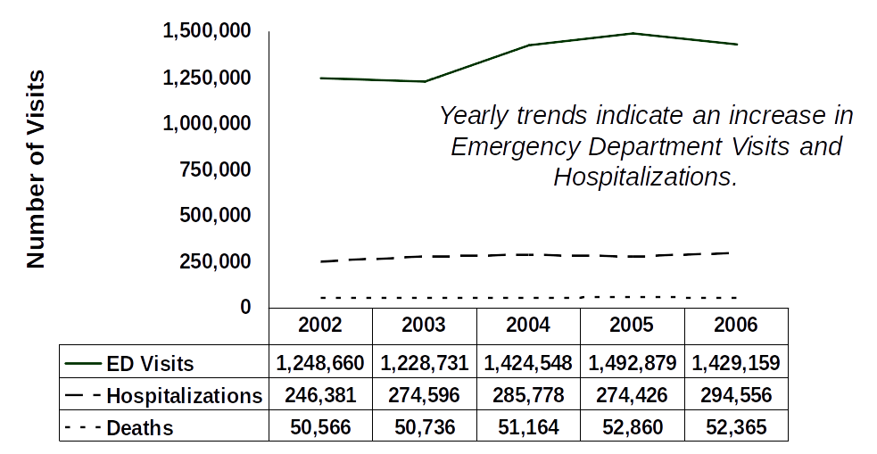

Ancillary Table for Figure 8: Annual Number Estimates of all Traumatic Brain Injury-Related Emergency Department Visits, Hospitalizations, and Deaths, United States, 2002-2006

 | 2002 | 2003 | 2004 | 2005 | 2006
Emergency Department Visits | 1,248,660 | 1,228,731 | 1,424,548 | 1,492,879 | 1,429,159
Hospitalizations | 246,381 | 274,596 | 285,778 | 274,426 | 294,556
Deaths | 50,566 | 50,736 | 51,164 | 52,860 | 52,365

Figure 9: Annual Rate Estimates of Fall-Related Traumatic Brain Injury-Related Emergency Department Visits, Hospitalizations, and Deaths, within Children Ages 0-14, United States, 2002-2006

The following figure, Figure 9, presents the trends for the annual rate estimates of fall-related TBI-related ED visits, hospitalizations, and deaths, within children ages 0-14, in the U.S. for the years 2002 to 2006. During this period, yearly trends indicate an overall, substantial increase in fall-related traumatic brain injuries in ED visits among children 14 years and younger. Specifically, there was a 62% increase for fall-related visits. However, hospitalizations during this time decreased by 30%, and deaths remained the same. The figure is a combined graph and data table. The x-axis of the graph represents years. Reading from left to right the years are 2002, 2003, 2004, 2005, and 2006. The y-axis indicates number of cases. Beginning at zero, the units of measure are 200, 400, and 600. In 2002, ED visits equaled 290 per 100,000 population and these rose to 501.2 in 2005, decreasing to 470.5 in 2006. Hospitalizations equaled 24.3 in 2002 and decreased to 14 in 2005 and rose slightly to 16.9 in 2006. Deaths for this time period remained constant at 0.1. The data have been reproduced as a separate table.

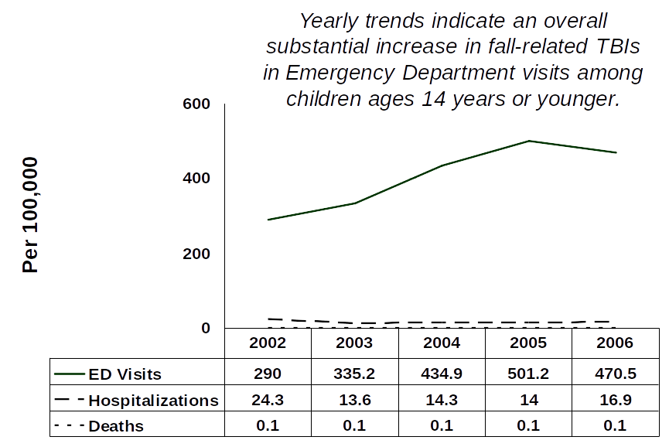

Ancillary Table for Figure 9: Annual Rate Estimates of Fall-Related Traumatic Brain Injury-Related Emergency Department Visits, Hospitalizations, and Deaths, within Children Ages 0-14, United States, 2002-2006

 | 2002 | 2003 | 2004 | 2005 | 2006
Emergency Department Visits | 290 | 335.2 | 434.9 | 501.2 | 470.5
Hospitalizations | 24.3 | 13.6 | 14.3 | 14 | 16.9
Deaths | 0.1 | 0.1 | 0.1 | 0.1 | 0.1

Figure 10: Annual Rate Estimates of Fall-Related Traumatic Brain Injury-Related Emergency Department Visits, Hospitalizations, and Deaths within Adults 65 and Older, United States, 2002-2006

The following figure, Figure 10, presents the trends for the annual rate estimates of fall-related TBI-related ED visits, hospitalizations, and deaths, within adults 65 and older, in the U.S. for the years 2002 to 2006. During this period, yearly trends indicate a substantial increase in fall-related traumatic brain injuries among persons 65 years or older in all three categories. ED visits increased by 46%, hospitalizations increased by 34% and deaths increased by 27%. The figure is a combined graph and data table. The x-axis of the graph represents years. Reading from left to right the years are 2002, 2003, 2004, 2005, and 2006. The y-axis indicates number of cases. Beginning at zero, the units of measure are 100, 200, 300, and 400. In 2002, ED visits equaled 263.7 per 100,000 population and these rose to 385.2 in 2006. Hospitalizations equaled 67.6 in 2002 and increased to 90.7 in 2006. Deaths equaled 17.3 and increased to 21.9 in 2006. These data have been reproduced as a separate table.

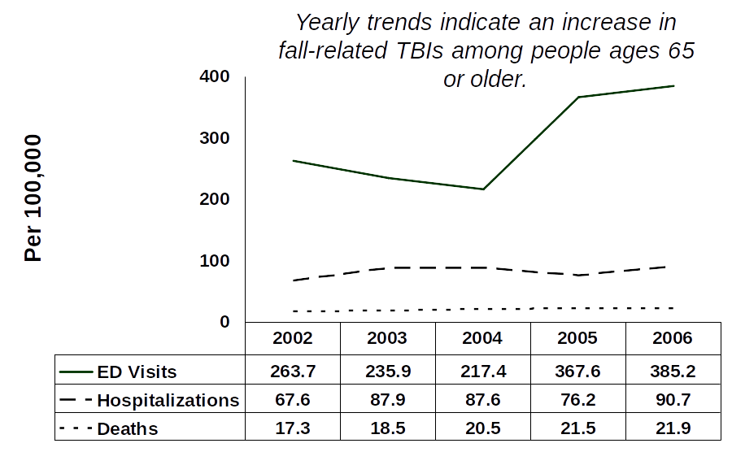

Ancillary Table for Figure 10: Annual Rate Estimates of Fall-Related Traumatic Brain Injury-Related Emergency Department Visits, Hospitalizations, and Deaths, within Adults 65 and Older, United States, 2002-2006

 | 2002 | 2003 | 2004 | 2005 | 2006
Emergency Department Visits | 263.7 | 235.9 | 217.4 | 367.6 | 385.2
Hospitalizations | 67.6 | 87.9 | 87.6 | 76.2 | 90.7
Deaths | 17.3 | 18.5 | 20.5 | 21.5 | 21.9

Appendix B: Methods and Data Sources

Appendix B: Methods and Data Sources

The data presented in this report originate from three different national data sources of CDC’s National Center for Health Statistics (NCHS): the National Hospital Discharge Survey (NHDS), the National Hospital Ambulatory Medical Care Survey (NHAMCS), , and the National Vital Statistics System (NVSS) multiple-cause-of-death file. These data sources were selected because national estimates for TBI-related injuries can be created using visits to EDs, hospitalizations, and deaths. Data for the years 2002 to 2006 were used. The reasons for using data for this 5-year time period were (1) to obtain the most recent estimates of the burden of traumatic brain injuries and (2) to increase the stability of the estimated numbers and rates for hospitalizations and ED visits by using multiple years.

Data Sources

ED Visits

The National Hospital Ambulatory Medical Care Survey (NHAMCS), conducted by CDC’s National Center for Health Statistics (NCHS), was used to characterize TBIs treated in EDs in the U.S. The target population of the NHAMCS is in-person visits made in the U.S. to EDs and outpatient departments of nonfederal, short-stay hospitals (hospitals with an average stay of less than 30 days) or hospitals that specialize in general medical or surgical procedures, and children’s hospitals. Of the NHAMCS data, only ED visits were included in this report. The NHAMCS uses a four-stage probability design with the stages being primary sampling units (PSUs), hospitals within PSUs, clinics or EDs within hospitals, and patient visits within clinics or EDs. Hospital staff were asked to complete patient record forms for a systematic random sample of patient visits occurring during a randomly assigned 4-week reporting period. Each visit was assigned a sample weight based on the inverse probability of selection with adjustments for non-response. The individual sample weights were summed to produce national estimates of TBI-related ED visits. For age, sex, and race, missing values were imputed by randomly assigning a value from a record with similar ED volume, geographic region, immediacy with which the patient should be seen, and primary diagnosis. Additional information about the NHAMCS ED component is available elsewhere. [Citation Number Five]

TBI-related cases were selected if one of the three diagnosis fields contained an ICD-9-CM diagnosis code for TBI [Citation Number Six] (see Table 18). The external cause of injury (E code) was assigned based on the first E code field. Emergency department patients who died in the ED, those who were later hospitalized, or those transferred to another facility, were excluded from the analysis of ED visits. During 2002 to 2006, the number of hospitals participating in the survey ranged from 352 to 406 (more than 91% of eligible, sampled hospitals each year), with the total number of unweighted ED visits ranging from 33,605 to 40,253. The annual number of unweighted TBI-related ED visits identified in the sample ranged from 412 to 460 for a total of 2,198 TBI-related ED visits sampled during 2002 to 2006.

Hospitalizations

The National Hospital Discharge Survey (NHDS) of the NCHS was used to estimate annual rates of TBI-related hospitalization. The NHDS provides data on discharges from nonfederal, short-stay hospitals (those with an average length of stay for all patients of less than 30 days), general (medical or surgical) hospitals and children’s hospitals in the U.S.. The NHDS uses a modified, three-stage probability design to select records, with the stages being PSUs, hospitals within the PSUs, and discharges within the hospitals. The modification of the design involved selection with certainty of the largest PSUs and hospitals. Demographic and medical data were collected for the selected discharges, and weights were assigned based on the inverse probability of selection with adjustments for non-response. The individual record weights were summed to produce estimates of TBI-related hospitalizations each year for the total U.S. population. Additional information about the NHDS data is available elsewhere.[Citation Number Seven] TBI-related cases were selected if one of the diagnosis fields contained an ICD-9-CM diagnosis code for TBI. [Citation Number Six] (see Table 18). External Cause codes, or E codes, were contained within the seven diagnosis fields, and the external cause of injury was classified using the first E code that appeared in the list of codes. Hospitalized patients who died during hospitalization or were transferred to another hospital were excluded from the analysis. During 2002 to 2006, the annual number of hospitals providing data for the survey ranged from 426 to 445 (88.9% to 93.9% of eligible, sampled hospitals), with the total number of unweighted discharges ranging from 319,530 to 376,328. The annual number of unweighted TBI-related hospitalizations identified in the sample ranged from 2,104 to 2,583 for a total of 11,880 unweighted TBI-related discharges sampled during 2002 to 2006.

Deaths

Multiple cause-of-death data from the mortality files of the NVSS were used to describe TBI-related deaths. In the U.S., state laws require completion of death certificates for all deaths; federal law mandates national collection and publication of deaths and other vital statistics. The NVSS, the federal compilation of these data, is the result of cooperation between NCHS and the states to provide access to statistical information from death certificates. Additional information about these data is available elsewhere.[Citation Number Eight] TBI-related cases were selected if an ICD-10 diagnosis code[Citation Numbers Nine and Ten] (for 2002–2006; see Table 19) for TBI appeared in Part I of the death certificate. The E code was obtained from the underlying cause of death field.

Identification of Traumatic Brain Injury Cases

For all data sources, TBI cases were identified using CDC’s case definition as described in Central Nervous System Injury Surveillance Data Submission Standards --2002.[Citation Numbers Ten and Eleven] The CDC definition includes all NHDS and NHAMCS records that contained in one or more of the diagnosis data fields the ICD-9-CM diagnosis codes in the appropriate range, as shown in Table 18, were identified as a TBI hospitalization or ED visit. All records that contained in Part I of the death certificate the ICD-10 diagnosis codes (for years 2002–2006) in the appropriate range, as shown in Table 19 were identified as a TBI death. A record was counted only once regardless of the number of diagnosis codes (any listed) that met the criteria for TBI. The increased use of 959.01 was accompanied by a corresponding drop in the use of 854[Citation Number Twelve]. Thus, to avoid underestimating TBIs, we included cases coded as 959.01. This is consistent with a previous CDC publication on TBI[Citation Number Thirteen] and the current CDC TBI case definition.

Table 18: ICD-9-CM Codes for Traumatic Brain Injury-Related Emergency Department Visits and Hospitalizations (2002–2006)

Description | ICD-9-CM (Hospitalizations and ED Visits)
Fracture of the vault or base of skull | 800.0-801.9
Other and unqualified multiple fractures of the skull | 803.0-804.9
Intracranial injury, including concussion, contusion, laceration, and hemorrhage | 850.0-854.1
Injury to optic nerve and pathways | 950.1-950.3
Shaken baby syndrome | 995.55
Head injury, unspecified | 959.01

Table 19: ICD-10 Codes for Traumatic Brain Injury-Related Deaths (2002–2006)

Description | ICD-10 (Deaths)
Open wound of the head | S01.0-S01.9
Fracture of the skull and facial bones | S02.0, S02.1, S02.3, S02.7-S02.9
Injury to optic nerve and pathways | S04.0
Intracranial injury | S06.0-S06.9
Crushing injury of head | S07.0, S07.1, S07.8, S07.9
Other unspecified injuries of head | S09.7-S09.9
Open wounds involving head with neck | T01.0
Fractures involving head with neck | T02.0
Crushing injuries involving head with neck | T04.0
Injuries of brain and cranial nerves with injuries of nerves and spinal cord at neck level | T06.0
Sequelae of injuries of head | T90.1, T90.2, T90.4, T90.5, T90.8, T90.9

External Cause of Injury

External cause of injury categorization was based on E codes and classified using categories adapted from CDC’s recommended frameworks for presenting injury data.[Citation Numbers Fourteen and Fifteen] The categories used are presented in Table 20.

Several changes occurred in the classification of external cause of injury between ICD-9 and ICD-10, including the prefixes used to distinguish external cause (from E codes for ICD-9 to codes beginning with V, W, X, Y, and *U [terrorism] for ICD-10) and the organization of transport incident codes (based on type of vehicle in ICD-9 and characteristics of the injured person in ICD-10).

For this report, the external cause of injury categories are as follows: motor vehicle-traffic; unintentional falls; assaults; and struck by or struck against. Struck by or struck against events are those in which a person was struck unintentionally by another person or an object, such as falling debris or a ball in sports, or that someone struck against an object, such as a wall or another person. For this report, only unintentional and undetermined struck by or struck against events were included. Struck by or struck against events related to assaults (for example, being struck by a fist) are in the assault category. Struck by or struck against events were only reported for all ages because small sample sizes precluded reporting them for all three data sources (NHAMCS, NHDS and NVSS).

Population Data

This report uses the U.S. Census bridged-race population estimates from 2002 to 2006 obtained from NCHS.[Citation Number Sixteen] The average annual population (derived by dividing the total population by five) is presented in Table 21. The 2000 standard population from the U.S. Bureau of the Census was used to calculate the age-adjusted TBI-related rates using the direct method.[Citation Number Seventeen] The weight applied to the average annual population to derive the 2000 standard population is also presented in Table 21.

Table 20: External Cause of Injury Categorization for ICD-9-CM Codes (Emergency Department Visits and Hospitalizations, 2002–2006) and ICD-10 Codes (Deaths, 2002–2006)

Description | ICD-9-CM | ICD-10
Motor vehicle traffic-related (MVT) [unintentional] | E810-E819 | V02-V04 (.1, .9), V09.2, V12-V14 (.3-.9), V19 (.4-.6), V20-V28 (.3-.9), V29 (.4-.9), V30-V79 (.4-.9), V80 (.3-.5), V81.1, V82.1, V83-V86 (.0-.3), V87 (.0-.8), V89.2
MVT Sub-set: Occupant | E810-E819 (.0,.1) | V30-V79 (.4-.9), V81.1, V82.1,  V83-V86 (.0-.3)
MVT Sub-set: Motorcycle | E810-E819 (.2,.3) | V20-V28 (.3-.9), V29 (.4-.9)
MVT Sub-set: Pedal Cycle | E810-E819 (.6) | V12-V14 (.3-.9), V19 (.4-.6)
MVT Sub-set: Pedestrian | E810-E819 (.7) | V02-V04 (.1, .9), V09.2
MVT Sub-set: Other and Unspecified | E810-E819 (.4, .5, .8, .9) | V80 (.3-.5), V87(.0-.8), V89.2
Falls  [unintentional and undetermined] | E880-E886, E888, E987 | W00-W19, Y30
Assault  [includes firearms and other methods] | E960-E969 | X85-Y09, Y87.1
Struck by and Struck Against | E916, E917 | W20-W22, W50-W52, Y29
Other and Unspecified | All other E codes | All other cause codes

Statistical Analysis

SAS software [Citation Number Eighteen] was used to calculate average annual numbers, rates, row percentages, and age-adjusted rates and total numbers. Average annual numbers were calculated by adding the numbers for all five years and dividing the totals by five. Average annual rates were calculated by dividing the total number for all five years by the total population for all five years. Row percentages were also calculated by dividing each number by the total number for all five years. Because numbers, rates, and row percentages were all calculated before rounding and were calculated based on the totals for all five years and not the annual average, some results may not be consistent across tables.
An age adjustment was made using the direct method to eliminate differences in observed rates that result from age differences in the population distribution. This adjustment was done to allow accurate comparison of two or more populations at one point in time or a single population at two or more points in time. Age adjustment by the direct method requires use of a standard age distribution; in this case, the year 2000 standard population was selected (See Table 21).

The following graphic is the formula to calculate the age adjusted rates using the direct method. Reading from left to right, the symbols in the formula represent the following:

Where r subscript i = age-specific rates for the population of interest multiplied by,

Capital W subscript i = age-specific weight based on the 2000 U.S. standard population, and

Where small case n = total number of age groups over the age range of the age-adjusted rate,


Based on the complex sample design of the NHAMCS and the NHDS, estimates of the number and rate of TBIs requiring hospitalization or treatment at EDs were reported based on the NCHS guidelines below: [Citation Number Nineteen]

- If the sample size was less than 30, the value of the estimate was reported, but it was not considered stable.
- If the sample size was 30 to 59, the value of the estimate was reported, but it may not be stable.

For death data, if the sample size was less than 20 for the 5 years combined, the rates were suppressed because the data are not considered stable.[Citation Number Seventeen]

Table 21: Estimated Average Annual 2002–2006 Population by Age Group, Sex, and Race; Weights for 2000 Standard Population by Age Group

 | Sex |  | Race
Age (yrs) | Male | Female | White | Black | American Indian, Alaska Native, Asian, or Pacific Islander | Total | Weights
0-4 | 10,240,416 | 9,784,061 | 15,582,248 | 3,260,109 | 1,182,120 | 20,024,477 | 0.0691356496
5-9 | 10,081,063 | 9,624,631 | 15,332,058 | 3,200,397 | 1,173,239 | 19,705,694 | 0.0725328983
10-14 | 10,740,169 | 10,229,818 | 16,259,412 | 3,503,737 | 1,206,837 | 20,969,987 | 0.0730317441
15-19 | 10,658,609 | 10,106,668 | 16,251,474 | 3,309,403 | 1,204,400 | 20,765,277 | 0.0721687774
20-24 | 10,671,421 | 10,077,694 | 16,341,821 | 3,115,714 | 1,291,580 | 20,749,115 | 0.0664775665
25-34 | 20,226,113 | 19,659,025 | 31,421,296 | 5,519,693 | 2,944,149 | 39,885,138 | 0.1355731628
35-44 | 22,007,839 | 22,085,520 | 35,614,403 | 5,731,205 | 2,747,751 | 44,093,359 | 0.1626127865
45-54 | 20,443,508 | 21,159,542 | 34,445,963 | 4,920,675 | 2,236,412 | 41,603,050 | 0.1348339972
55-64 | 13,997,124 | 15,075,707 | 24,786,789 | 2,911,295 | 1,374,746 | 29,072,831 | 0.0872470269
65-74 | 8,458,345 | 10,072,055 | 16,013,437 | 1,740,204 | 776,758 | 18,530,399 | 0.0660369801
>75 | 6,724,189 | 11,112,062 | 15,947,766 | 1,352,384 | 536,101 | 17,836,250 | 0.0603494104
Total | 144,248,796 | 148,986,783 | 237,996,667 | 38,564,816 | 16,674,093 | 293,235,577

Note regarding the data in Table 21: The weights in column 8 are for the 2000 standard US population.

Limitations

● Three different data sources were used. Results should be interpreted with caution because differences in study methods may have influenced the findings. The NHDS and NHAMCS were based on a sample of inpatients discharged from nonfederal short-stay hospitals (NHDS) and ED visits (NHAMCS), while NVSS multiple cause-of-death data included all deaths.

● The potential for sampling bias exists with any survey. NHDS and NHAMCS decrease this possibility including a stratified sampling of hospitals, random selection of discharges within hospitals and visits within EDs, and even distribution of sampling throughout the year.

● The overall burden of TBI in the U.S. may have been underestimated. An estimated 439,000 TBIs treated by physicians during office visits and 89,000 treated in outpatient settings were not included in this report.[Citation Number Twenty] In addition, TBI for which no medical advice was sought, an estimated 25% of all mild and moderate TBIs, were not included.[Citation Number Twenty-One]

- Analyses were not conducted separately by state because the sampling schemes used by both NHDS and NHAMCS
were designed to produce national estimates, not state-based estimates.

● The lack of external cause of injury coding (E coding) was potentially problematic. For the NHDS data, one third of cases were missing an E code. Increased E code reporting could increase the rates by external cause. Only data were reported for the leading causes of TBI (falls, struck by or struck against, motor vehicle- traffic, and assault) for the three data sets combined. The actual leading causes varied among ED visits, hospitalizations, and deaths. Causes beyond those were combined as ‘other or unknown’ due to limitations in sample size and consistency among all three data sources. As a result, some causes were not included individually, such as firearm injuries, which is a factor in some TBI deaths.[Citation Numbers Twenty-Two and Twenty-Three] These types of injuries were included in the “other” category.

● E codes may not capture all of the injuries attributable to a particular cause or intent, particularly challenging ones such as assault. Among children, 25% of all injuries resulting from assaults may not be accounted for by E codes.[Citation Number Twenty-Four] Assaults might not be properly recognized, especially in vulnerable populations, such as children[Citation Number Twenty-Five] and older adults.[Citation Number Twenty-Six]

● Injury severity was not included in this report for two reasons. First, we could not uniformly apply a measure of severity to all three data sets. ICDMAP-90,[Citation Number Twenty-Seven] a computer algorithm that converts ICD-9-CM diagnosis codes to a six-level score approximating the Abbreviated Injury Scale (AIS), was only applicable to NHDS and NHAMCS data. Second, at the time of publication, the ICDMAP- 90 has not been updated to include the ICD code 959.01, which is now part of the TBI ICD coded definition.

● The NHDS and NHAMCS data are based on hospitalizations and visits to EDs—not on individual persons. It is not possible to un-duplicate cases in which individuals were hospitalized or treated in EDs more than once for the same injury. Although, this limitation precludes calculating the true incidence of TBI, the effects on the data are assumed to be quite small. Specifically, data from a population-based follow-up study in South Carolina indicate a readmission rate to the hospital of approximately 4% and a readmission rate to the ED of 5% to 6%. Patients who transferred from another hospital were excluded in the hospitalization table for this report. Patients who have been hospitalized and later died from their injuries could be another source of over-counting. However, deaths that occurred among patients hospitalized or treated at EDs were excluded based on information available in the hospital discharge and ED data sets. Patients who were seen in the ED and later hospitalized could also be double counted; however, documented hospitalizations were excluded from those counted as seen in the ED. Emergency department patients reported to have been transferred were also excluded to help limit double counting. Because none of these data sets are mutually exclusive, the combined number or rate of TBI might be overestimated since some cases would still be double-counted within these national data sets. (see Figure 11).

The following figure, Figure 11, is a flow chart depicting the sources of potential case duplication when combining data sources for ED visits, hospitalizations, and deaths. On the left hand side of the flow chart are three boxes. The top box is labeled “Deaths”, the second box, directly below it is labeled “ Hospitalizations”, and the third box directly below this is labeled “ED Visits”. On the right hand side of the flow chart are five boxes. The first box on the right hand side is labeled “In Hospital Deaths” and includes the text: In-hospital deaths and deaths occurring in the ED were deleted. Two lines and an arrow connect this box to the boxes labeled “Deaths” and “Hospitalizations” on the left hand side of the chart. The second box on the right hand side, directly below the first, is labeled “Hospital Readmissions” and includes the text: Hospital readmission rates estimated at 4 percent of hospital admissions based on the state of South Carolina’s TBI surveillance data. One line and an arrow connect this box to the box labeled “Hospitalizations” on the left hand side of the flow chart. The third box on the right hand side, directly below the second is labeled “Transfer between Hospitals” and includes the text: Transfers from another hospital were deleted. One line and an arrow connect this box to the box labeled “Hospitalizations” on the left hand side of the flow chart. The fourth box on the right hand side, directly below the third is labeled “Hospitalized ED Patients” and includes the text: ED visits for patients admitted to the hospital or transferred to a different hospital were deleted. Two lines and an arrow connect this box to the boxes labeled “Hospitalizations” and “ED Visits.” Finally, the fifth box on the right hand side, directly below the fourth is labeled “ED Readmissions” and includes the text: ED readmission rates estimated at 5 to 6 percent of ED admissions based on South Carolina TBI surveillance data. One line and an arrow connect this box to the box labeled “ED Visits” on the left hand side of the flow chart.

Figure 11: Sources of Potential Case Duplication When Combining Traumatic Brain Injury-Related Emergency Department Visits, Hospitalizations, and Deaths

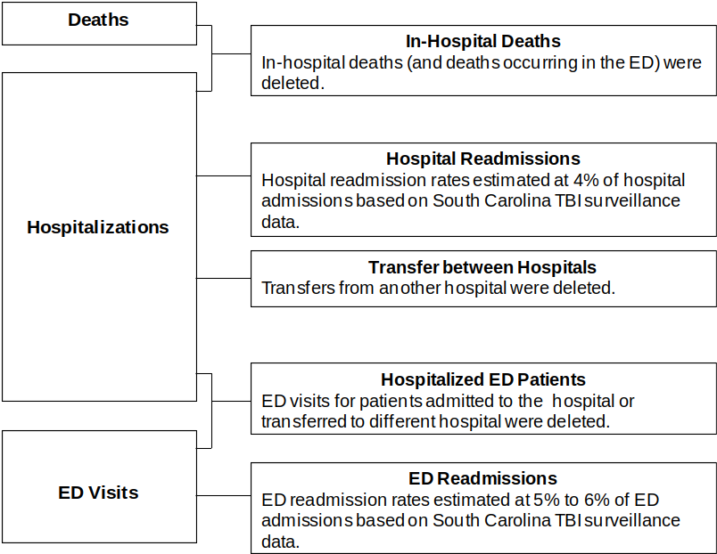

References

References

1. Centers for Disease Control and Prevention. Traumatic Brain Injury in the United States: A Report to Congress. Atlanta (GA): Department of Health and Human Services (US), CDC, National Center for Injury Prevention and Control; 1999.

2. Centers for Disease Control and Prevention. Report to Congress on Mild Traumatic Brain Injury in the United States: Steps to Prevent a Serious Public Health Problem. Atlanta (GA): Department of Health and Human Services (US), CDC, National Center for Injury Prevention and Control; 2003.

3. Traumatic Brain Injury in the United States, Emergency Department Visits, Hospitalizations and Deaths. Atlanta (GA): Centers for Disease Control and Prevention, National Center for Injury Prevention and Control; 2004.

4. Selassie A W, Zaloshnja E, Langlois, JA,Miller T, Jones P, Steiner C. Incidence of Long-term Disability Following Traumatic Brain Injury Hospitalization, United States, 2003. Journal of Head Trauma Rehabilitation. Focus on Clinical Research and Practice. 23(2):123-131, March/April 2008.

5. McCaig LF, McLemore T. Plan and operation of the National Hospital Ambulatory Medical Care Survey. Centers for Disease Control and Prevention, National Center for Health Statistics. Vital Health Stat 1994;1(34).

6. International Classification of Diseases: 9th Revision, Clinical Modification, 3rd ed. (ICD-9-CM). Washington (DC): Department of Health and Human Services (US); 1989.

7. Dennison C, Pokras R. Design and operation of the National Hospital Discharge Survey: 1988 redesign. Vital Health Stat 2000;1(39).

8. Arias E, Anderson RN, Hsiang-Ching K, Murphy SL, Kochanek KD. Deaths: final data for 2001. Centers for Disease Control and Prevention, National Center for Health Statistics. Natl Vital Stat Rep 2003;52(3).

9. International Classification of Diseases, 10th Revision (ICD-10). Geneva (Switzerland): World Health Organization; 2001.

10. Marr A, Coronado V, editors. Central Nervous System Injury Surveillance Data Submission Standards—2002. Atlanta (GA): Department of Health and Human Services (US), Centers for Disease Control and Prevention, National Center for Injury Prevention and Control; 2004.

11. Thurman DJ, Sniezek JE, Johnson D, Greenspan A, Smith S. Guidelines for Surveillance of Central Nervous System Injury. Atlanta (GA): Centers for Disease Control and Prevention, National Center for Injury Prevention and Control; 1995.

12. Coronado V.G., Thomas K.E., Sattin R.W., Johnson R.L. The CDC traumatic brain injury surveillance system: Characteristics of persons aged 65 years and older hospitalized with a TBI. Journal of Head Trauma Rehabilitation. 20(3): 215-228, 2005.

13. Langlois J, Kegler S, Butler J, Gotsch K, Johnson R, Reichard A, et al. Traumatic brain injury-related hospital discharges: results from a 14-state surveillance system, 1997. MMWR Surveillance Summaries 2003;52 (No. SS-4):1–20.

14. Centers for Disease Control and Prevention. Recommended framework of E-code groupings for presenting injury mortality and morbidity data. Atlanta (GA): Department of Health and Human Services (US), CDC, National Center for Injury Prevention and Control; 2001. Available from: URL: http://www.cdc.gov/injury/wisqars/ecode_matrix.html

15. Centers for Disease Control and Prevention. External Cause of Injury Mortality Matrix for ICD-10. Atlanta (GA): Department of Health and Human Services (US), CDC, National Center for Health Statistics; 2002. Available from: URL: www.cdc.gov/nchs/data/ice/icd10_transcode.pdf.

16. Centers for Disease Control and Prevention. U.S. Census Populations with Bridged Race Categories. Hyattsville (MD): Department of Health and Human Services (US), CDC, National Center for Health Statistics; 2003. Available from: URL: http://www.cdc.gov/nchs/nvss/bridged_race.htm

17. Miniño AM, Anderson RN, Fingerhut LA, Boudreault MA, Warner M. Deaths: Injuries, 2002. Centers for Disease Control and Prevention, National Center for Health Statistics; Natl Vital Stat Rep 2006; 54(10).

18. SAS Institute Inc. SAS/STAT User’s Guide, Version 9.2. Cary (NC): SAS Institute Inc.; 2008.
Control and Prevention, National Center for Health Statistics; Natl Vital Stat Rep 2006;54(10).

19. Centers for Disease Control and Prevention. National Hospital Discharge Survey 2001: Public Use Data File Documentation. Hyattsville (MD): Department of Health and Human Services (US), CDC, National Center for Health Statistics; 2003.

20. Schootman M, Fuortes LJ. Ambulatory care for traumatic brain injuries in the U.S., 1995–1997. Brain Inj 2000; 14:373–81.

21. Sosin DM, Sniezek JE, Thurman DJ. Incidence of mild and moderate brain injury in the United States, 1991. Brain Inj 1996;10:47–54.

22. Adekoya N, Thurman D, White D, Webb K. Surveillance for traumatic brain injury deaths—United States, 1989–1998. MMWR Surveill Summ 2002;51(No. SS-10):1–16.
23. Sosin DM, Sniezek JE, Waxweiler RJ. Trends in death associated with traumatic brain injury, 1979–1992. Success and failure. JAMA 1995;273(22):1778–80.

24. Winn DW, Agran PF, Anderson CL. Sensitivity of hospitals’ E-coded data in identifying causes of children’s violence related injuries. Public Health Rep 1995;110:277–81.

25. U.S. Advisory Board on Child Abuse and Neglect. A Nation’s Shame: Fatal Child Abuse and Neglect in the United States. Report No. 5. Washington (DC): Department of Health and Human Services (US), Administration for Children and Families; 1995.

26. Department of Health and Human Services (US), Administration for Children, Administration on Aging. The National Elder Maltreatment Incidence Study—Final Report. Washington (DC): Department of Health and Human Services (US); 1998.

27. MacKenzie EJ, Steinwachs DM, Shankar BS. Classifying trauma severity based on hospital discharge diagnoses: validation of an ICD-9-CM to AIS-85 conversion table. Med Care 1989;27:412–22.

