Supplementary Materials for THE WHEN AND WHO OF SOCIAL LEARNING AND CONFORMIST Transmission
Table of Contents
Participants 3
Formally defined frequency-dependent social learning strategies for N traits 4
Experimental Design 4
Experiment 1: Number of options 5
Experiment 2: Transmission Fidelity and Payoffs 6
Nakahashi, Wakano, and Henrich (2012) predictions for transmission fidelity and payoffs 7
Background Measures 8
Further Analyses and Results 13
Results with all 101 participants 13
Fig. 3 & Fig. 5 14
Table 1 15
Fig. 4 & Fig. 6 16
Table 2 18
Table 3 18
Fig. 7 20
Table 4 20
Reduced Model for Social Learning with Just IQ 22
Analyses with age and gender 23
Table 1 23
Table 2 24
Results for Experiment 2 without Scaling 24
Fig. 7 25
Table 4 25
Density plot with outliers 26
Fig. 7 with outliers 27
Robust Linear Model Conformist Bias Analysis (Table 4) 28
Performance 28
Predicting performance 29
Asocial vs Social Decision 31
References 32

Participants
All participants were recruited from the University of British Columbia’s Economics Participant Pool, which is open to the public, but primarily consists of undergraduate students. In our measures and background surveys, we included 2 vigilance check questions (“Click Disagree a Little” and “Click Somewhat Agree”). Of our 101 participants, 27 failed at least one of these two checks. Table S1 reports demographics for the (a) 74 usable participants and (b) 27 who failed the vigilance check question. We were unable to predict failure using our demographics, suggesting no observable difference between the two groups. In the next section, we report our main results with the 27 excluded participants from the main text included in the analysis, revealing no substantive difference in results.
 |  | Euro Canadian | East Asian Canadian | Other | TOTAL
Age | Mean | 23.95 | 20.69 | 21.46 | 21.73
 | SD | 9.57 | 2.59 | 2.77 | 5.55
Gender | Female | 10 | 24 | 5 | 39
 | Male | 10 | 15 | 10 | 35
Table S1 (a). Participant demographics for 74 participants included in main text.
 |  | White Canadian | East Asian Canadian | Other | TOTAL
Age | Mean | 21.75 | 22.60 | 21.00 | 22.30
 | SD | 4.19 | 5.38 | 1.00 | 4.86
Gender | Female | 1 | 13 | 3 | 17
 | Male | 3 | 7 | 0 | 10
Table S1 (b). Participant demographics for 27 participants excluded from main text.

Formally defined frequency-dependent social learning strategies for N traits
To operationalize our analysis, we consider four types of formally defined frequency-dependent social learning strategies, where $t$ is one of N cultural traits in the population, $p_{t}$ is the frequency of $t$ in the population and $p_{i}$ is the probability of an individual copying $t$.
- Conformist transmission – the disproportionate likelihood of adopting a common variant ($p_{i}>p_{t}$ if $p_{t}>1/N$).
- Unbiased social learning – adopting a common variant at or below the frequency of the trait in the population, but above chance (${p_{t}≥p}_{i}>1/N$ if $p_{t}>1/N$).
- Asocial learning – adopting a trait independent of the population frequency ($p_{i}⊥p_{t}$, so on average $p_{i}=1/N$ ceteris paribus).
- Anti-conformity – adopting the rare trait in the population ($p_{i}>1/N$ if $p_{t}<1/N$).

Experimental Design
The basic experimental design is illustrated in Fig. 1 and described in the Methods section of the main text. We used an Asch-style line judgement task, which has a long history of use in psychology. Apart from comparison to past research, the task is also simple to explain, has a uncontroversial “correct answer”, and removes priors from outside the experimental setting affecting specific decisions in the game (i.e. people don’t enter the experiment with a bias toward any particular line). Here we provide some additional details. Background measures can be found in the Background Measures section.

Experiment 1: Number of options
In Experiment 1, participants had to compare between 2 and 6 lines to identify the longest line. Each trial was worth a maximum of $1, however, the payoff associated with each line was proportional to the length of the selected line relative to all other lines. The longest line received $1 and the shortest line received no money. We calculated the payment (P) for each line using the following formula:
$$v\text{=}\frac{\text{max-length}}{\text{max}{\text{-min}}}$$
$$P=\frac{\sqrt{2-v}-\sqrt{v}}{\sqrt{2-v}+\sqrt{v}}$$
Where v is the relative difficulty of the line, calculated by subtracting the line length (length) from the longest line length (max) and dividing this by the difference between the longest (max) and shortest lines (min). Since v can range from 0 to 1, we can plot P over the range of v to show how the function behaves (Fig. S1 below).
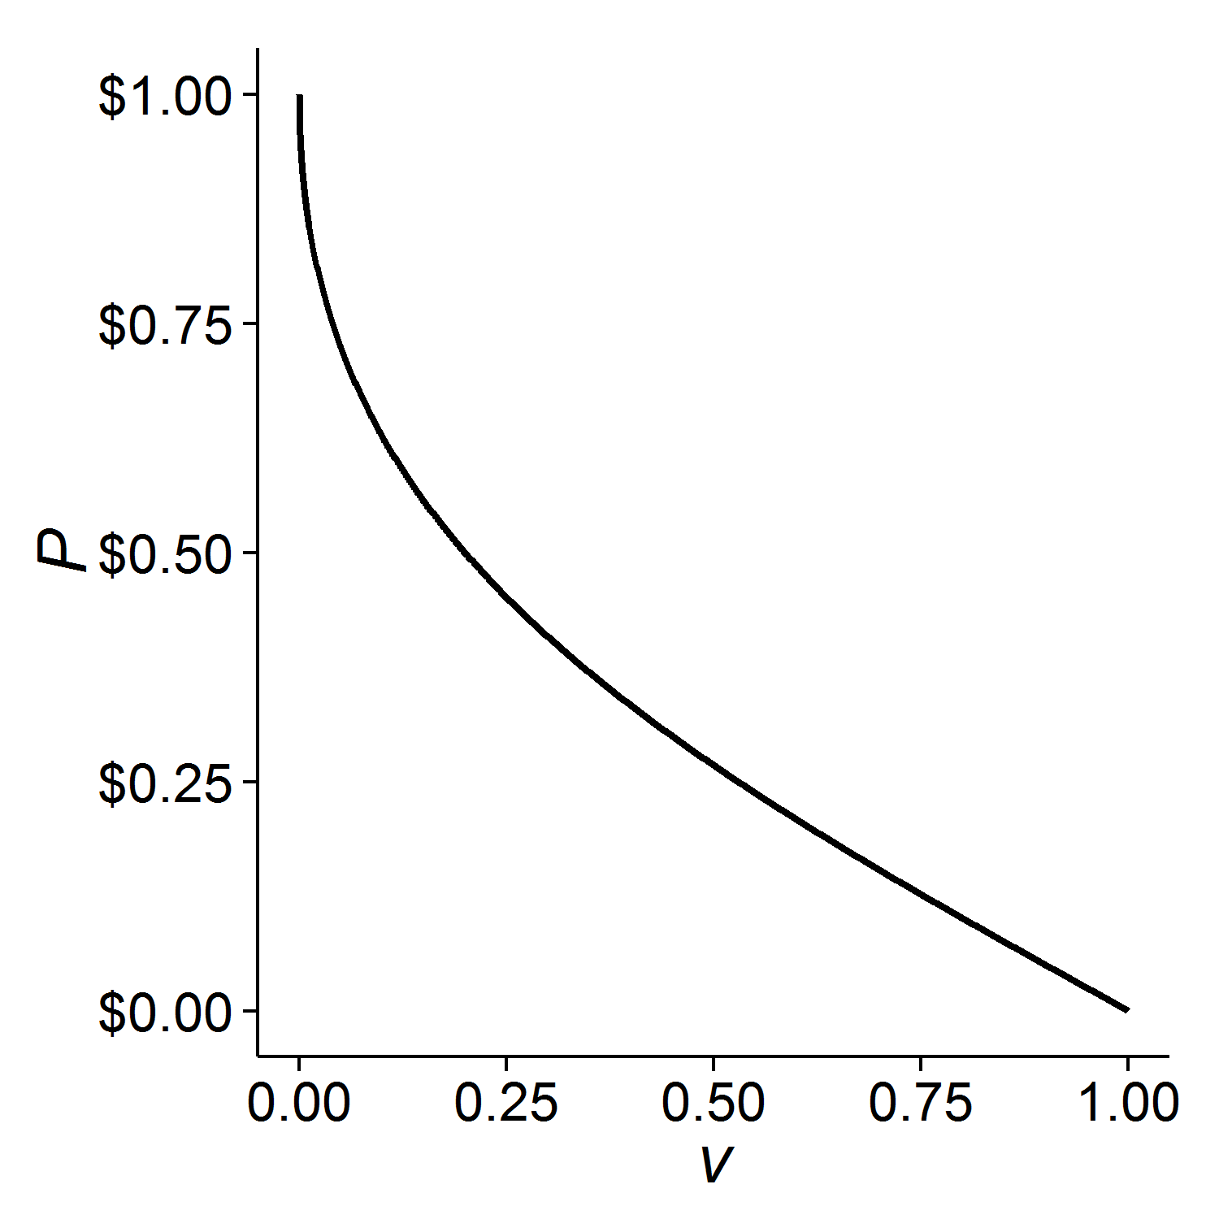
Fig. S1. Payments based on line difficulty. The function rapidly declines in payment (P) from the longest line (v = 0; P = $1) and then behaves almost linearly, reducing in value to the shortest line (v = 1; P = $0).

Experiment 2: Transmission Fidelity and Payoffs
In Experiment 2, we varied errors in transmission between 0% (only true social information) to 40% (i.e. 60% social information, 40% random). Fig. S2 below is a screenshot for how participants received this information.
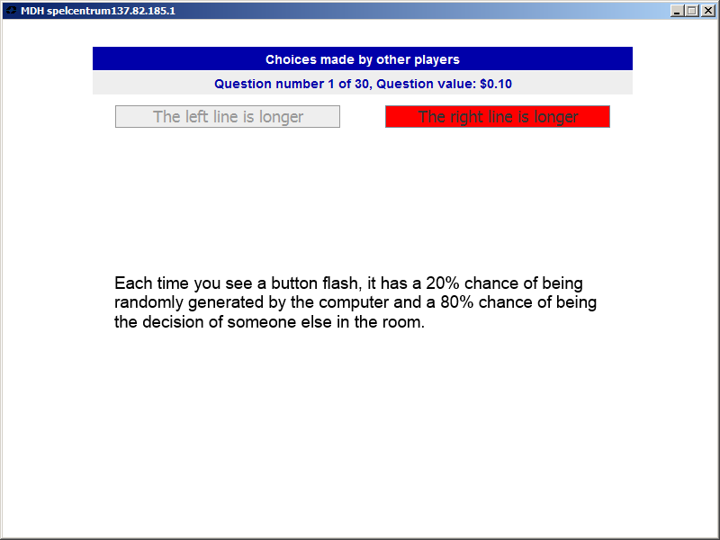
Fig. S2. Screenshot from Experiment 2 visible before and during the display of social information. Social information is conveyed in the form of flashes corresponding to the button clicked. The instructions reveal that 20% of flashes are randomly generated by the computer with the remaining 80% genuine decisions from other participants in the room.

Nakahashi, Wakano, and Henrich (2012) predictions for transmission fidelity and payoffs
The attached Mathematica file allows you to explore the effect of transmission error (migration in model) and payoffs (selection in model). We assume low selection and low error (less than 50%).

Background Measures
We measured theoretically derived individual-difference measures, other potential explanatory measures, and a variety of routine background measures. We list these below with citations, details, and sample items.
IQ: IQ was measured using Raven’s Advanced Progressive Matrices (Raven & Court, 1998). Only Raven Set 1 (12 questions) was included for the first 8 participants. After this first session, we realized we had enough time to include Raven Set 2 as well, so Raven 2 was included for all other sessions. However, 3 questions were inadvertently left out of Raven 2. Although these were later added, we removed them from our analysis to maximize the number of observations. This gave us a total of45 questions instead of 48 for combined Sets 1 and 2. There was no meaningful or significant difference in the scores for those who had these missing questions and those who did not (20.10 vs 20.08, p = .99). An example Raven item is shown below in Fig. S3.
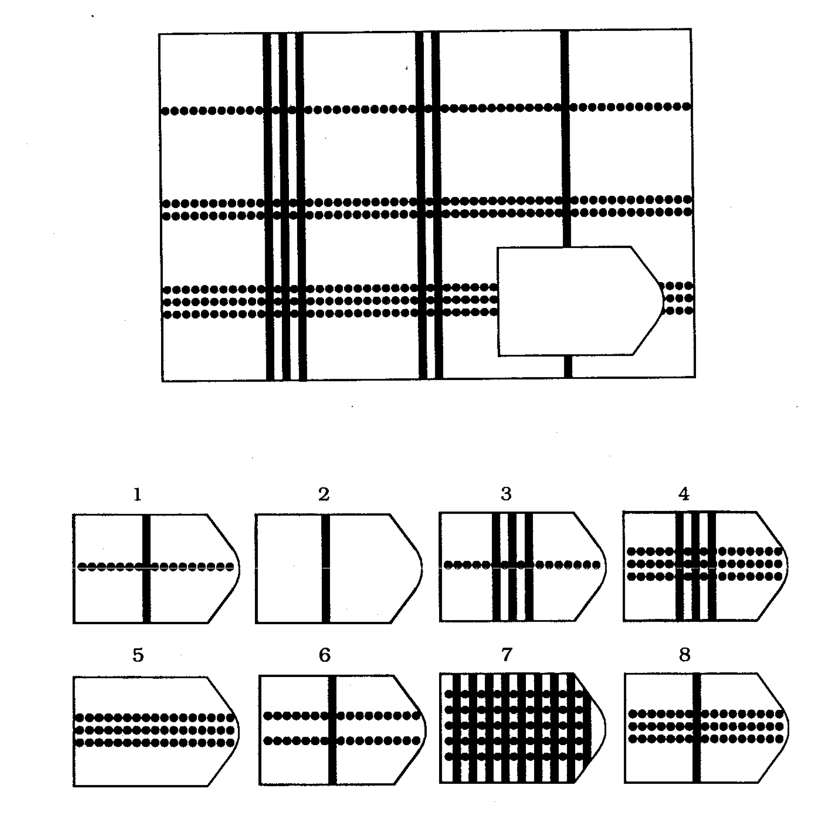
Fig. S3. Sample item from Raven’s Advanced Progressive Matrices.
Prestige and Dominance: We measured self-reported prestige using the Prestige and Dominance scale (Cheng, Tracy, & Henrich, 2010). An example item from the Prestige subscale: “Members of my peer group respect and admire me”. An example item from the Dominance subscale: “I enjoy having control over others”. Answers were provided using a 7-point Likert scale from “Not at all” to “Very much”.
Cultural Background: We asked for participant ethnic (or cultural) group, if they were born in Canada, how well they speak their native language, how much they identify with Canada (Inclusion of Other in the Self Scale; Aron, Aron, & Smollan, 1992), and their degree of acculturation (Vancouver Index of Acculturation; Ryder, Alden, & Paulhus, 2000). We classified participant ethnicities as being East Asian Canadian, Euro-Canadian, or Other Ethnicity. The Inclusion of Other in the Self Scale involves picking a pair of overlapping circles that best represents their level of identification with (1) their ethnic group and (2) other Canadians. The Vancouver Index of Acculturation includes Heritage Acculturation and Mainstream Acculturation subscales. An example question from the Heritage Acculturation subscale is “I often participate in my heritage cultural traditions”. An example question from the Mainstream Acculturation subscale is “I would be willing to marry a white North American person”.
Reflective vs Intuitive Thinking Styles: We measured reflective vs intuitive thinking styles using the Cognitive Reflection Test (CRT; Frederick, 2005). The CRT consists of 3 questions:
- A bat and a ball cost $1.10 in total. The bat costs $1.00 more than the ball. How much does the ball cost? (Answer in cents)
- If it takes 5 machines 5 minutes to make 5 widgets, how long would it take 100 machines to make 100 widgets? (Answer in minutes)
- In a lake, there is a patch of lily pads. Every day, the patch doubles in size. If it takes 48 days for the patch to cover the entire lake, how long would it take for the patch to cover half of the lake? (Answer in days)
Since this test is commonly used and these questions are often offered as logical puzzles, after answering the questions, we asked participants to identify any questions that they had seen before. Scores on the CRT are out of 3, so we excluded participants who had seen one or more of these questions. We also coded these questions for an Intuitive score for participants who gave the intuitive answers (some participants wrote an answer that was neither correct nor intuitive).
Personality: We measured the Big 5 Personality traits using a 44-item Big 5 Personality Inventory (John, Donahue, & Kentle, 1991; John, Naumann, & Soto, 2008). An example item from the Extraversion subscale: “I am someone who is talkative”. An example item from the Agreeableness subscale: “I am someone who is helpful and unselfish with others”. An example item from the Conscientiousness subscale: “I am someone who does a thorough job”. An example item from the Neuroticism subscale: “I am someone who can be tense”. An example item from the Openness subscale: “I am someone who is original, comes up with new ideas”. Answers were provided using a 5-point Likert scale from “Disagree strongly” to “Agree strongly”.
Rule Following: We measured the tendency to follow rules using the Rule Following Task (RFT; Kimbrough & Vostroknutov, 2013). The RFT involves participants controlling a stick figure who walks across the screen. The stick figure stops at a series of traffic lights (screenshot shown in Fig. S4 below). Participants are told “The rule is to wait at each stop light until it turns green.” Participants were given an initial endowment of $2.50 and each second this endowment decreased by 10c. This initial endowment was calculated such that only fully breaking the rules would ensure no loss of money. Thus participants were incentivized to break the rule and press Walk before the light turns green. How quickly they proceed in crossing the screen is a measure of their internalized rule following norms. The RFT has been shown to predict behaviour in a variety of economic games, including the public goods, dictator, ultimatum, and trust games (Kimbrough & Vostroknutov, 2013).
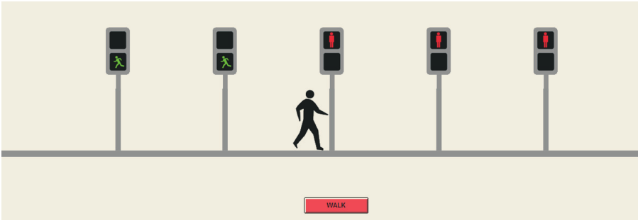
Fig. S4. Screenshot from the Rule Following Task.
The exact instructions provided to participants is as follows:
In the final part of this experiment, you control a stick figure that will walk across the screen.
Once the experiment begins, you can start walking by clicking the “Start” button on the left of the screen. Your stick figure will approach a series of stop lights and will stop to wait at each light. To make your stick figure walk again, click the “Walk” button in the middle of the screen.
The rule is to wait at each stop light until it turns green.
Your earnings in this part are determined by the amount of time it takes your stick figure to walk across the screen. Specifically, you begin with an initial endowment of $2.50. Each second, this endowment will decrease by 10c and you can lose money. The game was created in Europe and says Euros, but please read these as dollars.
This is the end of the instructions for this game. If you have any questions, please raise your hand and an experimenter will answer them privately. Otherwise, please wait quietly for the experiment to begin.
If participants asked questions about the task, experimenters simply said “all instructions have been provided”.
The Rule Following Task was only included after our initial 8 participants (when we realized we had more time to include further measures) and so was included after all other measures and tasks were completed so as to ensure all participants had the same experimental experience.
Other measures: In addition to the measures discussed, we asked participants for their age, gender, degree they were enrolled in or occupation if they were not a student, major or industry, whether they had lived their entire lives in Canada, where else they had lived, what suburb they spent most of their time in Canada, religious background, and importance of religion in their daily lives. In final debriefing questions, we also asked them to describe any strategies they were using in each game and for any remaining comments about the experiment.

Further Analyses and Results
Here we replicate the analyses and results from the main text with the inclusion of the 27 participants who failed vigilance check questions. We also show some additional analyses mentioned in the main text.

Results with all 101 participants
All tables and graphs from the main text are recreated here with the 27 exclusions included. We argue that the inclusion of these participants is defensible for the contextual predictors, since performance was incentivized. It is not defensible for individual-level predictors, which we also report, since there was no incentive to provide honest answers to these and these excluded participants failed one or more of the vigilance check questions.

Fig. 3 & Fig. 5
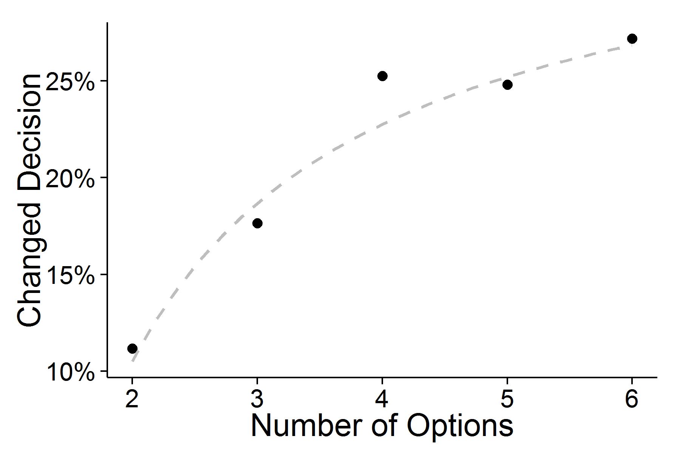
(a)
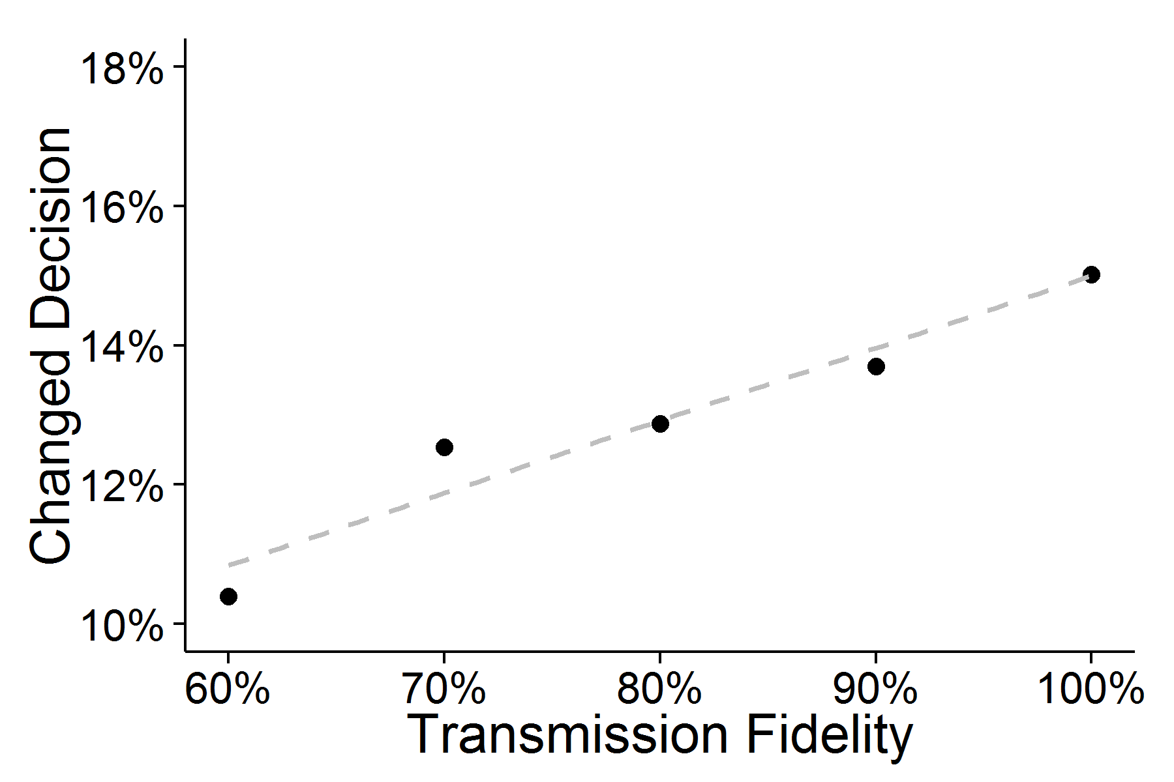 | 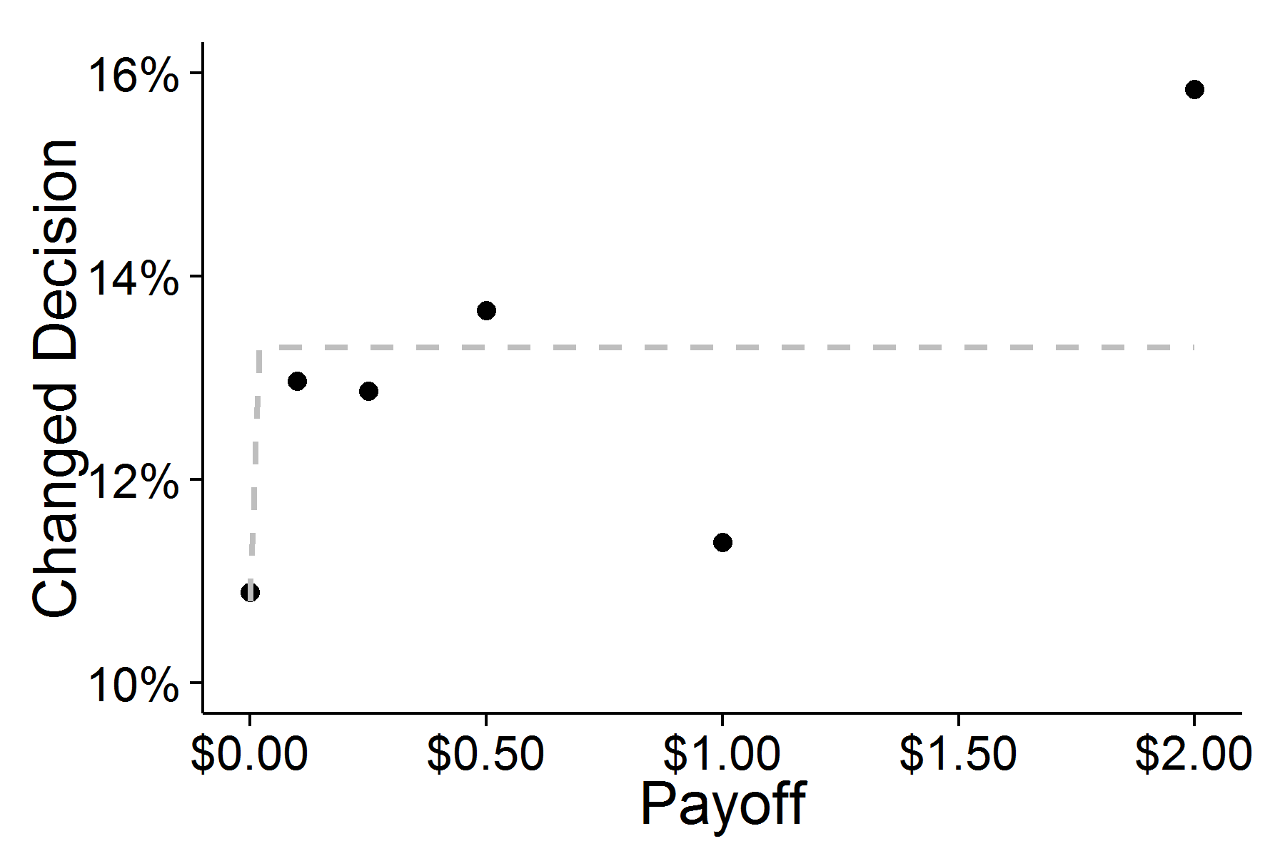
(b) | (c)
Fig. S5. Percentage of decisions that were changed after seeing social information for (a) number of options, (b) different levels of transmission fidelity, and (c) different question payoff values. Although there are too few points to be certain about the function that best fits these data, we used a non-linear least squares method to fit (a) to the reciprocal of traits $\left(y=-0.49∙1/x+0.35\right)$, (b) to a linear model $\left(y=0.10x+0.05\right)$, and (c) to a step-function $\left(y=0.13 \text{if} x>0 \text{;} y=0.11 \text{if} x=0\right)$; although the pattern with $1 and $2 is more extreme with the inclusion of these participants. Fit functions are plotted with a grey dashed line.

Table 1
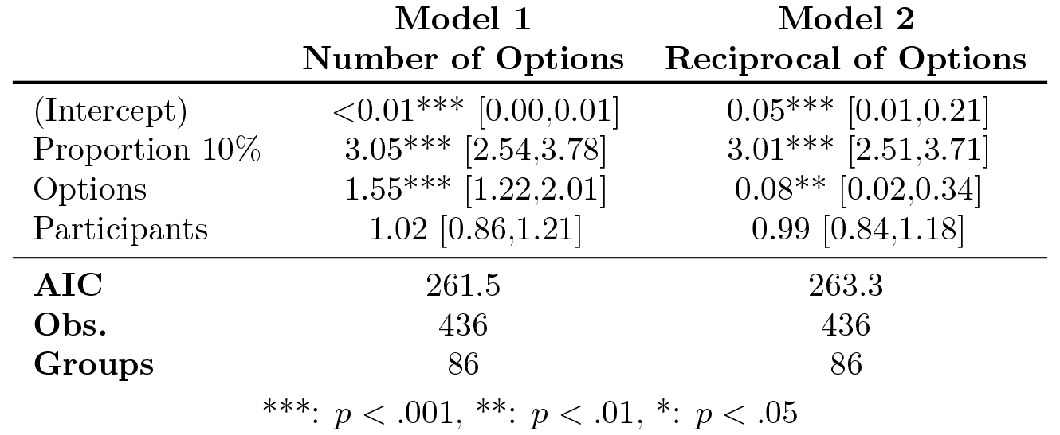
Table S2. Binary logistic multilevel model of decision to switch regressed on the proportion of participants in the option (in 10% increments for easier interpretation), the reciprocal and number of options (separate models), and the number of participants in the group. There are no substantive differences with the inclusion of the 27 participants excluded from the main analysis.

Fig. 4 & Fig. 6
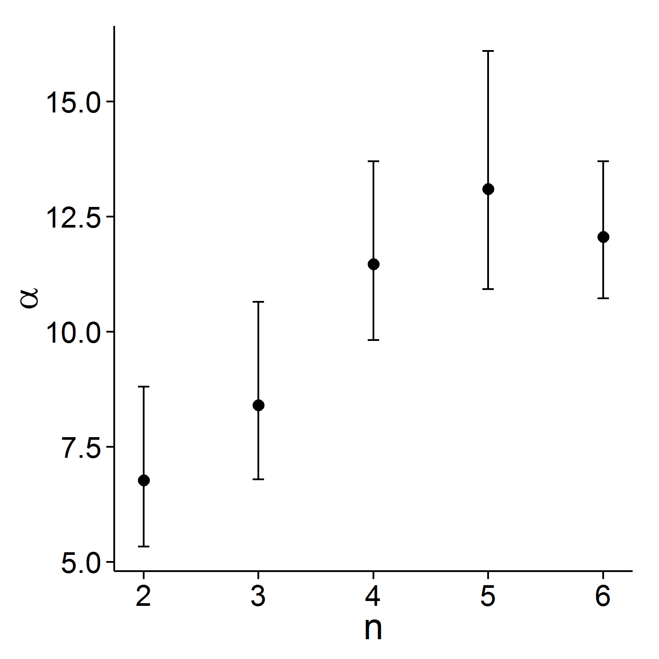 | 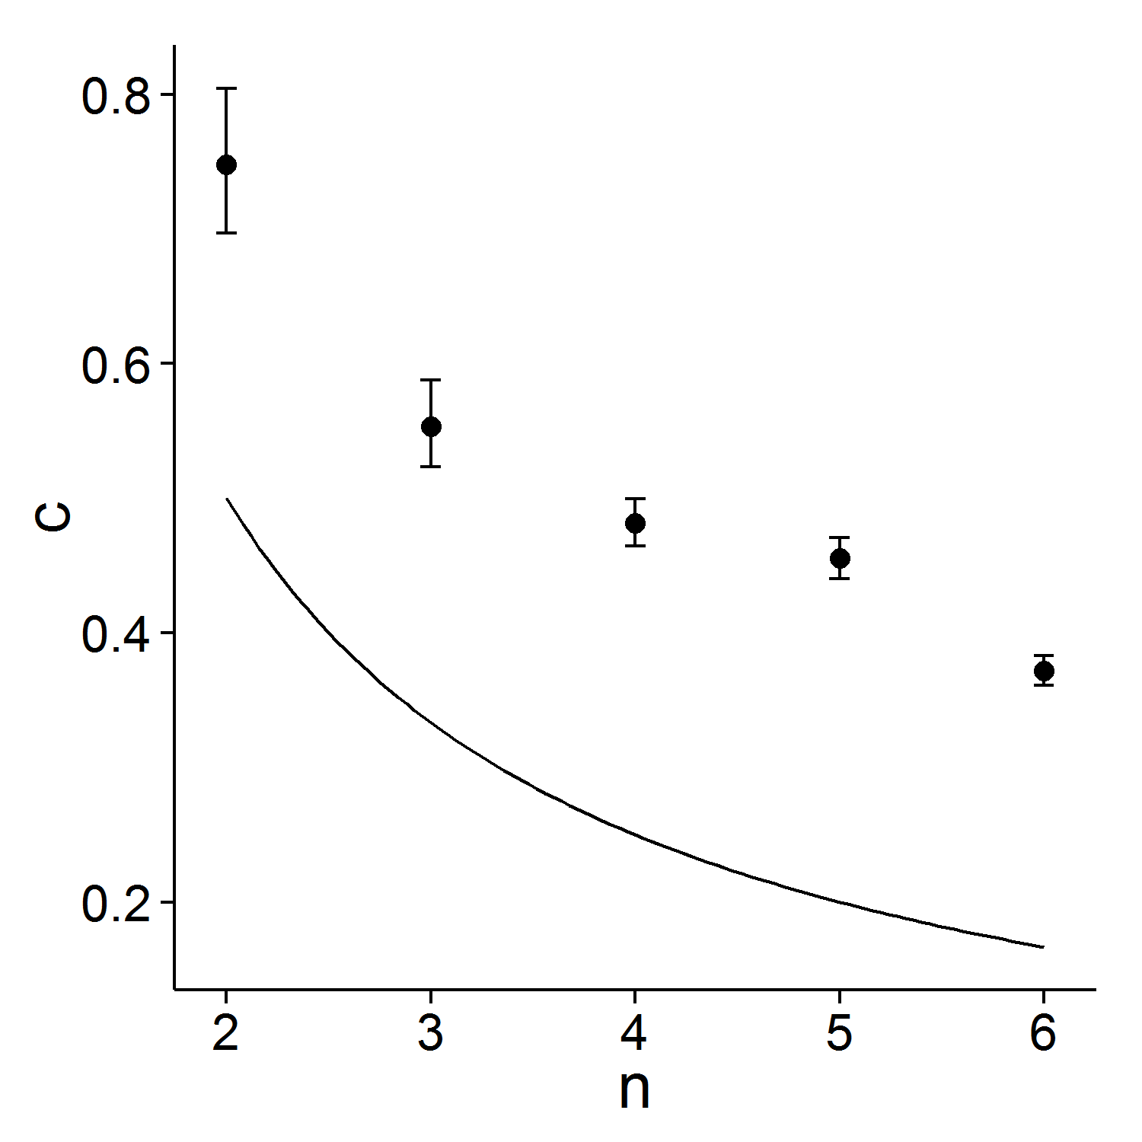
(a) | (b)
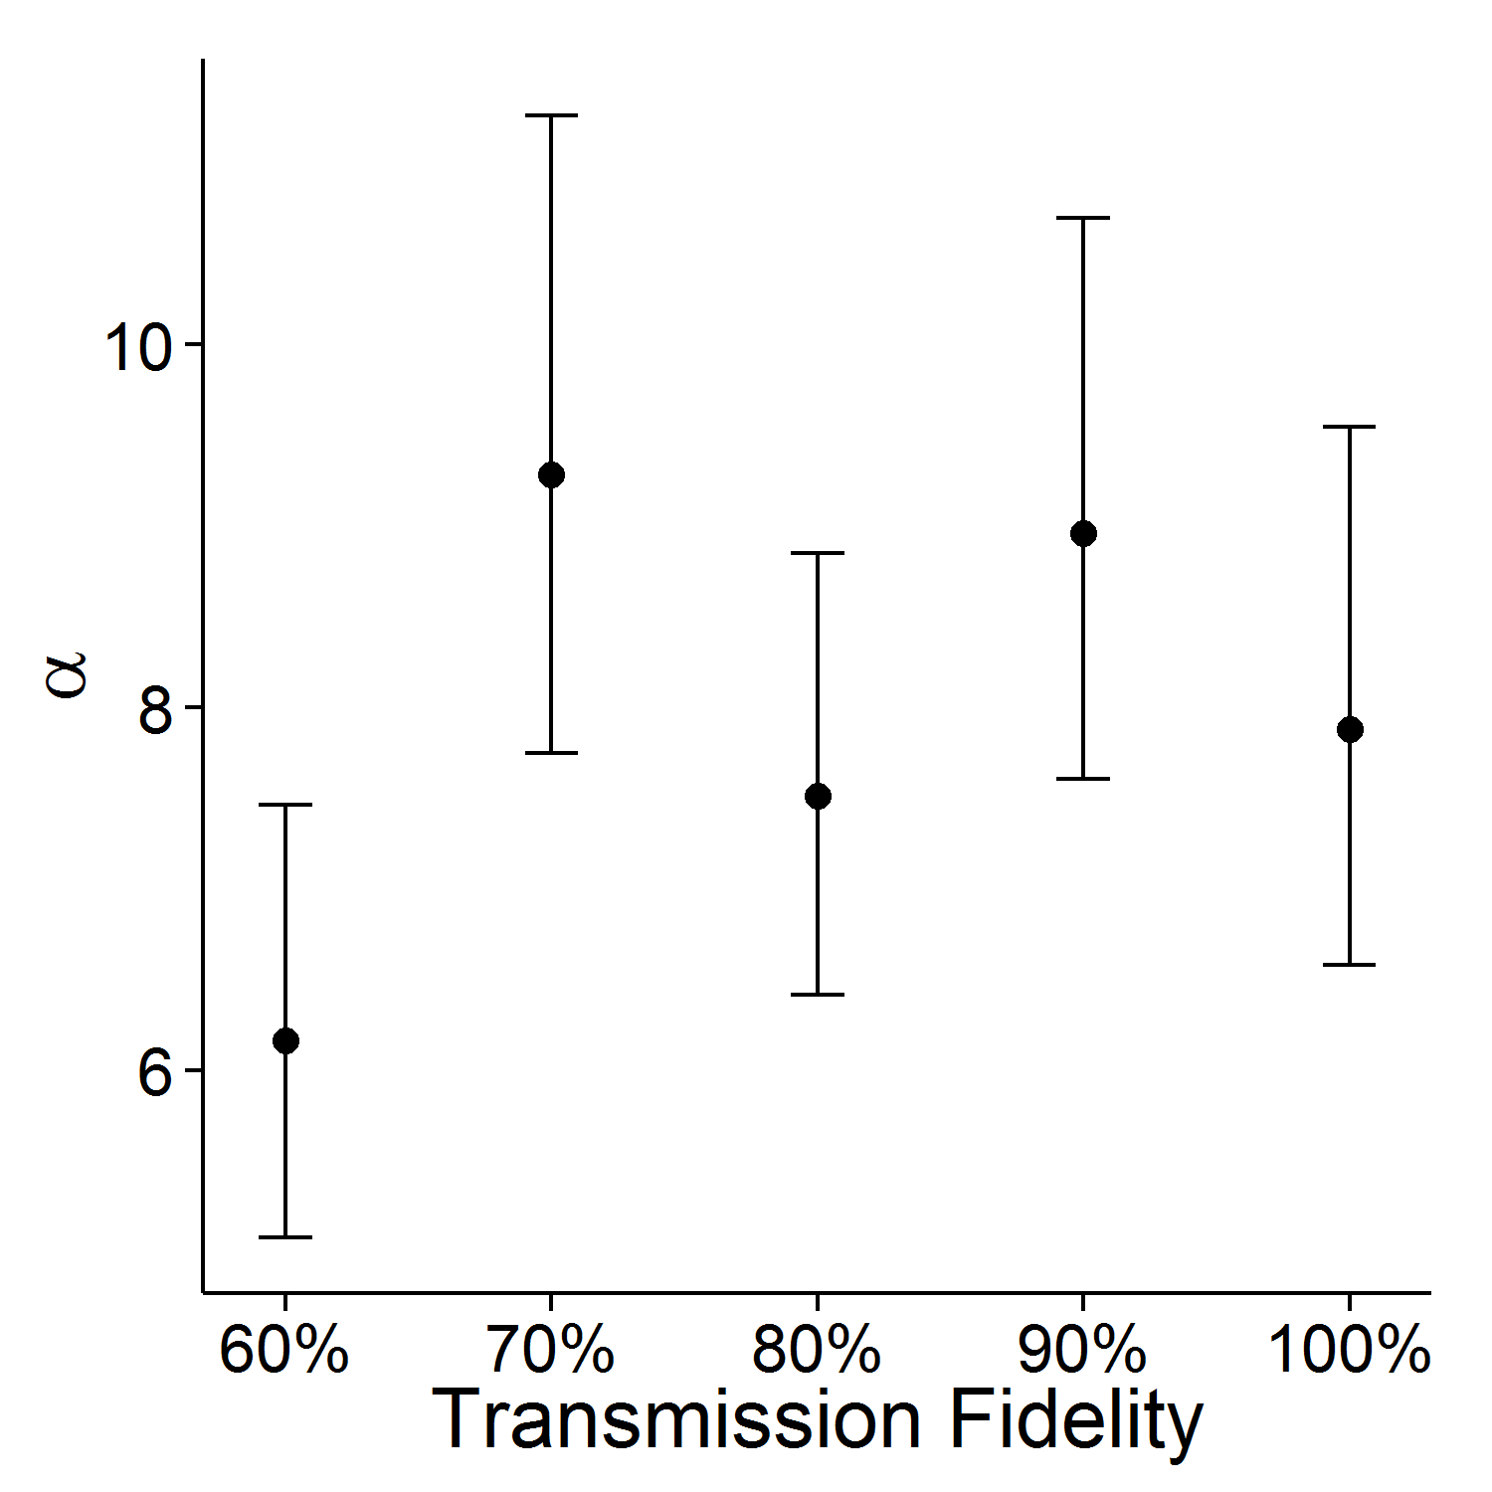
(c)
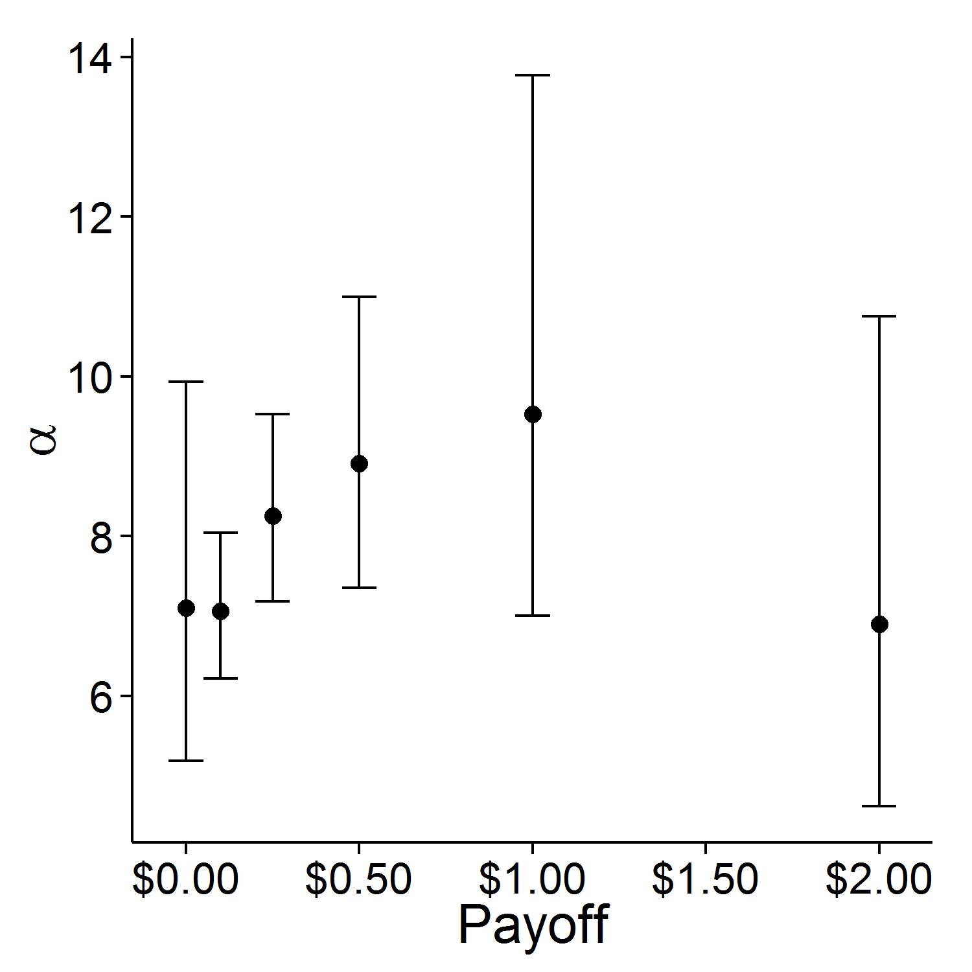 | 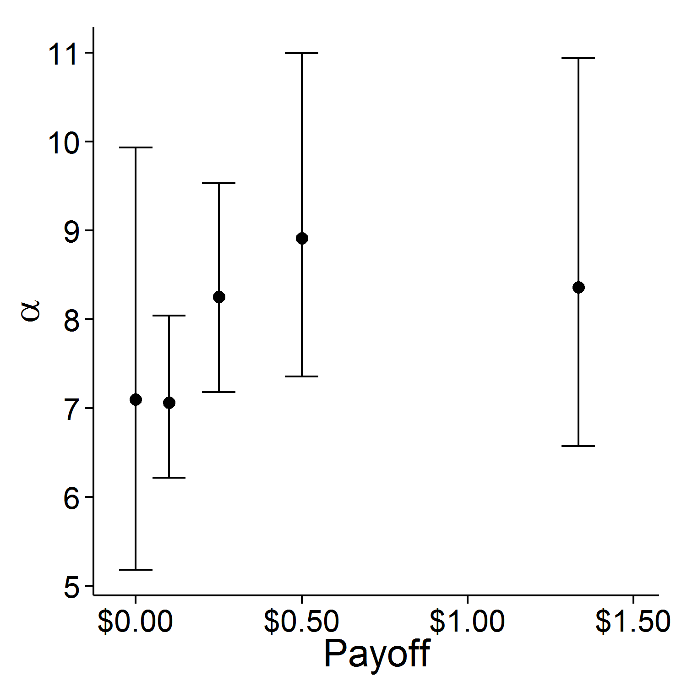
(d) | (e)
Fig. S6. Conformist bias. (a) Strength of conformist transmission parameter ($α$) as a function of number of options. The strength of the conformist transmission bias increases with more options. (b) Inflection point of logistic function as a function of number of options. The predicted value is shown as a solid line to distinguish it from the data (points) and model fitted values. The inflection point decreases, but remains higher than the predicted value, indicating an asocial prior. (c) Strength of conformist transmission parameter ($α$) as a function of transmission fidelity. Conformist transmission is strong when fidelity is higher than 60%, but at 60% it’s only slightly above unbiased transmission. Strength of conformist transmission parameter ($α$) as a function of question payoff with (d) all payoff values and (e) $1 and $2 averaged to increase sample size for the highest value. The strength of the conformist transmission bias increases with diminishing returns as the payoffs increase. There are no substantive differences with the inclusion of the 27 participants excluded from the main analysis, except that there is a clearer pattern in (a) for an increased conformist bias with more traits.

Table 2
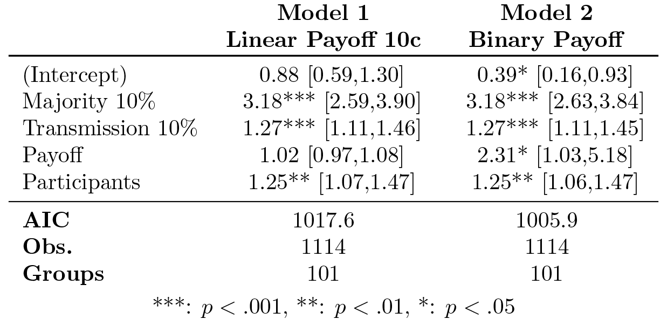
Table S3. Binary logistic multilevel model of decision to switch to majority on majority size, transmission fidelity, payoff, and number of participants in the group. All coefficients are odds ratios. We control for common variance created by multiple observations from the same person with random effects for each individual. There are no substantive differences with the inclusion of the 27 participants excluded from the main analysis.

Table 3
These results should be treated with caution, since it includes individual-difference measures from those who failed one or more vigilance check questions and may therefore have entered nonsense data for other individual-difference measures.
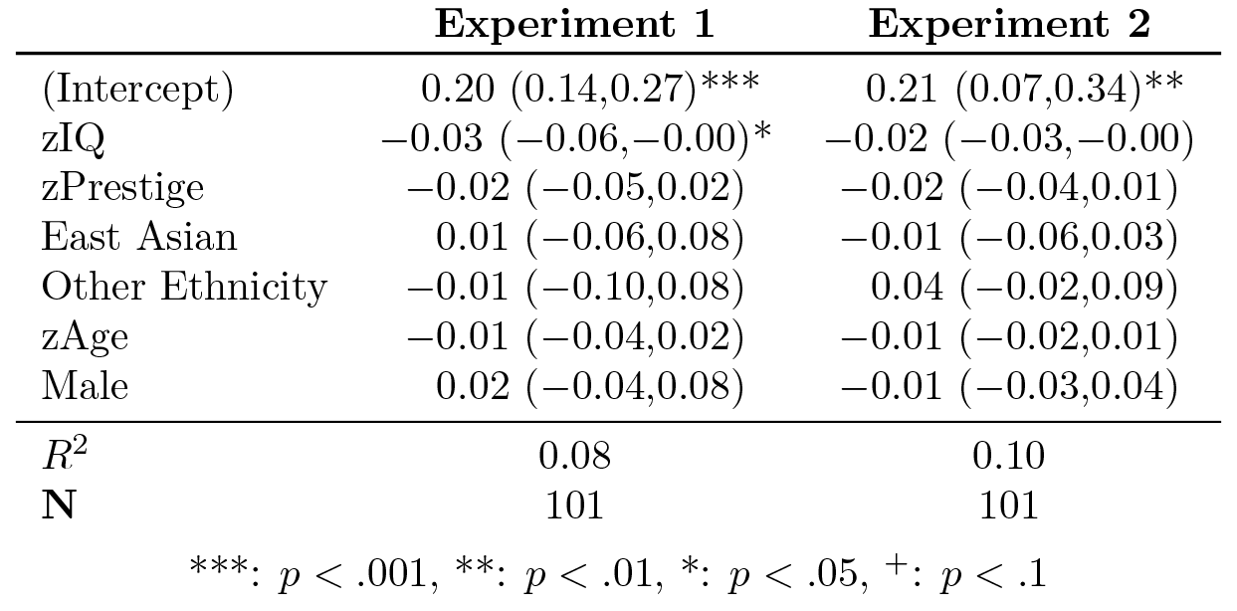
Table S4. OLS regression model percentage of decisions that were changed after viewing social information regressed on theoretical predictors as well as age and gender. All predictors with a “z” prefix are standardized z-scores. Ethnicity was dummy coded, with Euro Canadians as the reference group. These results show a negative relationship between IQ and social learning with higher IQ resulting in less social learning. The regression models reported show all theoretically inspired predictors; the regression model is significant when the non-significant predictors are removed (see Reduced Model below). Unsurprisingly, with the addition of those who failed the vigilance check, IQ is no longer a significant predictor in Experiment 2.

Fig. 7
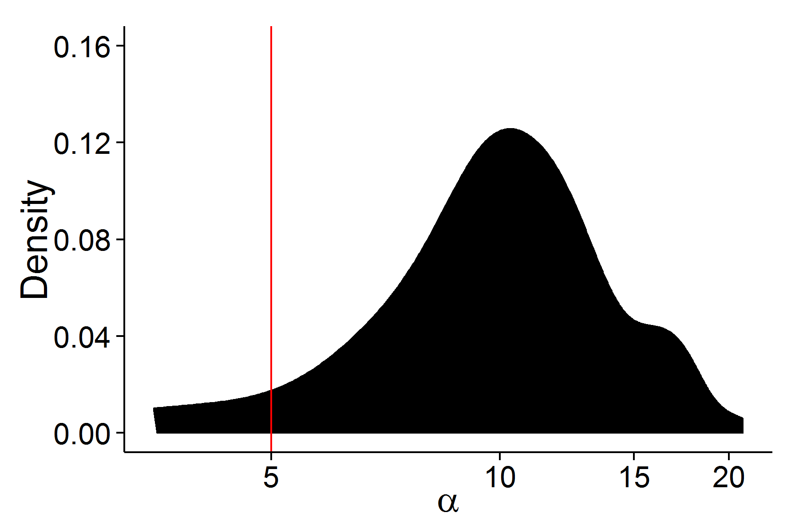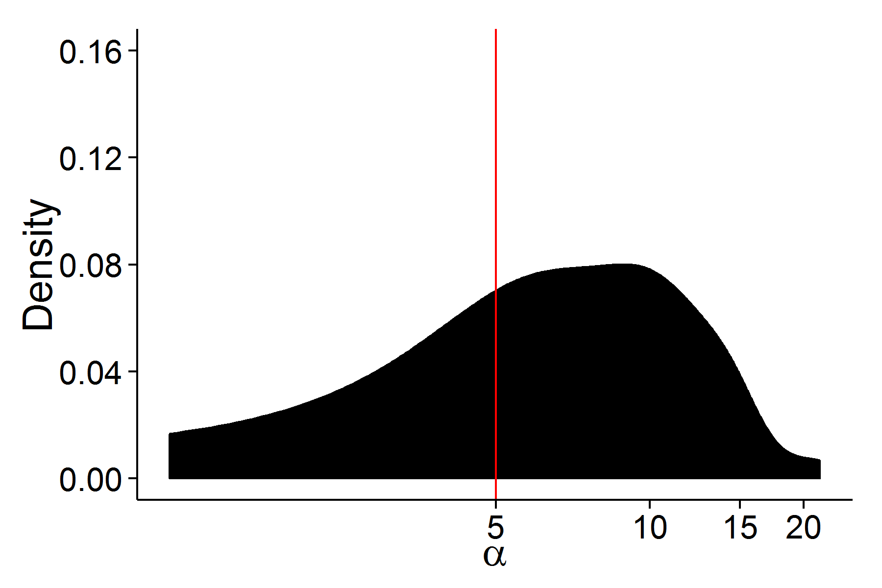
(a) | (b)
Fig. S7. Density distribution of $α$ conformist transmission values in (a) Experiment 1 and (b) Experiment 2, with$α$ calculated after scaling frequency of options by transmission fidelity. The red line indicates the cut off for conformist transmission with values to the left of this line indicating unbiased social learning. The x-axis is log-scaled. For visual purposes, we remove some outliers – see Density Plot with Outliers for figure including these.

Table 4
These results should be treated with caution, since it includes individual-difference measures from those who failed one or more vigilance check questions and may therefore have entered nonsense data for other individual-difference measures.
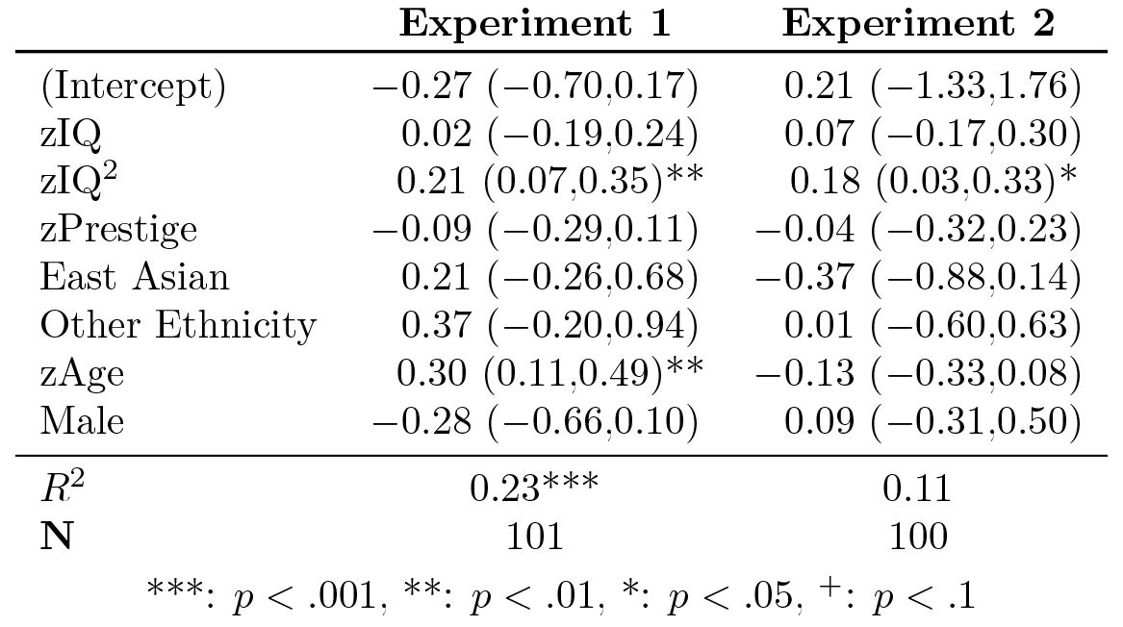
Table S5. OLS regression model of standardized log measures of strength of conformist transmission ($α$) regressed on our theoretical predictors as well as age and gender. All predictors with a “z” prefix are standardized z-scores. Ethnicity was dummy coded, with Euro Canadians as the reference group. These results suggest a consistent quadratic (U shaped) relationship between IQ and the strength of the conformist transmission bias. Both those who score high or very low on the IQ test are more likely to have stronger conformist transmission biases than those who score in the middle. In Experiment 1, which is arguably more sensitive than Experiment 2 because there are often more than 2 options, conformist biases strengthen among older individuals. In Experiment 2, we were unable to fit a sigmoid to the decisions of one of the individuals who failed a vigilance check question.

Reduced Model for Social Learning with Just IQ
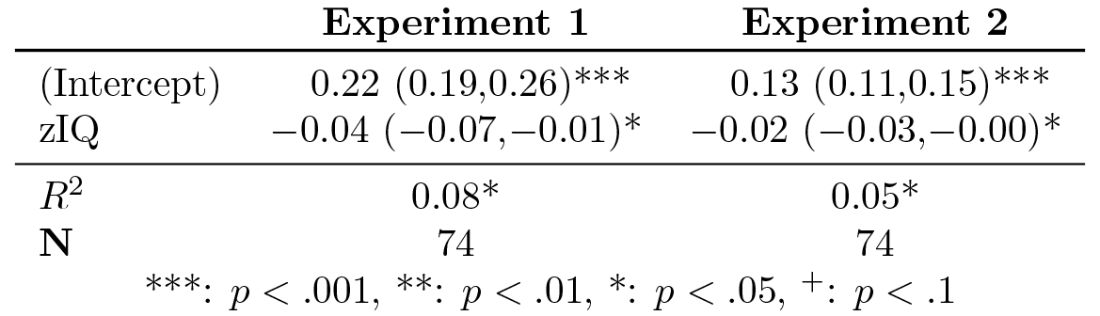
Table S6. OLS regression model percentage of decisions that were changed after viewing social information regressed on IQ. These results show a negative relationship between IQ and social learning with higher IQ resulting in less social learning. The models are significant in both experiments.

Analyses with age and gender
Here we show the full models controlling for age and gender for the contextual variables: number of options (Table 1 in main text) and transmission fidelity and payoff (Table 2 in main text).

Table 1
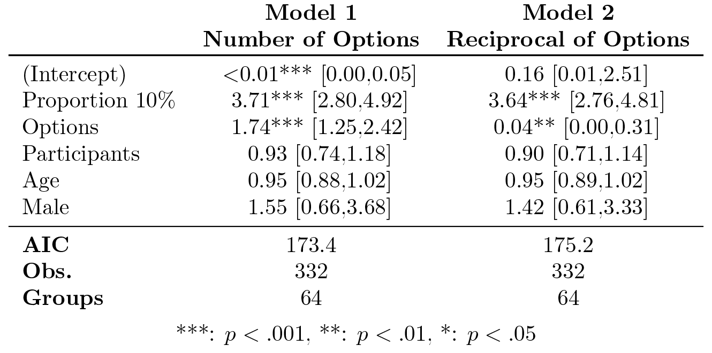
Table S7. Binary logistic multilevel model of decision to switch regressed on the proportion of participants in the option (in 10% increments for easier interpretation), the reciprocal and number of options (separate models), and the number of participants in the group. All coefficients are odds ratios. We control for common variance created by multiple observations from the same person with random effects for each individual.

Table 2
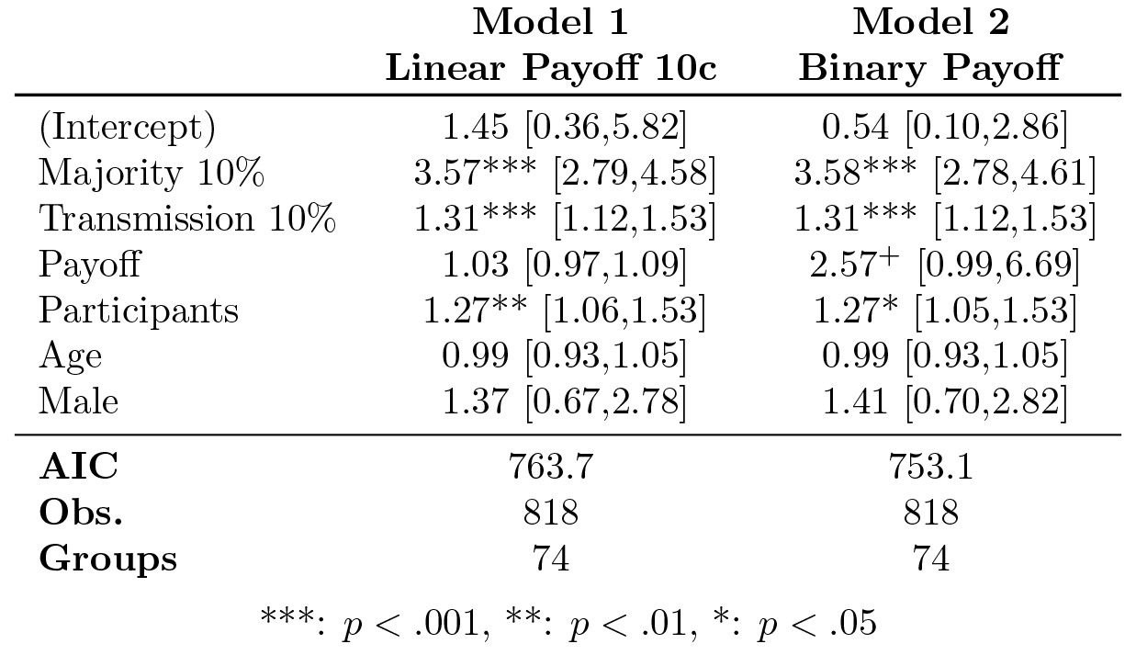
Table S8. Binary logistic multilevel model of decision to switch to majority on majority size, transmission fidelity, payoff, and number of participants in the group. All coefficients are odds ratios. We control for common variance created by multiple observations from the same person with random effects for each individual.

Results for Experiment 2 without Scaling
In Experiment 2, to calculate $α$ conformist bias scores for each participant, we scaled the proportion of participants for each option by the transmission fidelity, since we knew that there was a linear relationship between transmission fidelity and social learning (Fig. 5a). Here we report the results without this scaling.

Fig. 7
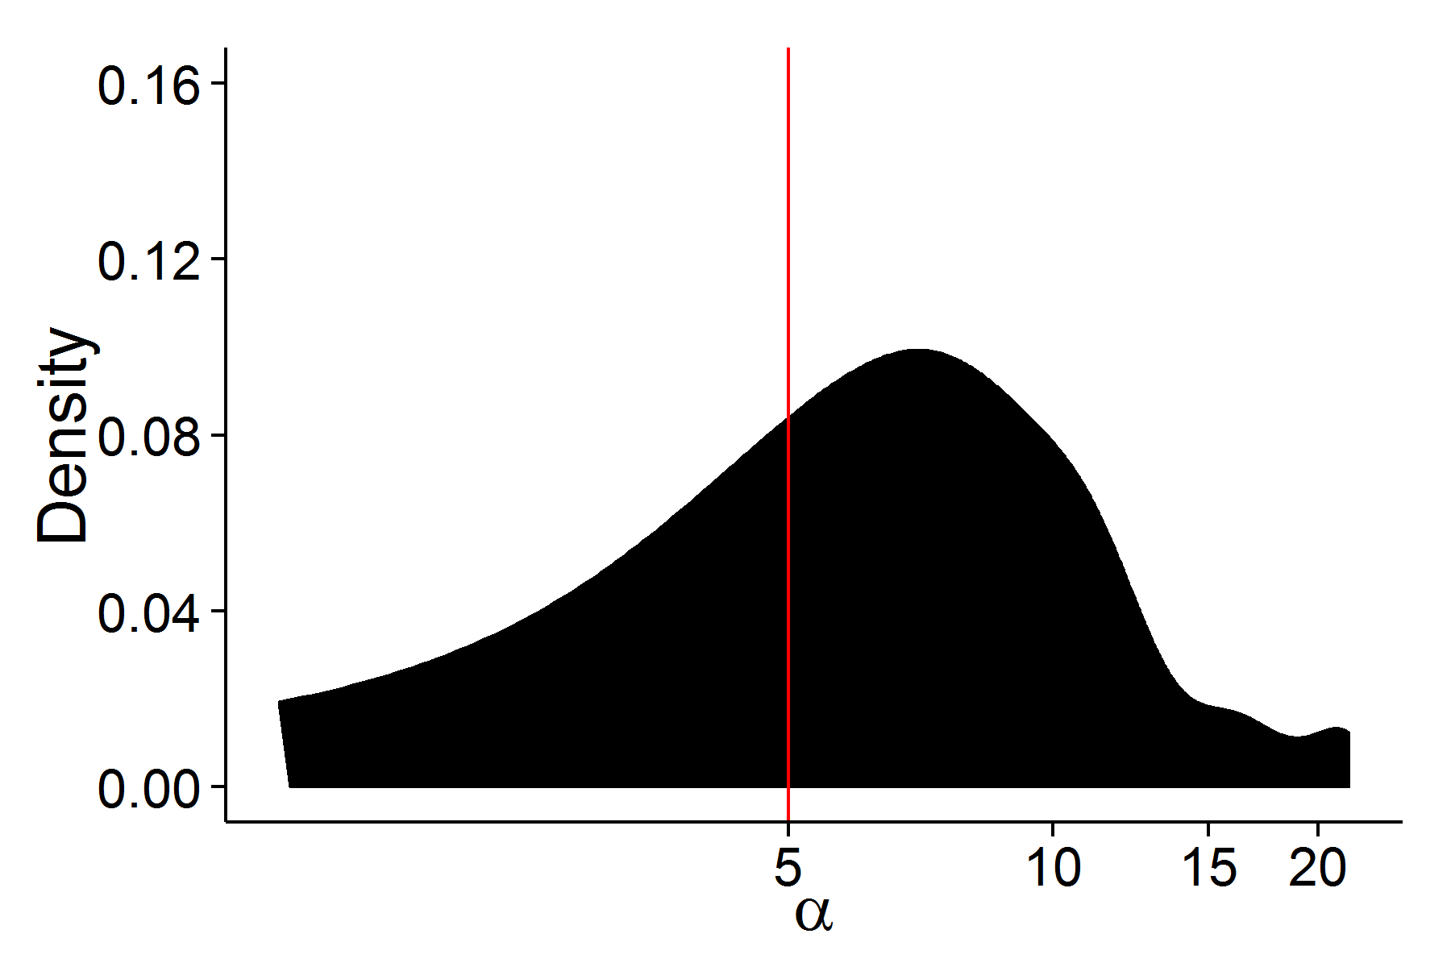
Fig. S8. Density distribution of $α$ conformist transmission values in Experiment 2, with$α$ unscaled by transmission fidelity. The red line indicates the cut off for conformist transmission with values to the left of this line indicating unbiased social learning. The x-axis is log-scaled. For visual purposes, we remove some outliers.

Table 4
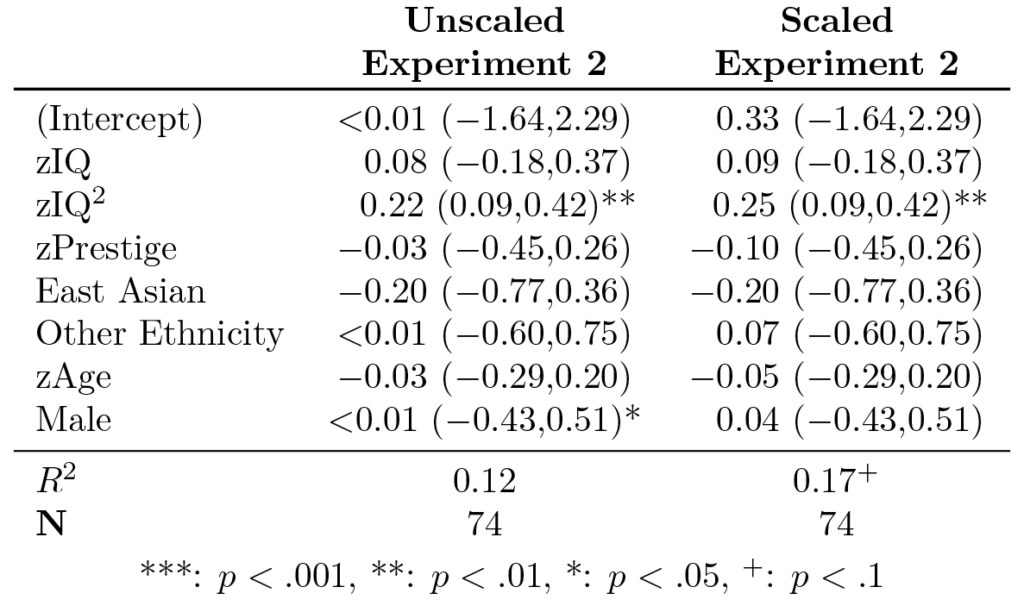
Table S9. Experiment 2 OLS regression model of standardized log measures of strength of conformist transmission ($α$) regressed on our theoretical predictors as well as age and gender. All predictors with a “z” prefix are standardized z-scores. Ethnicity was dummy coded, with Euro Canadians as the reference group. The model has a worse fit without scaling by transmission fidelity, but the overall pattern remains the same.

Density plot with outliers
Shown below are the density plots with outliers for conformist bias scores. Even after transforming there remain some outliers. We show our results are robust to these outliers by replicating the analysis reported in Table 4 using a Robust Linear Model.

Fig. 7 with outliers
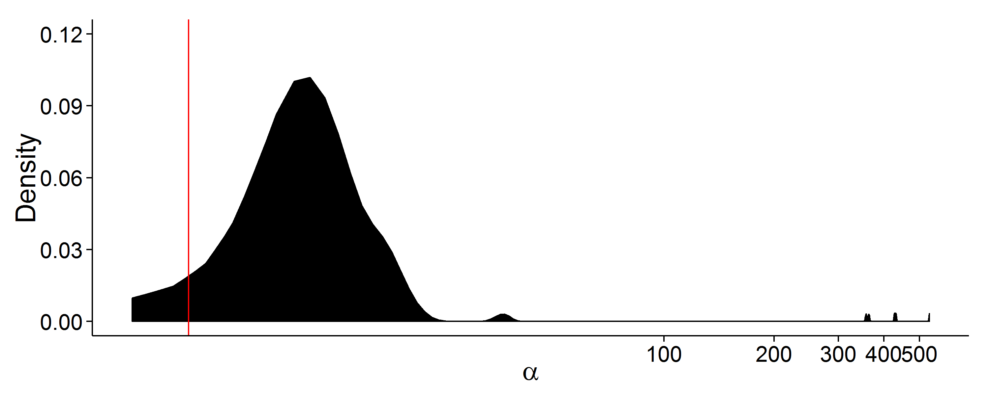
(a)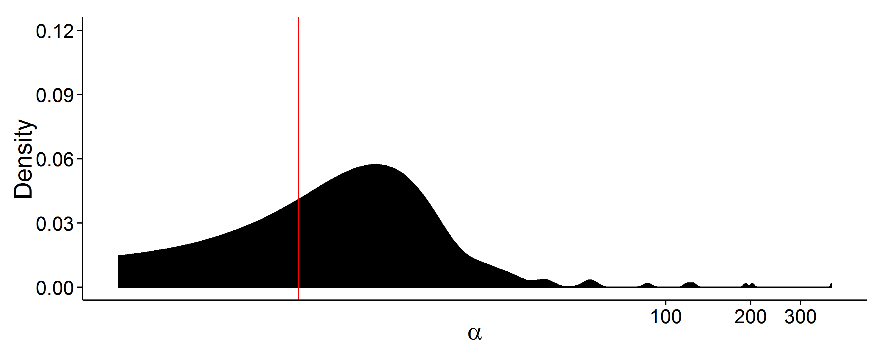
(b)
Fig. S9. Density distribution of $α$ conformist transmission values in (a) Experiment 1 and (b) Experiment 2, with$α$ calculated after scaling frequency of options by transmission fidelity. The red line indicates the cut off for conformist transmission with values to the left of this line indicating unbiased social learning. The x-axis is log-scaled.

Robust Linear Model Conformist Bias Analysis (Table 4)
To deal with outliers, we calculate the robust linear model using “rlm” from the “MASS” R package, which uses an MM-type regression estimator (Koller & Stahel, 2011). The general U-shaped relationship between IQ and the strength of the conformist-bias remains the same.
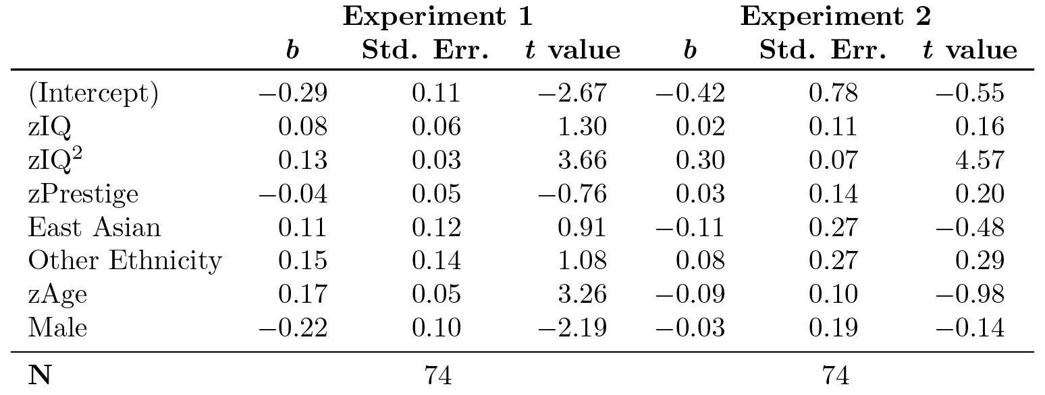
Table S10. Robust linear regression model of standardized log measures of strength of conformist transmission ($α$) regressed on our theoretical predictors as well as age and gender. All predictors with a “z” prefix are standardized z-scores. Ethnicity was dummy coded, with Euro Canadians as the reference group. These results suggest a consistent quadratic (U shaped) relationship between IQ and the strength of the conformist transmission bias. Both those who score high or very low on the IQ test are more likely to have stronger conformist transmission biases than those who score in the middle. In Experiment 1, which is arguably more sensitive than Experiment 2 because there are often more than 2 options, conformist biases strengthen among older individuals.

Performance
Here we show that our individual predictors do not predict performance. However, people do improve after social information, but the improvement is small (approximately 3% in for both experiments).

Predicting performance
No individual predictor was particularly effective (we tried several reduced models). With all individual predictors, we were still only able to explain 16% and 13% of the variance of the asocial decision and 8% and 13% of the social decision. In the analyses reported below, we omit the Cognitive Reflection Test (both Reflective and Intuitive scores) and the Rule Following Test, since some participants had seen some of the questions in the former and some early participants did not perform the latter. However, analyses with these included suggested that these did not reliably or significantly predict performance.

Asocial Decision
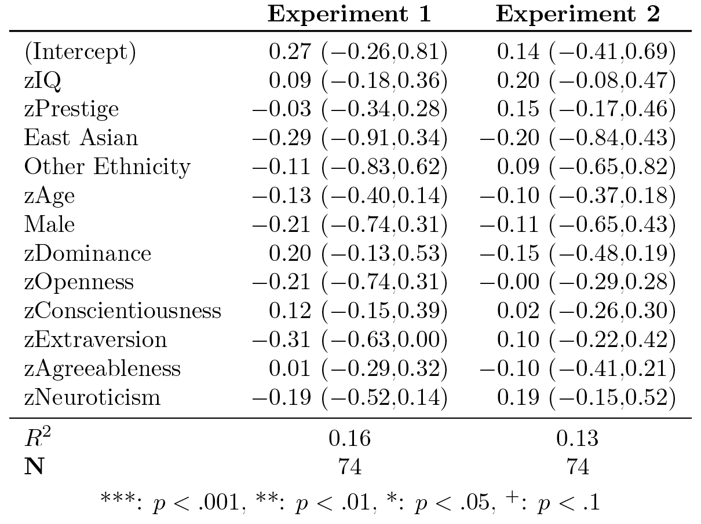
Table S11. Standardized asocial score regressed on all individual-level predictors. The model is not significant, nor are any predictors. Reduced models are also not significantly predictive.

Social Decision
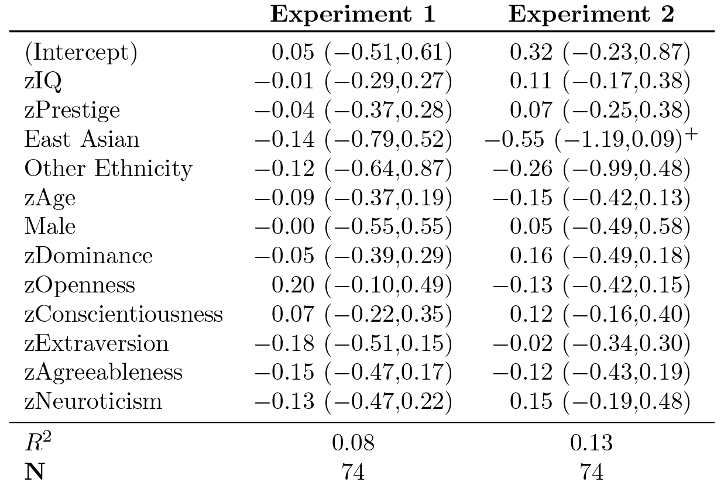
Table S12. Standardized social score regressed on all individual-level predictors. The model is not significant, nor are any predictors. Reduced models are also not significantly predictive.
Based on effect sizes, across both experiments and asocial and social decisions, IQ seems to positively predict performance (apart from Experiment 1 social decision, where it isn’t predictive). Being East Asian or older appears to negatively predict performance. Status and personality are not reliably predictive. However, all these effect sizes are statistically indistinguishable from zero.

Asocial vs Social Decision
We conducted a paired sample Student’s t-test for percentage scores before and after receiving social information. In Experiment 1 with multiple options, there was a marginally significant ~3% improvement (51.2% vs 54.1%, t(73) = -2.00, p = .050). In Experiment 2 with only two options, there was a significant ~3% improvement (65.0% vs 68.5%, t(73) = -4.94, p < .001).

References
Aron, A., Aron, E. N., & Smollan, D. (1992). Inclusion of Other in the Self Scale and the structure of interpersonal closeness. Journal of personality and social psychology, 63(4), 596.
Cheng, J. T., Tracy, J. L., & Henrich, J. (2010). Pride, personality, and the evolutionary foundations of human social status. Evolution and Human Behavior, 31(5), 334-347.
Frederick, S. (2005). Cognitive reflection and decision making. Journal of Economic perspectives, 25-42.
John, O. P., Donahue, E. M., & Kentle, R. L. (1991). The big five inventory—versions 4a and 54. Berkeley: University of California, Berkeley, Institute of Personality and Social Research.
John, O. P., Naumann, L. P., & Soto, C. J. (2008). Paradigm shift to the integrative big five trait taxonomy. Handbook of personality: Theory and research, 3, 114-158.
Kimbrough, E. O., & Vostroknutov, A. (2013). Norms Make Preferences Social Discussion Papers dp13-01: Department of Economics, Simon Fraser University.
Koller, M., & Stahel, W. A. (2011). Sharpening wald-type inference in robust regression for small samples. Computational Statistics & Data Analysis, 55(8), 2504-2515.
Raven, J. C., & Court, J. H. (1998). Raven's progressive matrices and vocabulary scales: Oxford Psychologists Press.
Ryder, A. G., Alden, L. E., & Paulhus, D. L. (2000). Is acculturation unidimensional or bidimensional? A head-to-head comparison in the prediction of personality, self-identity, and adjustment. Journal of personality and social psychology, 79(1), 49.

