**UserTW(100)**

has been a member for **7 months**  
was last seen: **today**  
ranked in the **top 5%** of sellers with **99.8%** positive feedback from **more than 300** transactions  
has **284** fans

Hello all **UserTW** here with all your Bud, Marijuana and MDMA related needs!  
  
Im a very honest guy and will always go above and beyond for my customers. If people put a little faith in me i guarantee i won't disappoint!!!

***BUSHY'S***  
  
SATIVA BUSHIES; New supply is in and ready. I will able to supply this weed for a long time to come.  
Pictures are up as well as the 1g, 3.5g and 7g listing  
  
***HYDRO***  
  
SUPER SKUNK - A mate of mine has some super skunk hydro which he described as 'dynamite' so its gotta be good! Listings are up... (SOLD OUT - NOT SURE OF NEXT ETA)  
  
A few people have asked me about Ounces (28g) unfortunately i can't do a special price for an ounce  
but feel free to get 2x 14g and I'll throw in free Express shipping (just select 'regular domestic' as your shipping method and I'll upgrade you to express)  
  
PLEASE NOTE; Unfortunately i didn't get as much as i would of liked so i can only offer listings up to 7g, sorry for anyone looking for larger quantities   
  
----------------------------------------------------------  
  
***MDMA***  
  
A mate has gotten his hands on some MDMA which I'll be selling in caps and by the gram, if people seem interested enough I'll get more. 1g is equal to about 10 caps. Listings are up...  
  
Please STOP asking where i get my MDMA from. If you want to buy it, buy it!!! If you want to know its history then im sorry but i cant help  
  
----------------------------------------------------------  
  
***PRICING***  
  
A lot of people are asking about my prices and why they seem to jump around all the time. My prices are all in US dollar and are set. I think the problem most people are having is that their profile is set to 'display prices in bitcoins' instead of 'display prices in dollars'. If you change your profile to 'display prices in dollars' you'll see my prices are always the same. Its the price of bitcoins that change.   
  
----------------------------------------------------------  
  
***POSTAGE AND PACKAGING***  
  
All orders will go out the same day as ordered or in rare cases early the next day. Orders placed on Friday after 10am will not go out till first thing Monday.  
  
All packages with be vacuum sealed for your safety and mine in a standard 'DL' sized envelope  
  
Postage is free for 'regular domestic' but I can ship 'express' if you need it there quicker but it will cost more  
  
PLEASE NOTE; Unfortunately I live outside the 'Express-Post Guaranteed Next Day Delivery' so some orders might take an extra day to arrive  
  
Delivery ETA seem to be 3-5 days with Regular Post and 2-3 days with Express  
  
A few people have commented on how compressed their weed is when it arrives on their end, I hope everyone understands its all part of the shipping process and unfortunately i do have to do it  
  
----------------------------------------------------------  
  
***PAYMENT***  
  
I've had alot of people ask me if i can do bank transfers or transfers using western union. Im sorry but i ONLY accept bitcoins for payment. NO EXCEPTIONS. It's all about being safe with this type of thing :)  
  
For bitcoins in Australia check out; http://www.spendbitcoins.com/buy/ or https://bitpiggy.heroku.com/  
  
PLEASE PLEASE PLEASE stop asking if i can do bank tranfers, where I live, if we can meet up or if i can do drop offs,  
I will never do anything that may jeopardize my anonymity!!!  
  
Please stop with the whole 'I dont have enough bitcoins' 'can we work something out' all my prices are set, bitcoins and payment are your responsibility not mine  
  
----------------------------------------------------------  
  
***FINALIZATION***  
  
Please Finalize your payment as soon as you a received your order. Im getting a lot of people (and i mean ALOT) not paying for their orders and orders having to wait 17 days be 'auto finalized'. If you do not pay I will make a note of your user name and will find it very hard to do business with you again. I go out of my way to get orders to you as quick as I possibly can, I think its only fare that YOU do the same, thanks...  
  
----------------------------------------------------------  
  
***PRIVNOTE***  
  
Please DO NOT use privnote to encrypt your message/address if you want to encrypt anything please use PGP encryption instead  
  
----------------------------------------------------------  
  
  
***BACKGROUND***  
  
WEED - I have been into weed for the last 15 years. I don't smoke all day everyday but after a long day at work there's nothing I enjoy more than a few pipes with my mates. I personally would rather smoke 'Bush-Buds' then 'Hydro' but a lot of my mates enjoy the opposite so each to there own  
  
MDMA - I haven't been a big fan of Ecstasy in the past its always messed with my head in the days after but i like this stuff. It seems cleaner with less come down (for me anyway).  
  
WARNING; Have too much tho and you will be grinding your face off :)  
  
----------------------------------------------------------  
  
***REVIEWS***  
  
I have just set up a new thread over on The Silk Road Forums at;  
'http://dkn255hz262ypmii.onion/index.php?topic=8788.0' for reviews  
so if anyone gets the chance and would like to post a review for my product it would be awesome!  
  
----------------------------------------------------------  
  
***FINAL NOTE***  
  
As i mentioned above I'm a very honest guy and will always go above and beyond for my customers. If anyone has any questions or comments please don't hesitate to ask and in the off chance we run into problems I will do WHATEVER it takes to make my customers happy  
  
----------------------------------------------------------

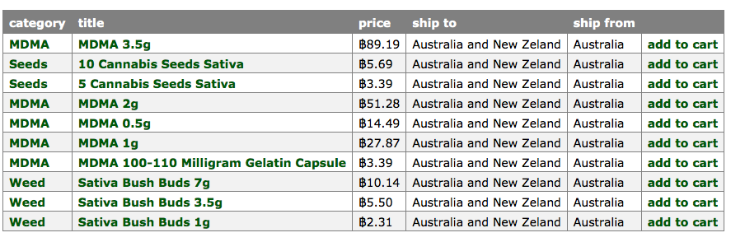

**Recent feedback**

| **rating** | **feedback** | **freshness** | **item** |
| --- | --- | --- | --- |
| 5 of 5 | Leave feedback here | 14 hours | item |
| 5 of 5 | Excellent service. Will use again and again. | 17 hours | item |
| 5 of 5 | weed is good packaging is good mdma is really good | 22 hours | item |
| 5 of 5 | Very professional 10/5 product I'm still peeking pupils as big as the moon | 1 day | item |
| 5 of 5 | Service & delivery:6/5!! Product: Appears to b a variation of Mdma, still a 110mg dose had me rolling for 3 - 4 hours, needed more. Will definitely use this vendor again! | 1 day | item |
| 5 of 5 | Product received promptly and as expected. Thanks. | 1 day | item |
| 5 of 5 | Got delivered super quick. Will up date once tried the mdma | 1 day | item |
| 5 of 5 | Quick and stealthy shipping as usual, what else can I say :) | 1 day | item |
| 5 of 5 | All good super quick as always | 1 day | item |
| 5 of 5 | amazing as always | 2 days |  |

**USERETM(99)**

has been a member for **11 months**  
was last seen: **today**  
ranked in the **top 10%** of sellers with **98.8%** positive feedback from **more than 300** transactions  
has **494** fans

Dear Aussie & Intergalactic Psychonaught's,  
  
We are a small & dedicated team of Aussie substance enthusiast's.  
  
We Make This Oath To YOU:  
  
- 24/7 Friendly & Helpful Customer Service  
- Quality Domestic Sourced Products + Fast & Secure Shipping.  
- Loyalty Bonus Program & Commitment To Continuous Improvement  
- Security Is Our Passion - Expert Stealth Shipping Practices  
  
Our aim is to find the most interesting and PURE substances known to man.  
  
We take security extremely seriously and invest heavily in research and development to ensure the safest SR shopping experience for our customers.  
  
Please read our **USERETM** profile below, which will answer any questions that you may have.  
  
"To deny our own impulses is to deny the very thing that makes us human."  
  
The " **USERETM** " Team  
  
Tormail: XXXXXXXXX@tormail.org

CUSTOMER SERVICE  
-----------  
We do offer customer service support 24/7 and will usually reply within a few hours. To ensure speedy processing of enquiries, please send regular plain text messages. During the order process, you may encrypt your address if you wish. Please send all messages thru the SR messaging system.  
  
Here is a thread with some of our feedback: http://dkn255hz262ypmii.onion/index.php?topic=4633.0  
  
  
ESCROW SYSTEM  
-----------  
We believe strongly in the SR Escrow system and will use it always with trusted buyers. New buyers with no history or buyers with high refund rates may be asked to finalise early. We have had a flawless delivery history.  
  
  
PRIVACY  
-----------  
All details are kept private and addresses are deleted as soon as they have been dispatched. You are free to encrypt your address with our PGP key when sending it if you feel it is necessary.  
  
  
PACKAGING  
------------  
-> The packages and envelopes all resemble business products/documents.  
-> Professional address label and premium packaging materials are used.  
-> LSD is shipped with extra care to preserve purity & strength of product.  
  
  
SHIPPING & HANDLING  
-------------  
We recommend Express Auspost Shipping for all customer orders due to the ability to track the item online and Express Post items are much safer due to their priority status.  
  
All orders will **USERETM** Security Processing stage to ensure that our latest security procedures are followed to ensure a successful and safe delivery, this stage could last for up to 24 hours.  
  
Express Post orders need to be processed first before being sent and could take up to 2 days to arrive - the benefits of Express are clearly the tracking to ensure a successful delivery.  
  
Standard Regular Domestic orders can take 3 to 4 days to arrive.  
  
We proudly have a 99.8% delivery success rate within Australia and 98.7% Overseas and with over 950+ Happy Delivered Customers, you can be assured of a genuine and professional transaction.  
  
  
**USERETM** EXPRESS Stealth Post (Mandatory for BULK orders)  
----------------------------  
- Cost: $9.97  
- Time: 1 to 3 days Business Days  
- Online Tracking  
- No signature required  
- Express shipping must be paid during checkout process.  
  
  
**USERETM** REGULAR Stealth Post  
----------------------------  
- Cost: FREE to anywhere in Australia  
- Time: 2 to 4 Business Days  
- No tracking  
- No signature required  
- Not recommended for larger orders.  
  
  
**USERETM** NEW ZEALAND EXPRESS Stealth Post  
----------------------------  
- Cost: $14.97  
- Time: 4 - 8 Business Days  
- Online Tracking.  
- No signature required.  
  
  
FRAUD  
----------------------------  
We have a 99.8% Delivery Success Rate - If your order does not arrive, please contact our team for a resolution. We take fraud seriously - if you defraud us you risk your surrounding area to be black-listed. We will engage in the resolution process within the SR system.  
  
DISPUTES  
----------------------------  
We will assess each case on it's merit and take into consideration the buyers stats, previous order history and legitimacy. All cases will be fully investigated & resolved. Refunds will only be issued as **USERETM** Money SR Gift Certificates.  
  
PGP/PRIVNOTE  
-----------  
We encourage you to encrypt your address however it is not mandatory as SR does already encrypt our messages and we clean out our mailbox every time we logout.  
  
If you have trouble with understanding or working PGP, you may use these services:  
  
https://privnote.com  
  
https://www.igolder.com/pgp/encryption/

We have noticed lately that some Australian vendors (Aussielollie & DopeBoyAus) have been neglecting their responsibility in providing a secure and professional shopping experience. One particular vendor has by his own admission been arrested and customer orders/details seized.  
  
This is NOT GOOD ENOUGH and we want to ensure our customers that we take extraordinary lengths to protect the safety, security and privacy of our customers.  
  
A **USERETM** Reserve Security Fund has been established to ensure that buyers orders are safe & secure (every order is backed by REAL BTC) to ensure we can continue to invest in new security technology to ship fast & securely and to protect our customers. This is a unique initiative developed by the **USERETM** Team.  
  
We strongly believe in the safety & security of our customers and have a flawless record for over 8+ months and have NEVER had a seizure or issue with LE.  
  
**USERETM** customers not only receive the highest quality products but you are ensuring peace of mind that you are dealing with an experienced and mature seller who will guarantee the security of your personal details and has high tech security systems and procedures to safely deliver your order without detection.  
  
Please choose your sellers carefully and have trust in our experience, professionalism and reliability.  
  
We make this commitment to you!  
  
**USERETM** Team

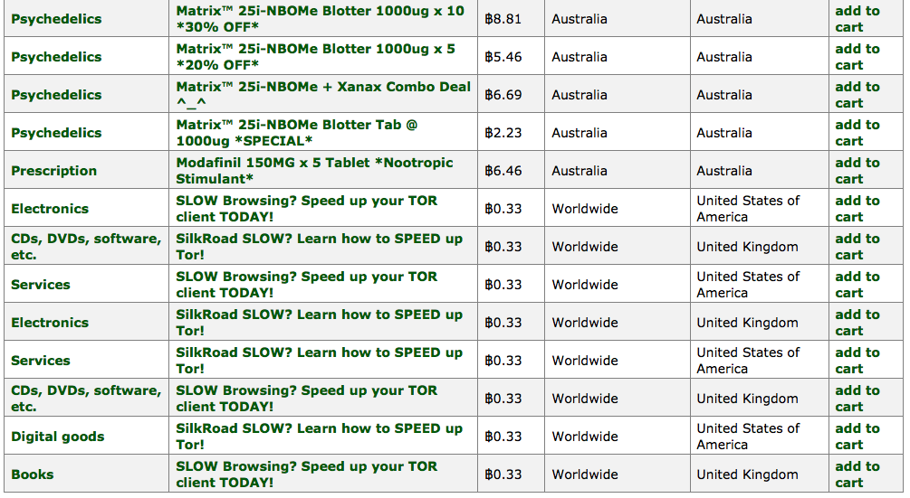

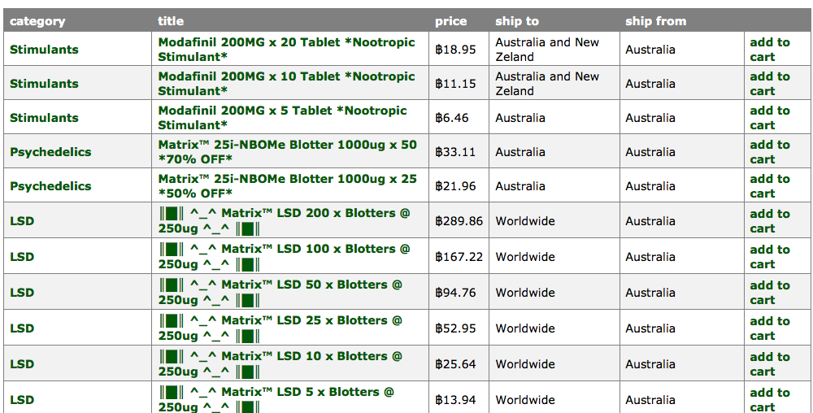

**Recent feedback**

| **rating** | **feedback** | **freshness** | **item** |
| --- | --- | --- | --- |
| 5 of 5 | Exactly as expected. | 25 minutes | item |
| 5 of 5 |  | 22 hours | item |
| 5 of 5 | Finalizing early for the most trusted and just generally AWESOME seller on SR - luvs you guys! | 1 day | item |
| 5 of 5 | A+ transaction, and thanks for the freebie. ETM rocks! | 1 day | item |
| 5 of 5 | FE for the BOSS! | 1 day | item |
| 5 of 5 | Excellent service as usual and an extra as well - thanks heaps :) | 1 day | item |
| 5 of 5 | Excellent thankyou. | 1 day | item |
| 5 of 5 | Excellent vendor, product arrived as advertised. Thanks ETM | 1 day | item |
| 5 of 5 | Arrived in 2 days! Cheers! :) | 2 days | item |
| 5 of 5 | You've got to experience the **USERETM** for yourself. 5/5 guys im tripping | 2 days | item |

**USERHH(100)**

has been a member for **2 months**  
was last seen: **today**  
ranked in the **top 22%** of sellers with **99.9%** positive feedback from **167** transactions  
has **70** fans

Back guys! so sorry, some personal probs, all good now :) new pgp coming later today!  
  
______________________________________  
  
  
Welcome everyone to my store! :)   
  
  
hey all my lovely friends :) I'm to want to be in the public so much but i would really appreciate it if any of you guys left me all your thoughts :)   
  
http://dkn255hz262ypmii.onion/index.php?topic=26326.0  
  
much love everyone! i hope everyone has enjoyed the service I have been providing xx  
___________________________________  
  
UPDATE:  
  
HEY ALLL MY FRIENDS!! I have decided to reduce prices for a bit to get sales going for you lovely folks :) enjoy!! love x  
  
I have also added a couple of bulk listing's for you awesome dudes out there :D  
  
Thank you so much so far for all your orders, I hope I have been a huge help for those in need.   
  
--------------------------------------  
  
  
  
I have some lovely xanax's listed for all you aussies in need. For the first 10 orders I will be offering free express postage! :)   
  
I understand prices are high, but they will eventually drop once I make my investment back for you all!  
  
Have fun and be safe!  
  
Any questions please dont be shy to ask, at the moment I am doing 5 and 10 tab listings, but please pm me if you wish to do a custom order :)  
  
One last silly reminder, please finalise orders once received, the quicker I receive coins, the more and cheaper products I can get ;)  
  
love you all x

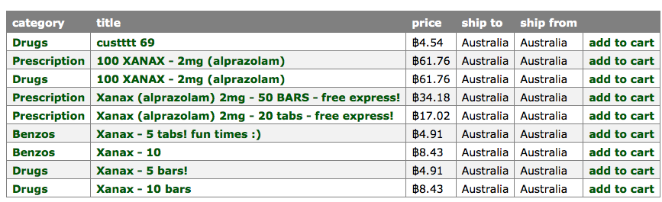

**Recent feedback**

| **rating** | **feedback** | **freshness** | **item** |
| --- | --- | --- | --- |
| 5 of 5 | super quick shipping. always a pleasure dealing with HH | 3 hours | item |
| 5 of 5 | Swift as usual | 1 day | item |
| 5 of 5 | Super fast delivery the main man for xanax | 1 day | item |
| 5 of 5 | I can no other answer make, but, thanks, and thanks. | 2 days | item |
| 5 of 5 | Leave feedback here | 2 days | item |
| 5 of 5 | :) | 2 days | item |
| 5 of 5 | FE for trusted seller :) super fast delivery :) | 2 days | item |
| 5 of 5 | This guy is a true professional. A gentleman and a scholar. A fucking legend. | 2 days | item |
| 5 of 5 | Top notch as usual... Overnight delivery with a bonus too! :) Cheers again **USERHH**. | 2 days | item |
| 5 of 5 | Thanks! Always got stock when needed :) | 3 days | item |

**USERMIA(98)**

has been a member for **5 months**  
was last seen: **today**  
ranked in the **top 30%** of sellers with **97.6%** positive feedback from **155** transactions  
has **162**

««««« UPDATE 17th July »»»»»   
  
Coming Soon!!! Slightly Delayed :'(  
  
* Methylone  
  
* MDPV  
  
* Mephedrone (4-MMC)  
  
  
Pre-Order Now As The Demand Is Going To Be Huge!   
  
  
  
Hello Everyone  
  
Forum Review Threads:   
  
http://dkn255hz262ypmii.onion/index.php?topic=12628.0   
  
http://dkn255hz262ypmii.onion/index.php?topic=13635.0  
  
+++++++++ STORE OPENED +++++++++++  
  
  
COKE - Is Out Pre Orders Opened! For Regulars ONLY!  
  
HEROIN - Is In Order Now!   
  
METH - Is out Pre Order Now!   
  
««««««««« Limited Supply »»»»»»»»»»»  
  
* Red Phosphorus Is NOW available!  
  
* Bulk Wholesale LSD NOW Available!  
  
* Hydroxylamine HCL Is NOW Available!   
  
  
When Pre ordering please put the following in the message title. Pre-Order (Drug of Choice)  
  
All The Best  
  
MIA   
+++++++++++++++++++++++++++++++++++++++  
***Opening Times***  
  
Monday to Saturday  
  
11am - 9pm all messages will be addressed during this time.  
  
9pm - 1am all orders will be packed ready for AM dispatch  
  
Welcome Aussie's To My Little Store!  
  
So you want some of the Best Cocaine on the Planet?  
  
But you don't want to order from overseas?  
  
I am focusing on Quality. We all know what the domestic street shit is.   
  
I commit to only selling A+ and I will never, ever CUT the product.   
  
I want long term domestic customers who value quality and professional service!  
  
While some will complain about price please consider the following:  
  
I pay for the product.  
I pay for shipping from overseas.  
I pay SR a commission.  
I take the time to carefully and discretely pack all orders.  
I invested in a vacuum sealer.  
I paid for the sellers account.  
And most important... I take the HUGE risk!  
  
So yes my domestic price is higher but I promise you when you want something fast, I am your LOCAL go to guy!  
  
If Silk Road Goes Down I Can Be Reached At XXXXXXXXX@tormail.net (But only if it goes down)  
  
Best Regards  
  
**USERMIA**

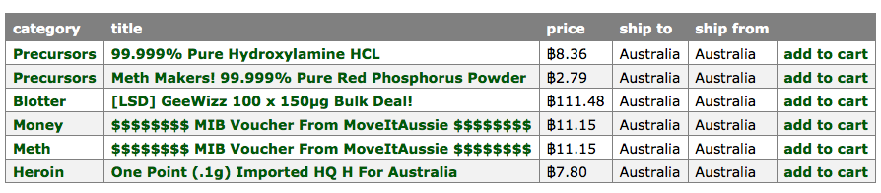

**Recent feedback**

| **rating** | **feedback** | **freshness** | **item** |
| --- | --- | --- | --- |
| 5 of 5 | Good communication. Seems to have it together. | 5 hours | item |
| 5 of 5 | arrived super quick, merchandise reasonable. | 2 days | item |
| 5 of 5 | :) | 2 days | item |
| 5 of 5 | Looks good and great communication, very good vendor. Can't fault the goods! | 3 days | item |
| 5 of 5 | excellent service and packaging, A+ | 4 days | item |
| 5 of 5 | excellent seller,arrived fast,over size,good gear,will definatly return! thanks mate! | 4 days | item |
| 5 of 5 | great stuff! a+++++++ would recommend | 4 days | item |
| 5 of 5 | Timely delivery, nicely packaged, very enjoyable merchandise - thx! | 5 days | item |
| 5 of 5 | :) | 6 days | item |
| 5 of 5 | Excellent comms, service etc. All round impressed and will return. Cheers bro. | 8 days | item |

**USERC(100)**

has been a member for **3 months**  
was last seen: **today**  
ranked in the **top 18%** of sellers with **99.6%** positive feedback from **more than 300** transactions  
has **108** fans

----- Supplying Hash and Quality Weed -----   
  
Hash - ** have a new batch in, it isnt mine and i got no idea how it was made. it presses a little softer and reports of the smoke is a fairly long lasting sativa high. i've listed it up under the older listings **  
  
High Quality indoor Weed - ** Currently Ak47 X Blueberry In very short supply listings up under the old AK47 once again **  
  
Great Quality Sativa - A great smooth cheap option if you swing that way :)  
  
My stock Varies from time to time, Mostly quality indoor grown strains, However in times of shortage i can get some great quality outdoor sativa, which is a pretty cheap alternative.  
  
----- Shipping -----   
  
FREE *Next day* delivery till end of May - Now over!!! i will be offering the same service for only 1btc.  
  
I wont go too far into the details, check my feedback for experiences. You would expect to see them no later than 4 days after sent, tho usually 1-2 days (next day in some cases).  
  
Monday - Midday Friday, orders out same day. From MIDDAY Friday will go out Monday morning. ** This may vary dew to other commitments.  
  
  
Address format 4-5 lines ONLY please Eg.  
  
Name Name  
33 Beat street  
(extra line for address if applicable)  
Somewheretown  
State 9999  
  
  
  
----- Payment -----  
  
Only Via Silk road, and please finalize the order once received. i do a good job to get your order to you fairly quick, so please do me a favor! people not finalizing are going to be on a black list for all vendors to see.  
  
  
----- Thanks -----  
  
Just like to say thanks for this different experience. and thank you for the great feedback! so many happy customers, And Please IF YOU HAVE ANY PROBLEMS WITH YOUR ORDER CONTACT ME FIRST BEFORE YOU LEAVE FEEDBACK!!!  
  
Link to a thread for review/feedback  
  
http://dkn255hz262ypmii.onion/index.php?topic=19509.msg196748#msg196748  
  
  
----- Contact -----  
  
Confidential information via silk road please use pgp key provided below. Also check this when you order as it may change. your confidential information is destroyed, deleted, erased, burnt and blown up once used! so buy with confidence..

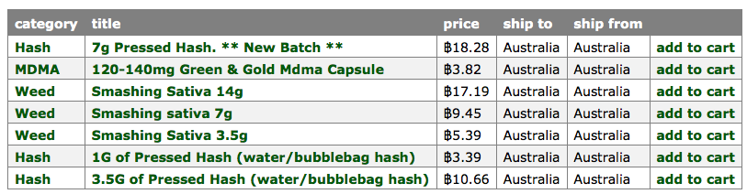

**Recent feedback**

| **rating** | **feedback** | **freshness** | **item** |
| --- | --- | --- | --- |
| 5 of 5 | Very nice product, fast postage and excellent customer service.  If your looking for a legit vendor experience then **USERC** is your man.  Will be sure to place another order when my supply runs low | 1 day | item |
| 5 of 5 | Not tested yet but overnight delivery and well packaged. No reason to doubt this trusted vendor. Will update after testing... Many thanks.  UPDATE: Terrific quality and had some of the best euphoria I've had since my SR purchases. To add to this, great follow up comms. I really like this vendor. I hope there is a steady supply in this space as I'll be a long term customer. thanks | 2 days | item |
| 5 of 5 | Good hash this time **USERC**, perfect softness for grinding and the high is a long lasting mellow head stone. Fast shipping, good stealth and he gave me some extra, Thankyou!!!! | 3 days | item |
| 5 of 5 | Quick and easy transaction. | 3 days | item |
| 5 of 5 | Just arrived, pre quick guys ;) | 4 days | item |
| 5 of 5 | awesome awesome stuff! smells and looks great! love it! | 8 days | item |
| 5 of 5 | Amazing packaging as always the hash was a good mellow smoke but it was quite compressed. Cheers again **USERC**! | 8 days | item |
| 5 of 5 | always good, always reliable FE | 10 days | item |
| 5 of 5 | Great buds. Fast and well packaged. | 11 days | item |
| 5 of 5 | Gr8 thanks mate | 11 days | item |